Turning waste into fuel

Introduction

Scientists work to understand the world around us and what they find out often ends up in the news. The work of scientists impacts our lives all the time, so it is very useful to be able to understand science writing. Read the science news story below and answer the questions.

Turning waste into fuel

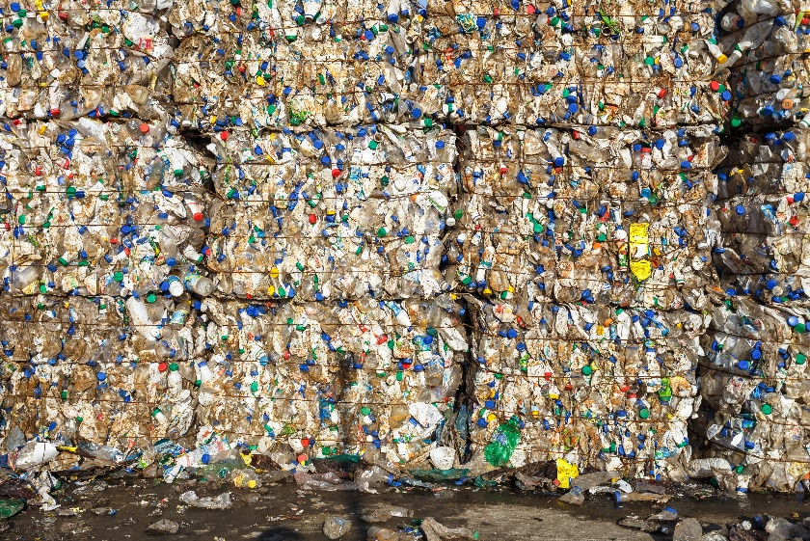

A photograph of stacked blocks of plastic waste © Shutterstock

Plastic waste can be converted into methane for fuel using a ruthenium-based catalyst. The technology could lessen our plastic waste problem as well as produce fuel.

Recovering chemicals from plastic waste is not new. Hydrocracking, which is often used in refining oil to make jet fuel and diesel, can convert plastic too. This reacts a feedstock with hydrogen and a catalyst. However, using the approach with plastic has been hampered by a lack of efficient catalysts.

Researchers investigated the use of ruthenium nanoparticles as a catalyst. They discovered this catalyst efficiently transforms the plastics polyethene, polypropene and polystyrene into methane that could be fed into natural gas networks.

Questions
- Why is recovering chemicals from plastic waste important?
- Which new process have researchers been investigating? Include the chemical substances involved in the process in your answer.
- Get two different coloured pens or pencils. Circle any scientific words in colour one. You will need the second colour later.
- In your own words, write down the meaning of the following scientific words from the news story. Use the glossary that accompanies this worksheet to help you.
- Catalyst
- Fuel
- Refining

Now that you have defined these words, use these words in a sentence. Think of when you have come across these words before and use your prior knowledge of these words to help you write.

Use the scale below to rate how much using the glossary is helping you understand the science in the story.

1 2 3 4 5 6 7 8 9 10

Not helping → Really helping

- Reread the news story. What do you think is the most important point of this news story? Share it with the person next to you. Using your second coloured pen or pencil, circle five to ten words that communicate that important point in the news story.

Use the scale below to rate how much circling words is helping you to understand the news story.

1 2 3 4 5 6 7 8 9 10

Not helping → Really helping

- Write down one new thing you have learnt from reading this science news story.

Use the scale below to rate how confident you would feel explaining the news story to the person next to you. Think of something else you can do when reading the text to help you understand the story and share it with the person next to you.

1 2 3 4 5 6 7 8 9 10

Not helping → Really helping

- Write your own summary of the news story for the other learners in your class. Use the prompts below.

- What have the scientists discovered? Try to write this in just one sentence. (Findings)
- What was the problem they were trying to solve? (Context)
- Why does their discovery matter? (Relevance/application)
- Think about who it matters to and what impact it could have for them. (Impact)
- In the news story you’ve just read, plastic waste is converted into methane for fuel using a catalyst. In the science classroom, we need to represent methane in different ways. Draw a molecule (for example the displayed formula) of methane. Methane has the formula CH_{4.}
- Catalysts are used in chemical reactions to speed up a reaction.
- Describe how a catalyst works.
- Give an example of a catalyst from an experiment or your everyday life.

Take it further

Scientists publish their findings in research articles. These are then written about by writers and journalists for different audiences. Research articles and other types of science writing can be very technical but they will mostly always cover the prompts in question 6.

- Read the story called Turning mixed plastic waste into natural gas with catalysis (available to download from: rsc.li/3RW42d9). This is based on the same research, but it is written for a different audience than the text at the top of this worksheet. Highlight the parts of the articles that link to each of the bullet points in different colours:
- What have the scientists discovered? (Findings)
- What was the problem they were trying to solve? (Context)
- Why does their discovery matter? (Relevance/application)
- Think about who it matters to and what impact it could have for them. (Impact)

- What differences do you notice between the research article Turning mixed plastic waste into natural gas with catalysis and the science news story at the top of this worksheet? Identify the differences and compare the news story with the research article in your answer.

- Imagine you are a professional science writer. Choose one of the options below and write a text about this research for:
- a post on social media;
- a magazine article aimed at adults who work in the chemistry industry;
- a report for school that gets published on the school website for other learners to read, including learners who are younger than you.

In each case, think about your audience (in other words, who will read it). Consider what they might want and need from the text. Make sure to leave space around your text so you can annotate it, explaining the decisions you have made for your audience. Consider the following and answer these prompts in your annotations:
- Did you include a photo, image or diagram? Did you include more than one? Why?
- Is your text long or short? Why?
- How much detail did you include in your text?
- Did you simplify or explain scientific language? Why or why not?

Glossary
Unfamiliar word | What it means
Catalyst | a substance that can speed up a reaction without being used up; it does this by lowering the activation energy for the reaction
Chemical | any basic substance that is used in or produced by a reaction involving changes to atoms or molecules
Feedstock | a starting substance for an industrial process, such as making solvents or detergents
Fuel | a substance that can transfer useful energy as heat when it is burned
Hamper | to make an action intended to achieve something more difficult
Hydrocracking | a process that uses heat and hydrogen to breakdown large molecules into smaller more useful ones
Methane | a gas with no smell or colour, often used as a fuel
Nanoparticle | a particle that is within 1–100 nanometres in diameter
Plastic | an artificial polymer that can be shaped when soft into many different forms and has many different uses. Polyethene, polypropene and polystyrene are all examples
Polyethene | a light, thin, soft plastic, often used for making bags or for keeping things dry
Polypropene | a type of plastic used for many purposes, such as food packaging, making ropes and making artificial fabrics
Polystyrene | a light, usually white plastic used for around objects to protect them from damage or putting around something to stop it from losing heat
Refining | the process of making different products from a basic product
Ruthenium | a transition metal element with chemical symbol Ru

Definitions of chemicals, hamper, methane, plastic (edited), polyethene, (shortened), polypropene, polystyrene (edited), refining (shortened), from Cambridge Dictionary, www.dictionary.cambridge.org/, © Cambridge University Press. Accessed February - Jan 2026. Used with permission.

