A microscale acid−base titration

Learning objectives
- Safely carry out a microscale titration of sodium hydroxide and hydrochloric acid.
- Use practical results to calculate an unknown concentration.

Introduction

In this experiment, you will use microscale titration apparatus to carry out an accurate titration on a much smaller scale. You will fill the microscale burette with a known concentration of hydrochloric acid and use a microscale pipette to transfer sodium hydroxide solution to a beaker. You will then carry out the titration, using your results to calculate the concentration of sodium hydroxide.

This technique can be a little fiddly at first! Microscale techniques allow us to work quicker and more safely (as less chemicals are used) while still maintaining accuracy in our results.

Equipment

Apparatus
- Graduated glass pipette, 2 cm³
- Pipette, 1 cm³, and pipette filler to fit (or a 1 cm³ plastic syringe)
- Plastic syringe, 10 cm³
- Fine-tip poly(ethene) dropping pipette
- Small lengths of rubber, plastic or silicone tubing
- Beakers, 10 cm³, x 2
- Clamp stand with two bosses and clamps

Chemicals
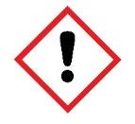
- Dilute hydrochloric acid, 0.10 M, about 10 cm³

- Sodium hydroxide solution (IRRITANT), about 10 cm³
- Phenolphthalein indicator solution (HIGHLY FLAMMABLE), a few drops

Health and safety
- Wear safety glasses throughout.

Method

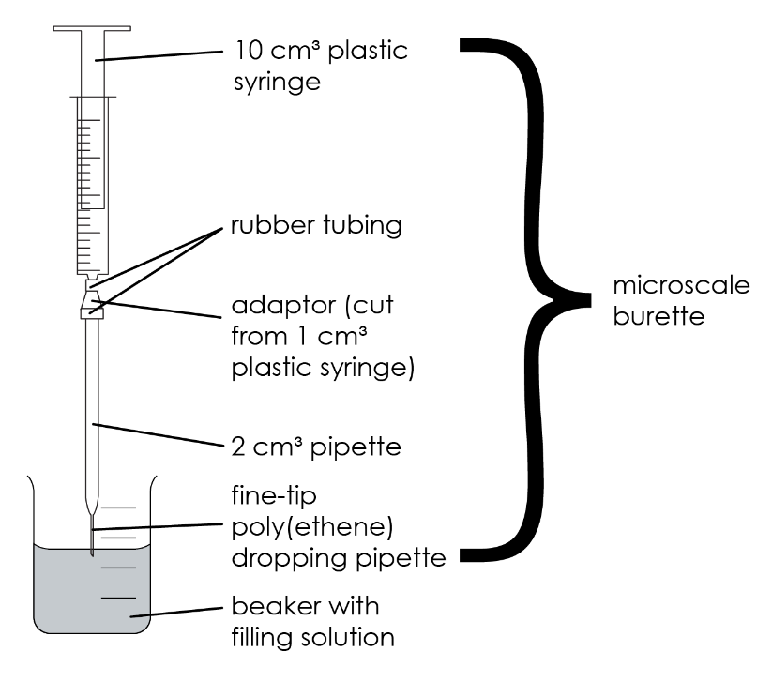
- Clamp the microscale burette as shown in the diagram. To fill the microscale burette, first push the syringe plunger completely down to ensure there is no air present inside. Place the tip of the microscale burette into the 0.10 M hydrochloric acid and slowly raise the plunger, making sure no air bubbles are drawn in. Fill all the way to the zero mark.
- Use the 1 cm³ microscale pipette and pipette filler to transfer exactly 1.0 cm³ of the sodium hydroxide solution into a clean 10 cm³ beaker.
- Add one small drop (no more!) of phenolphthalein indicator solution to the sodium hydroxide solution.
- Adjust the position of the microscale burette so that the tip is just below the surface of the sodium hydroxide and indicator solution in the beaker.
- Titrate the acid solution into the alkali by pressing down on the syringe plunger very gently, swirling to allow each tiny addition to mix and react before adding more.
- Continue until the colour of the indicator just turns from pink to permanently colourless.
- Record the volume of hydrochloric acid added at that point.
- Repeat the titration until you get reproducible measurements – concordant results within 0.1 cm³ of each other.

Results
 | Rough | Trial 1 | Trial 2 | Trial 3

Initial volume / cm³

End volume / cm³

Titre / cm³

Average titre = _____________________ cm³

Calculating the concentration of sodium hydroxide solution
- The equation for the neutralisation reaction is:

$$HCl(aq) + NaOH(aq) → NaCl(aq) + H_{2}O(l)$$

What is the molar ratio of hydrochloric acid to sodium hydroxide?

__________________________________________________________________________________

- Calculate the moles of 1 M hydrochloric acid used in the titration by following these steps:

- Convert your average titre from cm³ to dm³

$Volume \left({dm}^{3}\right)=\frac{\text{volume }\left({cm}^{3}\right)}{\text{1000}}$

__________________________________________________________________________________

- Use the equation, $concentration=\frac{moles}{volume ({dm}^{3)}}$ to find the moles of hydrochloric acid added.

__________________________________________________________________________________

- From the balanced symbol equation for the reaction, how many moles of sodium hydroxide reacted?
Hint: use your answer to Q1 to help you.

__________________________________________________________________________________
- What volume of sodium hydroxide was pipetted over in dm³?
$Volume \left({dm}^{3}\right)=\frac{volume ({cm}^{3})}{1000}$

__________________________________________________________________________________

- Use the equation, $concentration=\frac{moles}{volume ({dm}^{3})}$ and your answers to Q3a and 3b to find the concentration of sodium hydroxide.

__________________________________________________________________________________

- A student completed the titration and found the exact amount of hydrochloric acid to neutralise the sodium hydroxide. They repeated the experiment, adding the same volume of acid to the sodium hydroxide without indicator. They then used separation techniques to produce a pure, dry sample of the salt.
- Why did the student need to repeat the experiment without indicator?

__________________________________________________________________________________

__________________________________________________________________________________

- Which separation technique would the student use to produce a pure, dry sample of sodium chloride?

__________________________________________________________________________________

__________________________________________________________________________________
- Explain how the student could use melting point analysis to determine if the salt is pure.

__________________________________________________________________________________

__________________________________________________________________________________

