Using microbes to convert waste plastic

Introduction

Scientists work to understand the world around us and what they find out often ends up in the news. The work of scientists impacts our lives all the time, so it is very useful to be able to understand science writing. Read the science news story below and answer the questions.

Using microbes to convert waste plastic

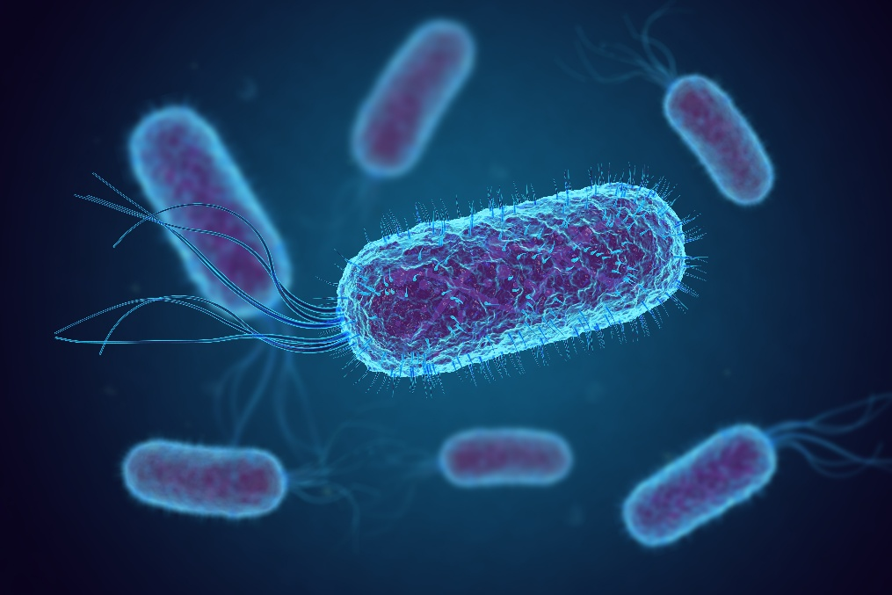

How a genetically engineered bacteria could reduce our planet’s plastic waste © Shutterstock

Polyethylene terephthalate (PET) is a widely used type of plastic. Most recycling technologies turn PET back into its monomers and then use them to make new plastic. Now, scientists have genetically engineered bacteria to transform PET plastic waste into vanillin, which is a very valuable chemical. Vanillin is the molecule responsible for the smell and taste of vanilla. It is used in food and cosmetics. Traditionally, it is extracted from the vanilla plant but global demand far outweighs the supply from natural sources.

The researchers genetically engineered a strain of the Escherichia coli (E. coli) microbe to produce enzymes that convert one of the monomers of PET into vanillin. These enzymes were introduced to a biological cell to carry out the reaction. There were challenges to overcome with the process including getting the substrate into the cell and removing the vanillin, which is toxic to the new strain of E. coli.

Questions
- Why is vanillin a valuable chemical?
- In your own words, explain the method scientists are using to turn plastic into vanillin.
- Get two different coloured pens or pencils. Circle any scientific words in colour one. You will need the second colour later.
- In your own words, write down the meaning of the following scientific words from the news story. Use the glossary that accompanies this worksheet to help you.
- Molecule
- Enzyme
- Monomer

Now that you have defined these words, use these words in a sentence. Think of when you have come across these words before and use your prior knowledge of these words to help you write.

Use the scale below to rate how much using the glossary is helping you understand the science in the story.

1 2 3 4 5 6 7 8 9 10

Not helping → Really helping

- Reread the news story. What do you think is the most important point of this news story? Share it with the person next to you. Using your second coloured pen or pencil, circle five to ten words that communicate that important point in the news story.

Use the scale below to rate how much circling words is helping you to understand the news story.

1 2 3 4 5 6 7 8 9 10

Not helping → Really helping

- Write down one new thing you have learnt from reading this science news story.

Use the scale below to rate how confident you would feel explaining the news story to the person next to you. Think of something else you can do when reading the text to help you understand the story and share it with the person next to you.

1 2 3 4 5 6 7 8 9 10

Not helping → Really helping

- Write your own summary of the story for the other learners in your class. Use the prompts below.
- What have the scientists discovered? Try to write this in just one sentence. (Findings)
- What was the problem they were trying to solve? (Context)
- Why does their discovery matter? (Relevance/application)
- Think about who it matters to and what impact it could have for them. (Impact)
- The news story you have just read is about converting plastic into monomers. In the science classroom, it is important to understand the monomers and polymers. In your own words, describe the difference between a monomer and a polymer.

Take it further

Scientists publish their findings in research articles. These are then written about by writers and journalists for different audiences. Research articles and other types of science writing can be very technical but they will mostly always cover the four prompts in question 7.
- Read the story called How microbes convert waste plastic bottles into vanillin (available to download from: rsc.li/4kcOEoV). This is based on the same research, but it is written for a different audience than the text at the top of this worksheet. Highlight the parts of the articles that link to each of the bullet points in different colours:
- What have the scientists discovered? (Findings)
- What was the problem they were trying to solve? (Context)
- Why does their discovery matter? (Relevance/application)
- Think about who it matters to and what impact it could have for them. (Impact)
- What differences do you notice between the research article How microbes convert waste plastic bottles into vanillin and the science news story at the top of this worksheet? Identify the differences and compare the news story with the research article in your answer.

- Imagine you are a professional science writer. Choose one of the options below and write a text about this research for:
- a post on social media;
- a magazine article aimed at adults who work in the chemistry industry;
- a report for school that gets published on the school website for other learners to read, including learners who are younger than you.

In each case, think about your audience (in other words, who will read it). Consider what they might want and need from the text. Make sure to leave space around your text so you can annotate it, explaining the decisions you have made for your audience. Consider the following and answer these prompts in your annotations:
- Did you include a photo, image or diagram? Did you include more than one? Why?
- Is your text long or short? Why?
- How much detail did you include in your text?
- Did you simplify or explain scientific language? Why or why not?

Glossary
Unfamiliar word | What it means
Cell | the smallest basic unit of a plant or animal
Enzyme | a naturally occurring catalyst made from protein that is produced by living cells to carry out the chemical reactions essential for life
Escherichia coli (E. coli) | a type of bacteria that can exist in food and the intestines of humans and other animals and can sometimes cause severe illness
Extract | to remove or take out something
Genetic engineering | the process or science of changing the structure of the genes of a living thing in order to make it healthier, stronger, or more useful to humans
Microbe | a very small living thing that can only be seen with a microscope
Molecule | two or more atoms connected by chemical bonds
Monomer | small molecules that can react with many other small molecules to form a polymer
Plastic | an artificial polymer that can be shaped when soft into many different forms and has many different uses
Polyethylene terephthalate (PET) | a strong plastic which can be spun into fibres used for a range of products including clothing, furniture, carpets, containers, bottles.
Reaction | When two or more substances react with and change each other
Strain | an organism from a particular group whose characteristics are different in some way from others of the same group
Substrate | a substance that an enzyme acts on to produce a chemical reaction
Toxic | poisonous
Vanilla | a substance made from the beans of a plant, used to give flavour to sweet foods
Vanillin | a chemical compound that is extracted from vanilla beans or prepared by a chemical process. It is used in flavouring foods and beauty products

Definitions of cell, Escherichia coli (E. coli) (edited) extract, demand, genetic engineering, microbe (edited), natural resource, plastic (edited), reaction, strain (edited), substrate, supply and toxic from Cambridge Dictionary, www.dictionary.cambridge.org/, © Cambridge University Press. Accessed Feb 2025 – Jan 2026. Used with permission.

