Using microbes to convert waste plastic

This resource forms part of the organic compounds and reactions (14-16) topic package where you will find more resources to embed literacy skills development into your teaching. You can edit all the linked files in this resource to best suit the needs of your learners.

Resource components

Reading comprehension sheet, present the news slides and script are also available from: rsc.li/4cxaNeS
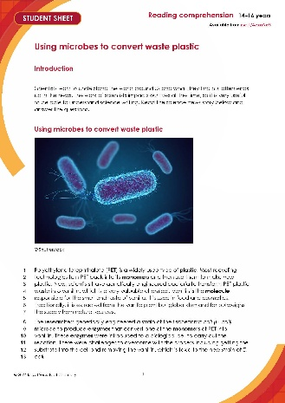 | 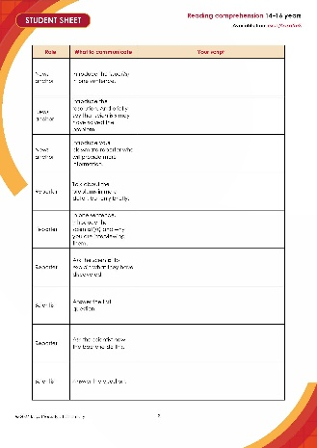 | 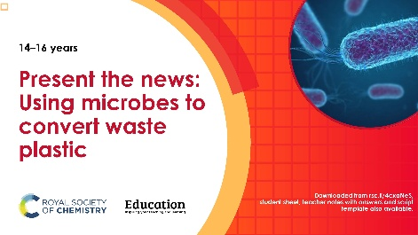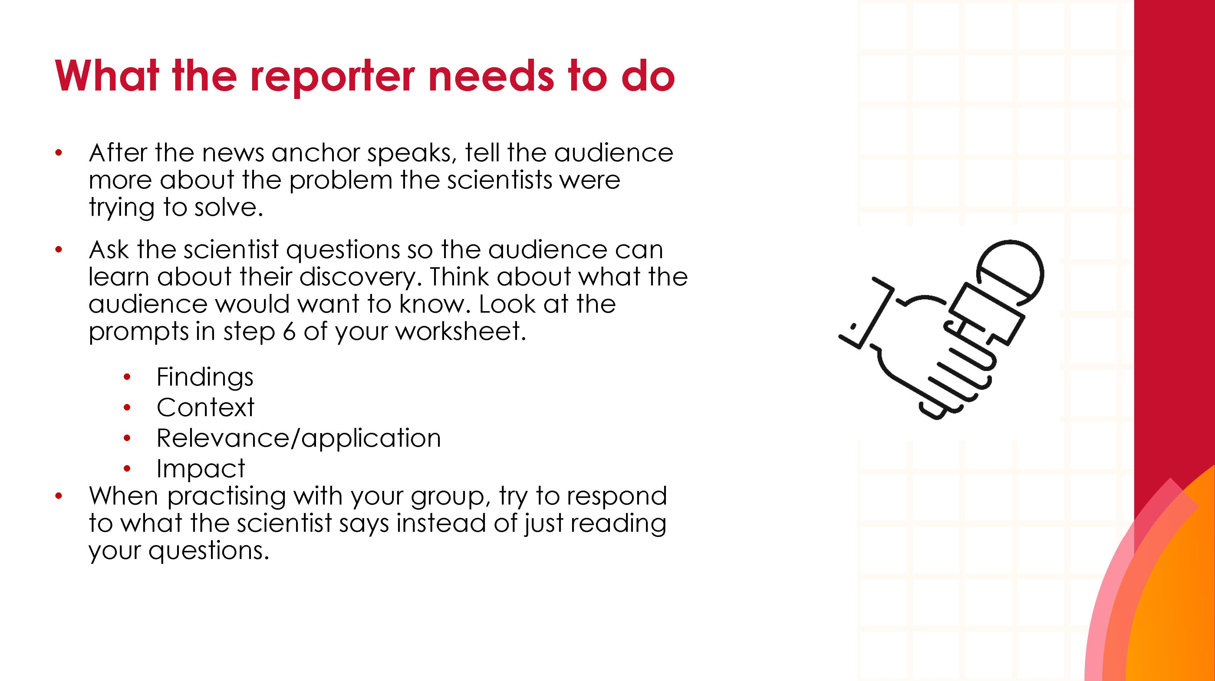
Reading comprehension worksheet: a simplified summary of a research article with comprehension questions and a glossary. | Present the news script: a template groups can write into. | Present the news slides: instructions and hints for a group presentation task.

Learning objectives
- Use active reading strategies to help you understand a science news story.
- Use the glossary to support your understanding of unfamiliar words.
- Know what key information to look for when reading a science news story.
- Understand how people write about science differently depending on their audiences.
- Confidently talk about the science news story, with consideration for your audience.

Questions 1–8 in the student sheet support learning objectives 1 and 2. Question 7 supports learning objective 3. Questions 9–11 support learning objective 4 and the ‘Present the news’ extension task supports learning objective 5.

Introduction

Reading about science is pivotal for understanding the world around us and the events and discoveries that effect our lives. In this reading comprehension, learners will actively engage with a simple text about a research article. Education in Chemistry has collated and distilled a wealth of science research news stories (see rsc.li/4jvfRU0). This reading comprehension resource is based on one of these stories relevant to the organic compounds and reactions (14-16) topic.

Reading comprehension activity

The story text has line numbers so you can easily direct learners to parts of the text. The line numbers can be disabled, more information on how to do this is available on Microsoft support: bit.ly/4cHKkeW

Model active reading

Before reading, show the headline and ask learners 'what do you think this text is about?' Read all the way through once without interruptions to allow learners to use context clues in the text to support their understanding and problem-solve unfamiliar vocabulary.

Read the text a second time and prompt learners throughout to actively engage with the text. You can ask:
- ‘How would you rephrase what’s just been said?’
- ‘What is this news story about?’
- 'Can you summarise this news story in a sentence?'
- 'Are any words in this text new to you?'

Find more information in: rsc.li/49Xyts5.

Consider using playback or recording software, so that learners can listen to the text on a device as they read along.

Question 7 asks learners to write a summary of the news story for their classmates. You can work through this question as a class first, before tasking learners to draw out the required information from the text independently. You can get learners to peer mark the summaries.

Taking it further

For questions 9 and 10, give learners access to a longer, more complex version of the reading comprehension text. This is available to download and print or can be viewed online. Learners will need a printed version to annotate in question 9. See: How microbes convert waste plastic bottles into vanillin (rsc.li/4kcOEoV).

Glossary of relevant terms

The glossary is pre-populated with vocabulary from the story that learners may need support with. The Education Endowment Foundation recommends prioritising teaching tier 2 and tier 3 terms, which learners are less likely to hear or read outside of their science lessons. More information on tier 2 and 3 terms can be found on the Education Endowment Foundation website, as well as reports and practical tools: bit.ly/4imgii2

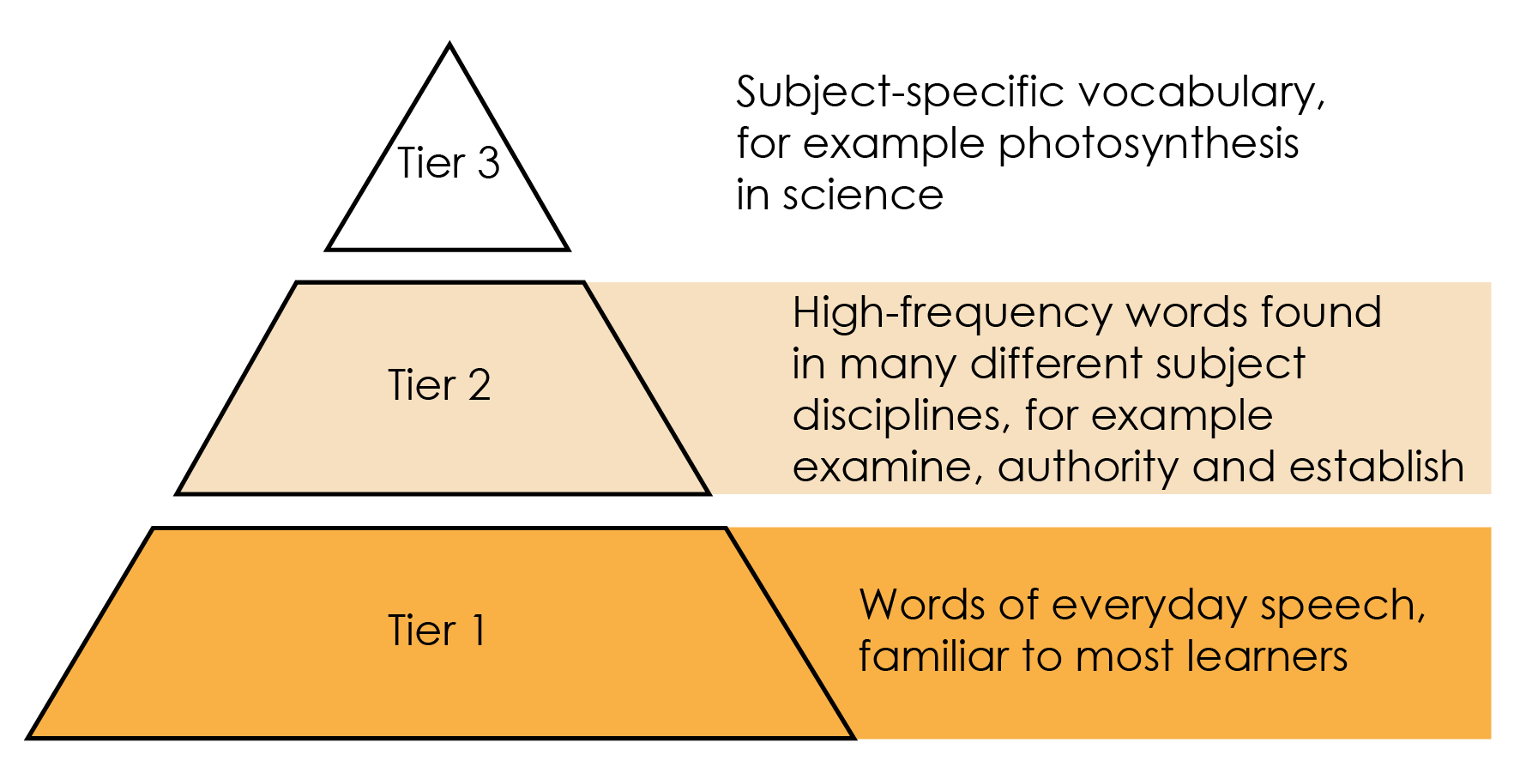

Reproduced with permission from Guilford Press, copyright 2013

Some words in the glossary are key terms and link with our key terms support resources (rsc.li/4js7w2I). For more challenge, remove or edit entries and task learners with researching and then populating the glossary.

Extension task: present the news

Instruct learners to present the science news story they have read as an item in a news programme.

Split learners into groups of three or four and assign each of them one of three roles – news anchor, reporter, or scientist. If there are more than three per group, assign multiple scientists. It’s important that everyone says something during the presentation.
- Project the ‘Present the news’ slides on the board. Slide 2 is the reading comprehension text to read aloud. Explain the task (slide 3) and provide learners with printouts of what each role needs to do (slides 4–6).
- Talk through the slide called ‘What does a good news presentation look like?’ (slide 7).
- Give learners the script template and direct them to prepare, as a group, what they want to say in the presentation. This will firstly involve reading the introduction on the script template, which you can do as a class if necessary. Allow learners about 45 minutes to prepare.
- Revisit the slide called ‘What does a good news presentation look like?’ (slide 7) before inviting the groups to present (allow five minutes per group).
- Direct learners to fill in the feedback sheet on the script template while their classmates are presenting. After all groups have presented, invite reflections and make notes of any learnings for the next speaking and listening activity.

Oracy Cambridge’s ‘Oracy skills framework’ provides more information about speaking and listening skills. For more information, see: bit.ly/4jBaTEG

Metacognition
This resource supports learners to develop their metacognitive skills in three key areas.
Aspect | Ideas for prompts
Plan | - Question 7 provides learners with a series of prompts to scaffold their summary of the science news story.  - The ‘present the news’ script introduction contains questions for learners to ask themselves when planning the presentation, for example about keeping to time.
Monitor | - Ask learners questions when reading the text aloud (see section called ‘model active reading’) to prompt them to monitor their understanding throughout the task.  - The comprehension questions prompt learners to assess how much the active reading strategies help them to understand the text and what other strategies they can employ to aid their understanding.
Evaluate | - Invite feedback on answers to the questions which use the 1–10 scale and collate a reading strategy ‘cheat sheet’ as a class. Revisit this cheat sheet next time you do a reading comprehension activity.  - Use the populated feedback table to reflect as a class on the strengths of the presentations and identify things to work on next time you do a class speaking and listening activity.

Example answers and guidance
- Vanillin is a valuable chemical because it responsible for the smell and taste of vanilla and is used in lots of food and cosmetics. Answers may also include mention of the demand for vanilla from natural sources surpassing supply.
- They are using bacteria that have been genetically modified to make an enzyme which will convert monomers in PET to vanillin.
- Scientific words: PET, plastic, monomers, enzyme, molecule, substrate, genetically engineered, chemical, vanillin, toxic, E. coli, microbe, biological cell, bacteria, reaction, researchers, strain.

The point of this exercise is simply to prompt learners to consider which potentially unfamiliar words are specific to science or chemistry, compared to for example connecting words. The list above is an example and there may be variation in answers.
- Any similar definitions to the below, use these definitions to check for accuracy:
- Molecule – two or more atoms connected by chemical bonds.
- Enzyme – a naturally occurring catalyst made from protein that is produced by living cells to carry out the chemical reactions essential for life.
- Monomer – small molecules that can react with many other small molecules to form a polymer.

Learners rate how much the glossary is helping them. Do a rough show of hands to gauge confidence and note learners’ responses.

- Ask learners to share what they think is the most important point of the news story.

Look for a good understanding of the most important point of the news story. Example answer – genetically engineered bacteria, enzymes, PET into vanillin.

Learners rate how much circling words is helping them. Do a rough show of hands to gauge confidence and note learners’ responses.

- Ask learners to share what they have learned from reading the news article.

Learners rate their confidence explaining the story. Do a rough show of hands to gauge confidence and note learners’ responses. Ask learners to share their strategies for the benefit of the class.

How learners rate the techniques in questions 3 and 4, and their confidence to explain the story, can inform your approach to future reading comprehension activities.

- Indicative answers for summary of story.
- What have the scientists discovered? (Findings)
- Genetically engineered bacteria (E. Coli) can produce enzymes which turn monomers of PET into vanillin.
- What was the problem they were trying to solve? (Context)
- In general, what to do with large amounts of plastic waste. Specifically, how to turn waste plastic into a higher value product.
- Why does their discovery matter? (Relevance/application)
- It will help reduce the amount of plastic waste and is also a new way to make vanillin.
- Think about who it matters to, and what impact it could have for them. (Impact)
- Since vanillin is used in food and cosmetics, an increased supply of vanillin could mean these industries can make more of their products, or/and the products could be made more cheaply (if the price of vanillin goes down because there is more available).
- On the other hand, an increased supply of synthetic vanillin may have a negative effect on people involved in growing and selling natural vanilla.
- A monomer is a single unit that can be joined with other monomers to create a polymer. A polymer is a very large molecule made by joining together lots of small molecules.

Taking it further
- Learners should highlight the full article in different colours using the prompts. See the highlighted text below as an example.
- What have the scientists discovered? (the finding)
- What was the problem they were trying to solve (the context)
- Why does their discovery matter? (relevance/application)

How microbes convert waste plastic bottles into vanillin
Original article by Jack Washington. Adapted by Neil Goalby
Scientists in the UK have genetically engineered Escherichia coli to transform plastic waste into vanillin. Instead of simply recycling plastic waste into more plastic, the system demonstrates for the first time that you can use plastic as a feedstock for microbial cells and transform it into something with higher value.
Polyethylene terephthalate (PET) is one of the most widely used types of plastic. Most existing recycling technologies degrade PET into its constituent monomers, ethylene glycol and terephthalic acid, then repurpose them in second-generation plastic materials. The researchers want to upcycle these monomers into alternative products.
The researchers used genetic engineering to create a strain of E coli that converts terephthalic acid into vanillin. Vanillin is the molecule responsible for the characteristic smell and taste of vanilla. Traditionally it is extracted from the vanilla plant, but global demand far outweighs supply from natural sources.
The modified E coli produces enzymes to convert terephthalic acid to vanillin through an oxidation, a methylation and two reduction steps. Through careful optimisation of reaction conditions and media, eventually a sweet spot was found where each of the enzymes was able to play its part in the biocatalytic transformation of terephthalic acid to vanillin.
Unfortunately, getting the cell to carry out the transformation was only half of the battle. A huge challenge is physically getting the substrate into the cell so that the chemistry can happen. To overcome this, the scientists added small amounts of alcohol that essentially poke holes in the cell membrane to increase its permeability. Another complexity was that vanillin itself is toxic to their new strain of E coli. To mitigate these toxicity issues, they removed the product from the reaction mixture in situ by extracting it into oleyl alcohol.

- Answers will vary, but can include a selection of the following:
- the article is longer
- it contains more scientific words
- it contains more details about the discovery and the laboratory work done.

- Look out for an awareness of different writing formats and an appreciation that different audiences have different needs or interests, for example:
- shorter version, links to other interesting articles, key message up front, relevant pictures or video clips;
- longer version, lots of detail, including information on who did the research and maybe their contact information;
- simplifying complicated language, pictures to aid understanding.

Example script for ‘Present the news’
Role | What to communicate | Example script
News anchor | Introduce the issue(/s) in one sentence. | Plastics are very useful materials. When they come to the end of their use, we recycle much of them, but unfortunately a lot still end up in landfill.
News anchor | Introduce the resolution. And briefly say that scientists may have solved the problem. | Now, by cleverly using bacteria, scientists have found a way of using waste plastic to make a valuable chemical called vanillin, which gives food a vanilla flavour and has other uses too.
News anchor | Introduce your classmate reporter who will provide more information. | Our reporter (name of learner) has been investigating.
Reporter | Talk about the problems in more detail, but only briefly. | Vanillin is an incredibly useful molecule but at the moment global demand far outweighs the supply. At the same time, we are producing an enormous quantity of plastic waste, and not all of it gets recycled.
Reporter | In one sentence, introduce the scientist(/s) and why you are interviewing them. | I am here with (learner name) who has found a way to make vanillin using waste plastic
Reporter | Ask the scientist to explain what they have discovered. | (Learner name) tell us about what you have discovered.
Scientist | Answer the first question. | We have discovered a way to use bacteria to break down waste plastic and turn it into vanillin.
Reporter | Ask the scientist how the bacteria do this. | How do the bacteria do this?
Scientist | Answer the question. | We genetically engineered the bacteria to make an enzyme which turns plastic monomers into vanillin.
Reporter | Ask the scientist why the discovery is important. | Why is this an important discovery?
Scientist | Explain what a difference this research could make to people. | It means that we can make more vanillin to help with demand. Natural vanilla comes from vanilla pods, which come from vanilla plants. But the vanilla flavouring, as we all know, is extremely popular! So having access to synthetic vanilla can increase the global market availability.
Reporter | Ask the scientist to explain how this discovery might also help deal with waste plastic. | How might this discovery help with the problem of waste plastic?
Scientise | Respond to the question. | The bacteria use monomers from PET, a popular type of plastic, to make the vanillin. So we are also potentially reducing the amount of plastic going to landfill or reducing the amount which needs to be recycled.
Reporter | Thank the scientist. | Thank you very much for your time.
Scientist | Acknowledge the thanks. | No problem, thank you for having me
News anchor | Say something in response to what the scientist and the reporter have said, which reflects what your audience might be thinking. Thank the reporter. This will end the presentation. | A way to reduce plastic waste which can also help to make useful -and tasty(!) - products. I’d like to know if discoveries like this could make the process of recycling plastics into new plastics more efficient. Perhaps one for the future!

Acknowledgements

Vocabulary tier diagram: Beck, Isabel L., Margaret G. McKeown, and Linda Kucan. Bringing Words to Life: Robust Vocabulary Instruction. New York: Guilford Press, 2013.

