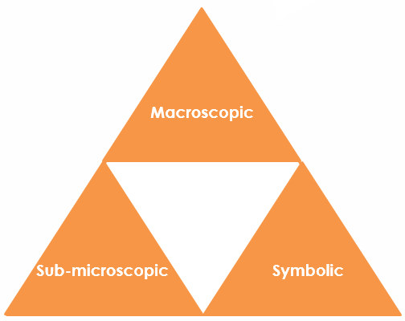
Tin from tin oxide: Johnstone’s triangle

Learning objectives
- Name reactants and products from their description.
- Calculate relative formula mass from a given formula and relative atomic masses.
- Calculate the mass of a product from the mass of a reactant.

Introduction

Tin can be extracted from tin oxide by reaction with carbon. The mass of tin oxide can be used to determine the number of moles of the tin oxide reacting. The balanced equation shows one mole of tin is produced from each mole of tin oxide. The number of moles of tin can then be used to determine the mass of tin that can be produced.

Johnstone’s triangle

In chemistry we make sense of the things that we can see by representing what we can’t see using formulas, equations, diagrams and models.

Johnstone’s triangle is a way of thinking about these different concepts as different corners of a triangle:
- Macroscopic – what we can see. Think about the properties we can observe, measure and record.
- Sub-microscopic – smaller than we can see. Think about the particle or atomic level.
- Symbolic – representations. Think about how we represent chemical ideas, including symbols and diagrams.

Being able to connect and move between these three different levels is important for scientific understanding.
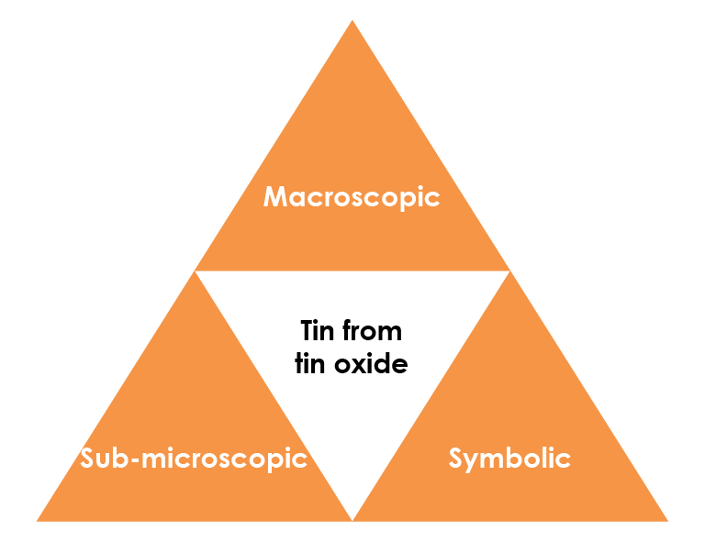

© Shutterstock/Ermak Oksana

Macroscopic – what we can see

Tin is extracted from the compound tin oxide by heating

with carbon. Carbon monoxide gas is also produced.

Add the name of each substance next to its description.
Name | Description
 | colourless gas
 | shiny silvery solid
 | black solid
 | white solid

Tin cans are usually made of steel that is coated in tin.

Symbolic – representations

The equation for the extraction of tin from tin oxide is: ${SnO}_{2}$(s) + 2C(s) → Sn(l) + 2CO(g)

Suggest why tin (Sn) has the state symbol (l).

_________________________________________________

_________________________________________________

Give the name of the compounds represented by the following formulas.

${SnO}_{2}$ : ____________________________________________

CO: _______________________________________________

Calculate the relative formula mass of tin oxide.

A_{r} (Sn) = 119 A_{r} (O) = 16

M_{r} (${SnO}_{2}$) = _______________________________________

<Fill in the model answer using Bradley Hard ITC, font size 14, font colour #4F81BD.

If you need to use diagrams please provide an example and we will redraw these in-house.>

Sub-microscopic – smaller than we can see

Use the chemical equation to determine the number of moles of tin extracted from each mole of tin oxide.

Calculate the mass of tin produced from 30 kg of tin oxide using the following steps:

1. Convert 30 kg into g. 30 kg = ____________________________________ g

2. Calculate the number of moles of tin oxide in 30 kg.

$Moles=\frac{mass ({SnO}_{2})}{M_{r}({SNO}_{2})} =$

3. State the number of moles of tin produced: ________________________

4. Calculate the mass of tin produced.

_____________________________________________________________________

Convert your answer into kg: _________________________________________

