Tin from tin oxide: Johnstone’s triangle

This resource is from the Johnstone’s triangle series which can be viewed at: rsc.li/4qq2DLK. It will help learners to understand the different ways you need to think in chemistry, and to build their mental models and understanding.

Learning objectives
- Name reactants and products from their description.
- Calculate relative formula mass from a given formula and relative atomic masses.
- Calculate the mass of a product from the mass of a reactant.

How to use Johnstone’s triangle

Use Johnstone’s triangle to develop learners’ thinking about scientific concepts at three different conceptual levels:
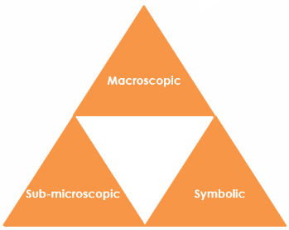
- Macroscopic – what we can see. Think about the properties you can observe, measure and record.
- Sub-microscopic – smaller than we can see. Think about the particle or atomic level.
- Symbolic – representations. Think about how we represent chemical ideas including symbols and diagrams.

For learners to gain a deeper awareness of a topic, they need to understand it at all three levels.

When introducing a topic, don’t introduce all three levels of thinking at once. This will overload working memory. Instead complete the triangle over a series of lessons, beginning with the macroscopic level and introducing other levels, in turn, once secure.

The three levels are interrelated. For example, learners need visual representation of the sub-microscopic in order to develop mental models of the particle or atomic level.

Find further reading about Johnstone’s triangle and how to use it in your teaching at: rsc.li/4qq2DLK.

Scaffolding

Share the structure of the triangle with learners prior to use. Tell them why you are using it and how it will help them to develop their understanding. Use an ‘I try, we try, you try’ approach when introducing Johnstone’s triangle for the first time.

More resources

To further develop learner’s thinking in all areas of Johnstone’s triangle, try our Developing understanding of reacting ratios (masses) worksheet (rsc.li/498JyaF). This includes icons in the margin referring to the conceptual level of thinking needed to answer the question.
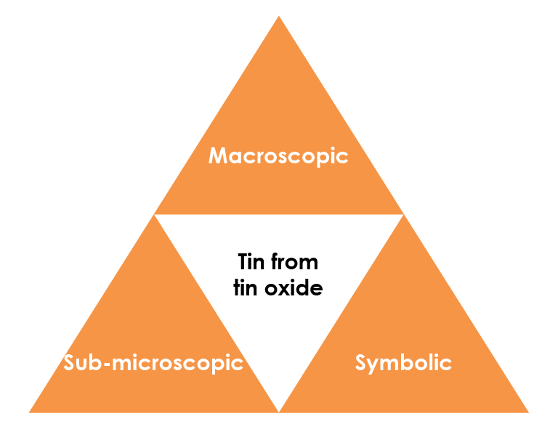

© Shutterstock/Ermak Oksana

Symbolic – representations

The equation for the extraction of tin from tin oxide is: ${SnO}_{2}$(s) + 2C(s) → Sn(l) + 2CO(g)

Suggest why tin ($Sn$) has the state symbol (l).

The tin is in the liquid state because the reaction takes place at a high temperature.

Give the name of the compounds represented by the following formulas.

SnO₂ tin oxide

CO carbon monoxide

Calculate the relative formula mass of tin oxide.

A_{r} (Sn) = 119 A_{r} (O) = 16

M_{r} (${SnO}_{2}$) = 1 x 119 + 2 x 16 = 151

<Fill in the model answer using Bradley Hard ITC, font size 14, font colour #4F81BD.

If you need to use diagrams please provide an example and we will redraw these in-house.>

Sub-microscopic – smaller than we can see

Use the chemical equation to determine the number of moles of tin extracted from each mole of tin oxide. 1 mole

Calculate the mass of tin produced from 30 kg of tin oxide using the following steps:

1. Convert 30 kg into g. 30 kg = 30 x 1000 = 30000 g

2. Calculate the number of moles of tin oxide in 30 kg.

$Moles=\frac{mass ({SnO}_{2})}{M_{r}({SNO}_{2})} =$ 30000 / 151 = 199 moles (3 sf)

3. State the number of moles of tin produced. 199 moles (3 sf)

4. Calculate the mass of tin produced.

Mass (Sn) = moles (Sn) x A_{r} (Sn) = 198.68 x 119 = 23642 g

Convert your answer into kg 23.642 kg or 23.6 kg(3 sf)

Tin cans are usually made of steel that is coated in tin.

Macroscopic – what we can see

Tin is extracted from the compound tin oxide by heating

with carbon. Carbon monoxide gas is also produced.

Add the name of each substance next to its description.
name | description
carbon monoxide | colourless gas
tin | shiny silvery solid
carbon | black solid
tin oxide | white solid

