Researchers finally isolate elusive calcium bicarbonate crystals

Original article by Mason Wakley. Adapted by Nina Notman.

Crystals of a key mineral responsible for water hardness synthesised for first time

If you are a fan of the Great British Bake Off, you likely have some sodium hydrogencarbonate, $NaHCO_{3}$, better known as hydrogencarbonate of soda, in your kitchen. This white crystalline powder reacts with acids in cake batter to produce carbon dioxide gas, which helps cakes rise.

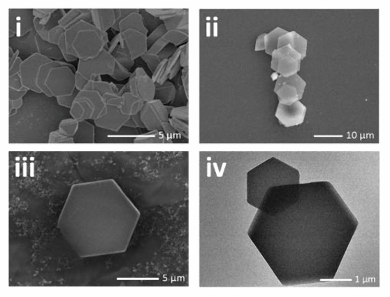
If you live in a hard water area, calcium hydrogencarbonate, $Ca{(HCO_{3})}_{2}$, is also in your kitchen, dissolved in the water flowing from your taps. But unlike its sodium counterpart, it is only present in a solution. Despite trying for around two centuries, scientists have not been able to isolate calcium hydrogencarbonate crystals – until now. Earlier attempts failed because the salt rapidly decomposes to calcium carbonate $(CaCO_{3})$ when the water it is dissolved in evaporates. In hard water areas, these calcium carbonate crystals line the inside of kettles.

Source: © 2025 American Chemical Society
These electron microscope images show the first‑ever calcium hydrogencarbonate crystals, revealing neat hexagonal shapes that scientists could only imagine until nowtable

Researchers in China have now reported that they have successfully isolated crystals of calcium hydrogencarbonate. The team made the salt in ethanol rather the water used in previous attempts. They pumped carbon dioxide into an ethanol solution to make hydrogencarbonate ions, which then formed calcium hydrogencarbonate salt by forming ionic bonds with calcium ions also present in the ethanol solution. Calcium hydrogencarbonate is insoluble in ethanol, so the salt formed as a crystalline precipitate.

The research team then probed the calcium hydrogencarbonate’s structure, revealing that it has a similar crystal structure to calcium carbonate. Using the same strategy, the team then made hydrogencarbonate crystals of strontium and barium, which were also previously difficult to synthesise.

This breakthrough expands scientists’ understanding of how metal–hydrogencarbonate bonds form within ionic compounds. The researchers also suggest that materials like these could support new ways to capture carbon dioxide from the atmosphere and inform global challenges.
This is adapted from the article Calcium bicarbonate crystals synthesised for first time in Chemistry World. Read the full article: bit.ly/4ajyZRo

