IDEAL – metal and acid practical

This example IDEAL sheet accompanies the article Go slow for IDEAL learning outcomes in Education in Chemistry which you can view at: rsc.li/4kkMdlB
I
Identify the equipment required
D
Describe how to carry out the investigation
E
Explain the difference between a compound and a mixture
A  Analyse what the graph shows about the reaction between different metals with an acid | 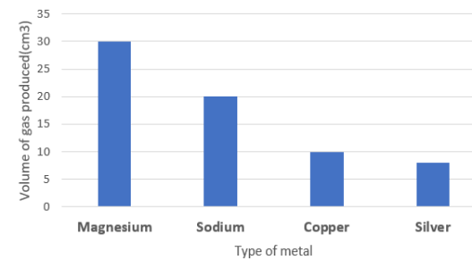
L
Link to exam questioning:
Describe what is happening when an acid reacts with a metal (3 marks)

