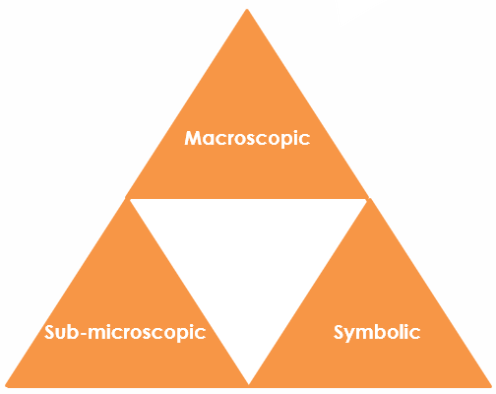
Sodium hydroxide solution: Johnstone’s triangle

Learning objectives
- Describe how to identify whether a beaker contains sodium hydroxide or water.
- Recognise the unit symbols used for concentration.
- Interpret particle diagrams of solutions in terms of how they represent concentration.

Introduction

Sodium hydroxide solution is alkaline. A concentration of 1 g/dm³ means that 1 gram of sodium hydroxide is dissolved in 1 decimetre cubed of water.

Johnstone’s triangle

In chemistry we make sense of the things that we can see by representing what we can’t see using formulas, equations, diagrams and models.

Johnstone’s triangle is a way of thinking about these different concepts as different corners of a triangle:

- Macroscopic – what we can see. Think about the properties we can observe, measure and record.
- Sub-microscopic – smaller than we can see. Think about the particle or atomic level.
- Symbolic – representations. Think about how we represent chemical ideas, including symbols and diagrams.

Being able to connect and move between these three different levels is important for scientific understanding.
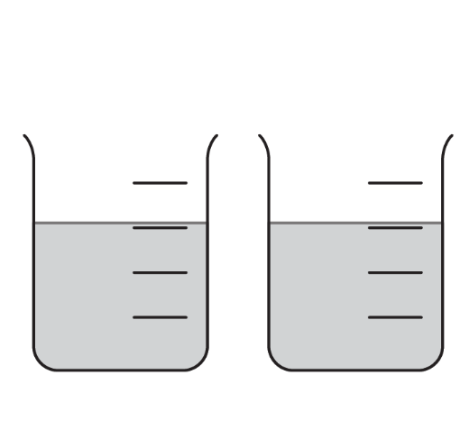

Macroscopic – what we can see

Sodium hydroxide solution is clear, colourless and alkaline.

One beaker contains sodium hydroxide solution and the

other contains water.

Suggest how you could identify the sodium hydroxide.

__________________________________________________________

__________________________________________________________

__________________________________________________________

__________________________________________________________

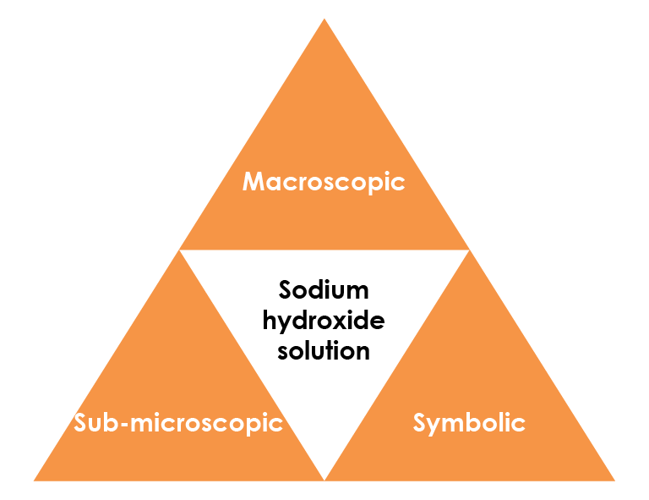

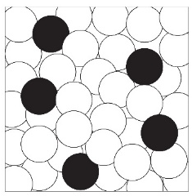

Sub-microscopic – smaller than we can see

Solutions are sometimes represented using simple particle diagrams.

Give the type of the particles shown by the circles.

Choose from atoms, ions or molecules.

water ________________ sodium and hydroxide ________________

Describe how the diagram could be changed to show a more concentrated solution.

____________________________________________________________________

____________________________________________________________________

Look at the number of each type of particle shown in the diagram. Explain what is unrealistic about the number water molecules compared to the number of ions.

____________________________________________________________________

____________________________________________________________________

____________________________________________________________________

Symbolic – representations

g/dm³ is a unit of concentration.

Complete the sentences to describe the symbols.

g represents ____________ and is a unit for ____________ . dm³ represents decimetres cubed and is a unit for ____________ . The / sign means ’per‘ (or for every).

A solution of sodium hydroxide with concentration 4 g/dm³ has 4 g of sodium hydroxide dissolved in 1 dm³ of water.

Determine the number of grams of sodium hydroxide dissolved in 1 dm³ of solution with concentration 20 g/dm³.

__________________________________________________

