Sodium hydroxide solution: Johnstone’s triangle

This resource is from the Johnstone’s triangle series which can be viewed at: rsc.li/4sCkujW. It will help learners to understand the different ways you need to think in chemistry, and to build their mental models and understanding.

Learning objectives
- Describe how to identify whether a beaker contains sodium hydroxide or water.
- Recognise the unit symbols used for concentration.
- Interpret particle diagrams of solutions in terms of how they represent concentration.

How to use Johnstone’s triangle

Use Johnstone’s triangle to develop learners’ thinking about scientific concepts at three different conceptual levels:
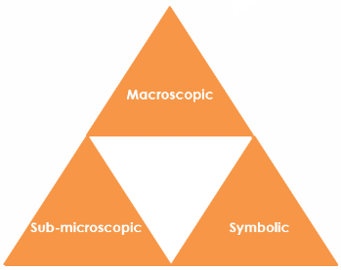
- Macroscopic – what we can see. Think about the properties you can observe, measure and record.
- Sub-microscopic – smaller than we can see. Think about the particle or atomic level.
- Symbolic – representations. Think about how we represent chemical ideas including symbols and diagrams.

For learners to gain a deeper awareness of a topic, they need to understand it at all three levels.

When introducing a topic, don't introduce all three levels of thinking at once. This will overload working memory. Instead complete the triangle over a series of lessons, beginning with the macroscopic level and then introducing other levels.

The levels are interrelated. For example, learners need visual representation of the sub-microscopic to develop mental models of the particle or atomic level.

Find further reading about Johnstone’s triangle and how to use it in your teaching at: rsc.li/4sCkujW.

Scaffolding

Share the structure of the triangle with learners prior to use. Tell them why you are using it and how it will help them to develop their understanding. Use an ‘I try, we try, you try’ approach when introducing Johnstone’s triangle for the first time.

More resources

To further develop learner’s thinking in all areas of Johnstone’s triangle, try our Developing understanding of concentration and mass worksheet (rsc.li/3YoYMC8). This includes icons in the margin referring to the conceptual level of thinking needed to answer the questions.
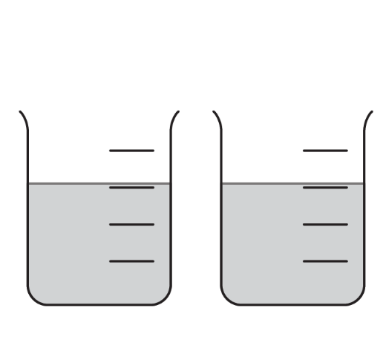
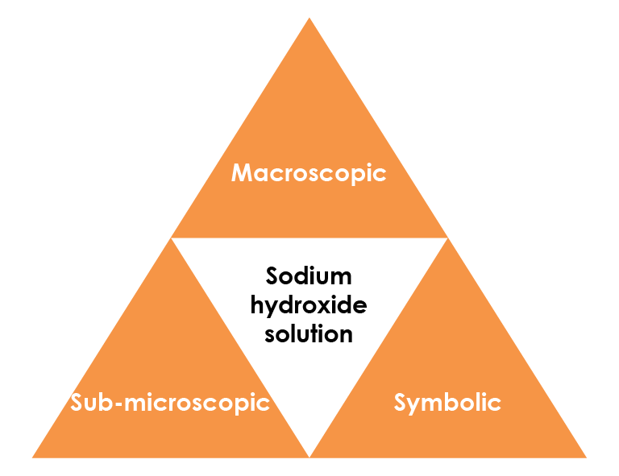

Macroscopic – what we can see

Sodium hydroxide solution is clear, colourless and alkaline.

One beaker contains sodium hydroxide solution and the

other contains water.

Suggest how you could identify the sodium hydroxide.

Use litmus or universal indicator

paper. The paper will turn blue/purple if dipped in

sodium hydroxide solution because it is an alkali.

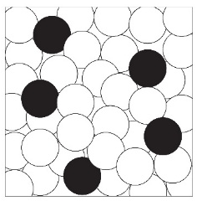

Sub-microscopic – smaller than we can see

Solutions are sometimes represented using simple particle diagrams.

Give the type of the particles shown by the circles.

Choose from atoms, ions or molecules.

water molecules sodium and hydroxide ions

Describe how the diagram could be changed to show a more concentrated solution.

More circles would be coloured black.

Look at the number of each type of particle shown in the diagram. Explain what is unrealistic about the number water molecules compared to the number of ions.

In reality there are many more water molecules than sodium hydroxide ions.

Symbolic – representations

g/dm³ is a unit of concentration.

Complete the sentences to describe the symbols.

g represents grams and is a unit for mass. dm³ represents decimetres cubed and is a unit for volume. The / sign means ’per‘ (or for every).

A solution of sodium hydroxide with concentration 4 g/dm³ has 4 g of sodium hydroxide dissolved in 1 dm³ of water.

Determine the number of grams of sodium hydroxide dissolved in 1 dm³ of solution with concentration 20 g/dm³.

1 x 20 = 20 g

