Iron and sulfur reaction

Learning objectives
- Recall definitions of elements and compounds.
- Safely heat a mixture of two elements and record observations.
- Calculate masses using the principles of conservation of mass.
- Plot data and make predictions from the graph.

Introduction

When chemical reactions occur, atoms are rearranged to form different substances. The original elements, once combined, have different chemical and physical properties than when they were reactants.

In this demonstration and class experiment, you will observe an exothermic reaction of two elements, iron and sulfur, to form the compound iron sulfide. The two solids are mixed and heated in a test tube (or ignition tube) and changes in their properties can be observed.

Equipment

Apparatus
- Safety glasses
- Prepared ignition tube
- Bunsen burner
- Heat resistant mat
- Test tube tongs

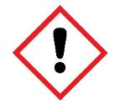
Chemicals
- Iron powder (potential IRRITANT)
- Sulfur – finely powdered roll or flowers

Safety and hazards
- Wear eye protection throughout and ensure that the lab is well ventilated.
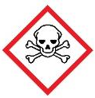
- Iron powder, $Fe$(s), (potential IRRITANT) can cause severe irritation in eyes because the iron oxidises rapidly in the saline environment. Do not touch or rub eyes after handling the iron powder.
- Sulfur dioxide, $SO_{2}$(g), is formed if the sulfur catches fire (TOXIC).
Method
- You will be provided with a pre-prepared ignition tube containing the iron−sulfur mixture and a mineral wool plug.
- Using suitable tongs or test tube holders, heat the iron−sulfur mixture in the tube until it just starts to glow. Then, turn off your Bunsen burner.
- Leave the ignition tube to cool on the heat resistant mat.

Diagram

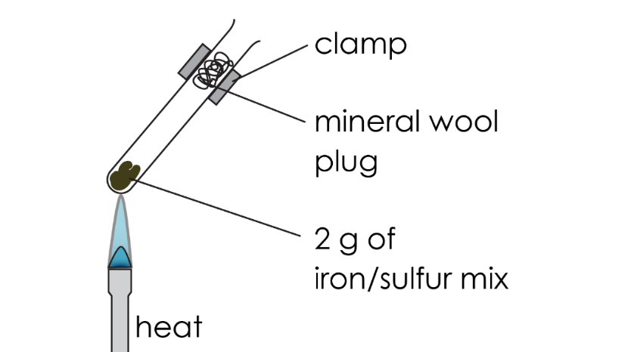

Follow-up questions
- Describe the appearance of the mixture of iron and sulfur before you heated it. Include information on both the state and colour.

__________________________________________________________________________________

__________________________________________________________________________________
- Explain how you know that a chemical reaction has occurred between iron and sulfur. Refer to descriptions of changes in colour in your answer.

__________________________________________________________________________________

__________________________________________________________________________________

- In the reaction you completed, you reacted iron (Fe) with sulfur (S) to produce iron sulfide (FeS).
- Write a word equation for this reaction.

__________________________________________________________________________________
- Write a symbol equation for this reaction.

__________________________________________________________________________________
- Identify the reactants in this reaction.

__________________________________________________________________________________
- Identify the product in this reaction.

__________________________________________________________________________________
- When iron reacts with sulfur to produce iron sulfide, mass is conserved. Explain what this means using the principle of conservation of mass.

__________________________________________________________________________________

__________________________________________________________________________________
- Calculate the mass of iron sulfide formed when 1 gram of iron reacts exactly with 0.57 grams of sulfur.

__________________________________________________________________________________

__________________________________________________________________________________
- Calculate the mass of sulfur needed to react exactly with 2.5 grams of iron to produce 3.9 grams of iron sulfide.

__________________________________________________________________________________

__________________________________________________________________________________
- When 10 grams of iron reacts exactly with 5.7 grams of sulfur, iron sulfide is formed.
- Calculate the mass of iron sulfide formed.

__________________________________________________________________________________
- Calculate the percentage by mass of sulfur in the compound using the equation below.

$$Percentage by mass of sulfur= \frac{Mass of sulfur}{Total mass of iron sulfide} × 100$$

__________________________________________________________________________________

__________________________________________________________________________________

__________________________________________________________________________________

__________________________________________________________________________________

- Iron reacts with sulfur in an exothermic reaction. This means that energy is released to the surroundings as heat.
- Name the piece of equipment used to measure temperature.

__________________________________________________________________________________
- At the start of the reaction the temperature was 23°C. The highest temperature measured was 247°C. Calculate the temperature change.

__________________________________________________________________________________

__________________________________________________________________________________
- A student heated iron and sulfur so they reacted completely to form iron sulfide.

They increased the mass of iron and sulfur each time and recorded the final mass of iron sulfide produced to one decimal place.

Their results are shown in the table below,

Mass of iron (g) | Mass of iron sulfide (g)
1 | 1.6
2 | 3.1
3 | 4.7
4 | 6.3
6 | 9.4
7 | 11.0
8 | 12.6
9 | 14.1

- Plot a graph of the data above on the graph paper provided on the next page.

- Draw a line of best fit.

- The student forgot to record the data for the mass of iron sulfide produced when 5 grams of iron was used. Predict the mass of iron sulfide using the line of best fit.

__________________________________________________________________________________
- Predict the mass of iron used to produce 10 grams of iron sulfide.

__________________________________________________________________________________

