Concentration and mass

Introduction

These questions are designed to help you to develop mental models (pictures in your head) of solutions of different concentrations expressed in g/dm³. Use the icon in the margin to find out which level of understanding the question is developing.
 | Macroscopic: what we can see. Think about the properties that we can observe, measure and record.
 | Sub-microscopic: smaller than we can see. Think about the particle or atomic level.
 | Symbolic: representations. Think about how we represent chemical ideas including symbols and diagrams.

Questions
- Concentration compares how much solute is dissolved in the same volume of water.

Three different masses of some orange crystals are dissolved in equal volumes of water.

This forms three solutions with different concentrations.

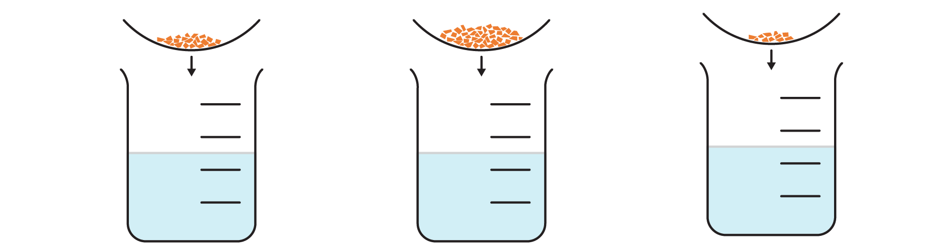
A | B | C

- Give the letter of the mixture that will form the solution with the highest concentration.

- Label the solutions with the letter of the mixtures which created them.

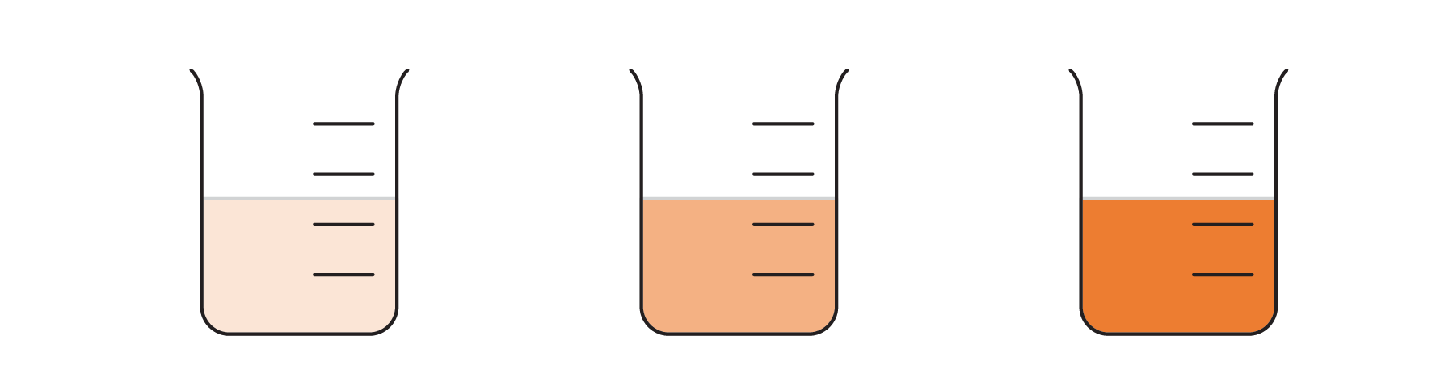


- The greater the mass of a solute that is dissolved in a given volume of water, the more particles of solute are in the solution. A more concentrated solution has more solute particles in a given volume than a less concentrated solution.

A website shows two solutions with different concentrations using a simple particle model.

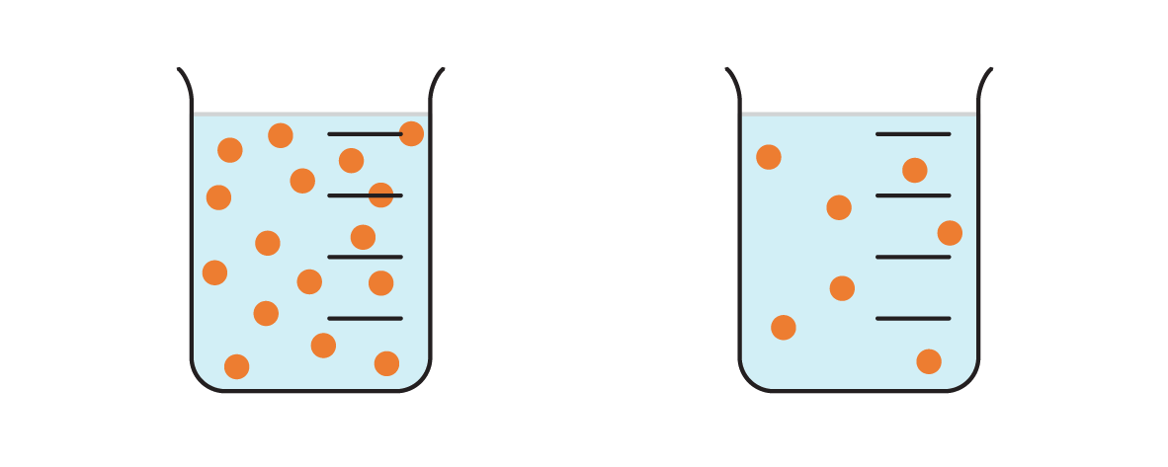
A | B

- Give the letter of the diagram that shows the more concentrated solution.

- Suggest one way in which the diagrams help to explain concentration.

_________________________________________________________________________________

_________________________________________________________________________________

_________________________________________________________________________________

Another website uses a different diagram to show the particles that make up a more concentrated and less concentrated solution.

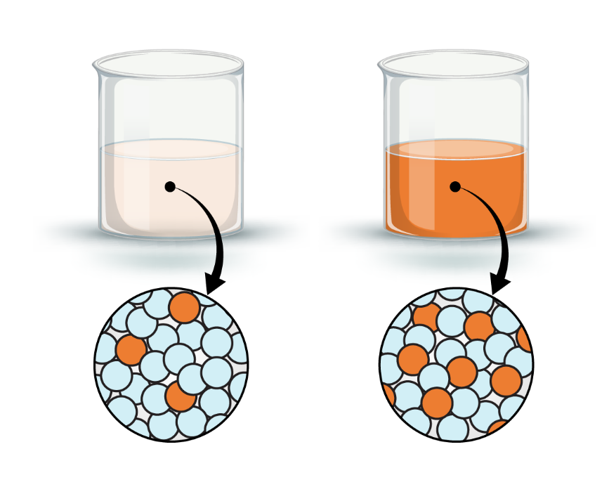

- Explain why this diagram is a better representation of the particles that make up a more concentrated and less concentrated solution.

_________________________________________________________________________________

_________________________________________________________________________________

_________________________________________________________________________________

- Concentration can be given as the number of grams dissolved to create 1 dm³ (1000 cm³) of solution. The units are written g/dm³.

Solution D contains 2 g in 1 dm³.

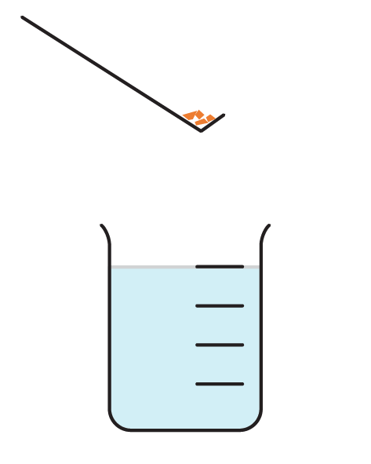
D

- Give the concentration of solution D: _____ g/dm³

Solution E contains 6 g in 2 dm³.

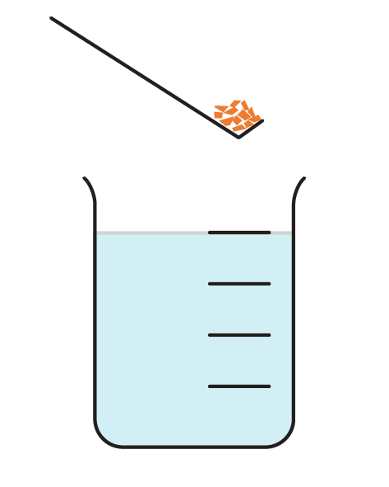
E

- Determine the number of grams in 1 dm³ of solution E: ______g

- Give the concentration of solution E: _______g/dm³

- State which solution is more concentrated. Solution _______

A third solution is created. Solution F contains 4 g in 0.5 dm³.

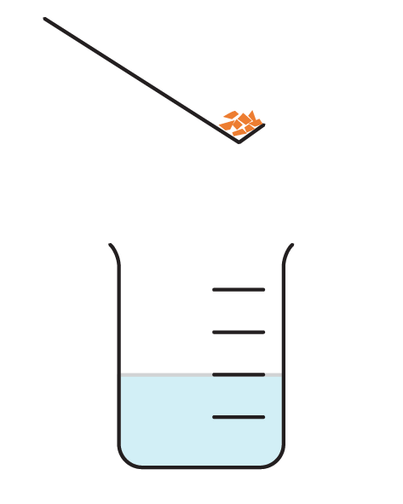
F

- Determine the number of grams that would be in 1 dm³ of solution F: ______g

- Give the concentration of solution F: ______g/dm³

- State whether solution F is more or less concentrated than solution D. __________

- Concentration can be calculated using this mathematical formula:

$$concentration \left(in g/{dm}^{3}\right)= \frac{mass (in g)}{volume (in {dm}^{3})}$$

Although the units of concentration are always given as the number of grams per dm³, volume is often measured in cm³.

1 dm³ = 1000 cm³. To change from cm³ to dm³ divide by 1000.

- Complete the table to convert the volumes in cm³ to volumes in dm³.
divide by 1000

Volume in cm³ | Volume in dm³
1000
5000
500
50
100
10
250
25

- Complete the table to determine the concentration of each solution.
Mass in g | volume in cm³ | volume in dm³ | concentration in g/dm³
0.5 | 50
0.1 | 25
0.2 | 10
- A salt solution is poured into different containers. The solution has the concentration 100 g/dm³.

A large beaker contains 1000 cm³ of the salt solution.

- Determine the mass of salt dissolved. ____________g

- A mathematical formula can be used to calculate the mass of salt dissolved in a given volume of solution.

$$mass (in g) = concentration (in g/{dm}^{3}) x volume (in {dm}^{3})$$

Explain why it is important to convert the volume of solution into dm³.

__________________________________________________________________________________

__________________________________________________________________________________

__________________________________________________________________________________

__________________________________________________________________________________
- Calculate the mass of salt in each container.
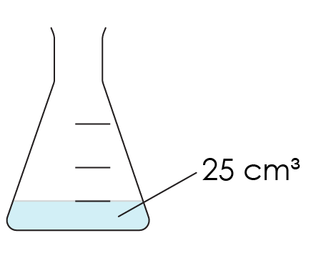 | 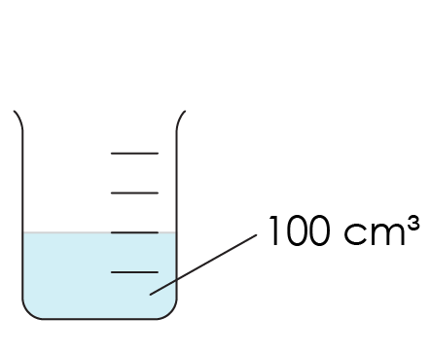 | 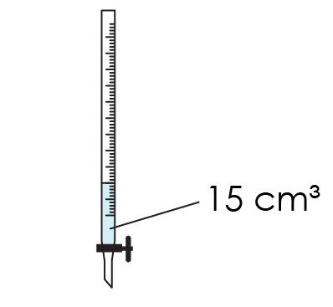 | 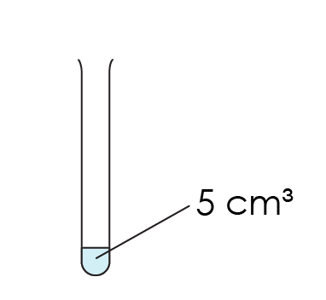
Conical flask | Beaker | Burette | Test tube

- Conical flask

_________________________________________________________________________________

_________________________________________________________________________________
- Beaker

_________________________________________________________________________________

_________________________________________________________________________________
- Burette

_________________________________________________________________________________

_________________________________________________________________________________
- Test tube

_________________________________________________________________________________

_________________________________________________________________________________

