Heating chocolate and egg

This investigation is part of the Nuffield practical collection, developed by the Nuffield Foundation and the Royal Society of Chemistry. Delve into a wide range of chemical concepts and processes with this collection of over 200 step-by-step practicals: rsc.li/43bjGql

Learning objectives
- Safely heat egg white and chocolate using a Bunsen burner and record observations.
- Describe and explain observations from a chemical reaction.
- Categorise statements as relating to chemical or physical changes.
- Distinguish whether a change is chemical or physical from given observations.

Success criteria

The practical allows learners to safely heat both chocolate and egg and record their observations. It also allows for discussion of LO1 and LO2.

Completing the follow-up questions, using support from the lesson slides, will allow learners to succeed in LO2, LO3 and LO4.

Introduction

In this simple experiment, learners use a Bunsen burner and water bath to investigate the different effects of heat on chocolate and egg white. The practical provides a clear introduction to physical and chemical changes and can be used to ensure learners practice how to use Bunsen burners safely.

This straightforward, if somewhat messy, experiment should take no more than 30 minutes.

Scaffolding

There are two versions of the student worksheets: scaffolded () and unscaffolded (). The scaffolded sheet offers more support to allow learner to access the questions.

For example, answers require learners to choose from a series of pre-populated answers or to fill in gaps for longer answer questions. Hints are found after some of the questions to support learners further and guide their answers.

Integrated instructions are available in the presentation slides.

Technician notes

Read our standard health and safety guidance (rsc.li/3zyJLkx) and carry out a risk assessment before running any live practical.

Equipment

Apparatus
- Safety glasses
- Test tubes, x 2
- Beaker, 250 cm³
- Bunsen burner
- Heat resistant mat
- Tripod
- Gauze
- Test tube rack
- Test tube holder

Chemicals
- Chocolate, a few grams
- Egg albumen (egg white), about 4 cm³

Health, safety and technical notes
- Wear eye protection throughout.
- Do not sit down while heating the beaker or handling the hot test tubes.
- Do not taste foods in a laboratory. The food or the apparatus may be contaminated. Strictly enforce this ‘no tasting’ rule.
- Cooking chocolate is the best type of chocolate for this experiment (other types melt too slowly). Grate the chocolate and pre-load it into a test tube for each working group, sufficient to give about 2 cm depth of molten chocolate when heated – this may require trials to establish the correct amount of grated chocolate.
- In the UK, use eggs with the ‘lion brand’ stamp as these should be salmonella free. Separate the egg whites from the yolks of sufficient eggs to provide enough for about 4 cm³ of egg white for each working group. Then pre-load the egg white into a test tube for each working group.
- At the end of the lesson, ask learners to hand back their test tubes with the contents still inside, as recovery and cleaning may cause less mess than leaving it to the learners. The chocolate is best removed by re-melting it and pouring it out of the tubes.

Method

A full method is provided in the student worksheet (rsc.li/405Rtjn).

Teaching notes

This experiment is appropriate for classes at an early stage in their science education, so students are likely to be inexperienced in the safe and skilful use of the Bunsen burner. This is a good opportunity to develop their ability to use the Bunsen burner and emphasise safety points, such as standing up when doing experiments that involve heating.

The main purpose of the experiment is to introduce physical and chemical change, and the associated ideas of reversible and non-reversible changes. The chemical change in the egg white should take no more than five minutes once the water is boiling, and grated cooking chocolate should melt in about the same time. Many children will have met this in primary school.

On cooling, the chocolate will solidify to a solid mass and students may be distracted by the change of form from the grated material at the start. If so, ask your technician to pre-melt the chocolate in the tubes and allow it to solidify again before the lesson, but note that it will then take longer for the chocolate to melt in the experiment.

Follow-up questions
- Scaffolded and unscaffolded
Statement | Chemical change | Physical change
Can easily be undone (reversible) |  | ✓
Cannot easily be undone (irreversible) | ✓
No new material formed |  | ✓
New materials formed that are different to the starting materials | ✓
Heat or light given off | ✓
Colour change (permanent) | ✓
Change in state |  | ✓

- Scaffolded
- Heating chocolate is a physical change.
- C There is a reversible change of state

Unscaffolded

Heating chocolate is a physical change. This is because the chocolate changes from a solid to a liquid when heated and then back to a solid when cooled. This is a change of state.

- Scaffolded
- Heating egg white is a chemical change.
- B There is a colour change

Unscaffolded

Heating egg white is a chemical change as when it is heated there is a permanent colour change and it is not reversible when the temperature cools.

- Scaffolded and unscaffolded
Scenario | Chemical change | Physical change
Bread being toasted

Making ice cubes

Boiling water in a kettle

Iron rusting

Baking a cake

Driving a car

Ice cream melting

Fireworks

- Scaffolded
- Hydrochloric acid and sodium hydroxide
- Sodium chloride and water
- A New products are formed
- This is a physical change.

Unscaffolded
- Hydrochloric acid and sodium hydroxide
- Sodium chloride and water
- Two new products are formed.
- This is a physical change not a chemical change so there are no new products.

- Scaffolded
This is a physical change as although there is a colour change this is reversible on heating and cooling.

- Scaffolded

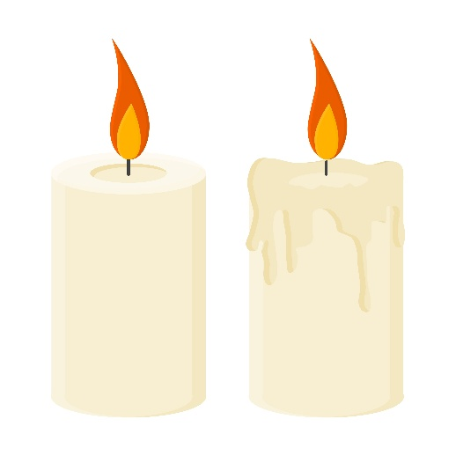
Image © Shutterstock/22Ravi22
physical change:
melting
chemical change:
burning

Unscaffolded
When you light a candle some of the wax reacts with oxygen and burns. This is a chemical change as it releases heat and light and produces new materials. As this reaction releases heat, some of the wax melts changing state from a solid to a liquid. When the candle it no longer burning, this wax will cool and turn back to a solid. This is an example of a physical change.

