Heating chocolate and egg

Learning objectives
- Safely heat egg white and chocolate using a Bunsen burner and record observations.
- Describe and explain observations from a chemical reaction.
- Categorise statements as relating to chemical or physical changes.
- Distinguish whether a change is chemical or physical from given observations.

Introduction

Changes can occur in chemicals which may be physical or chemical. A chemical change is one where new substances are formed which have a different chemical structure. Observations of colour change, temperature change or sometimes a change of state could be a sign of this. Often these are irreversible. Physical changes on the other hand are reversible and are often associated with changes of state. An example is ice melting. The liquid water can then be frozen to reverse this.

In this experiment, you will use a Bunsen burner and water bath to investigate the different effects of heat on chocolate and egg white to determine whether they undergo a chemical or a physical change on heating.

Equipment

Apparatus
- Safety glasses
- Test tubes, x 2
- Beaker, 250 cm³
- Bunsen burner
- Heat resistant mat
- Tripod
- Gauze
- Test tube rack
- Test tube holder

Chemicals
- Chocolate, a few grams
- Egg albumen (egg white), about 4 cm³

Health, safety and technical notes
- Wear eye protection throughout.
- Do not sit down while heating the beaker or handling the hot test tubes.
- Do not taste foods in a laboratory. The food or the apparatus may be contaminated.

Diagram

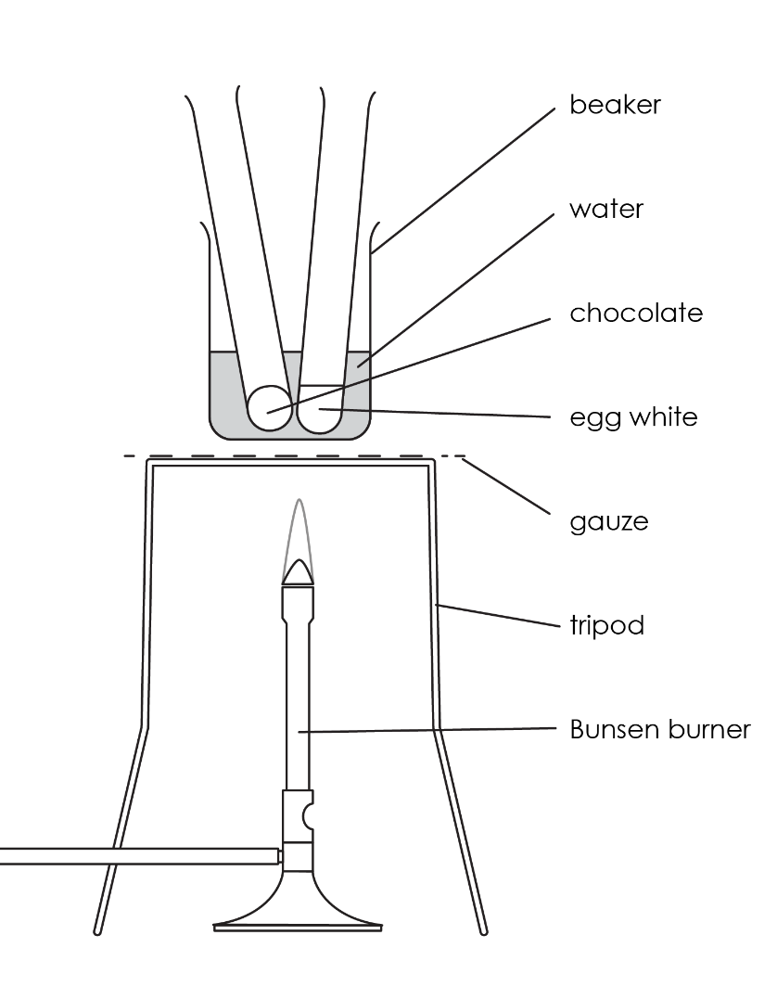

Method
- Add cold water to the beaker until it is about one-third full and place it on the tripod and gauze.
- Place a test tube containing egg white and a second test tube containing chocolate in the beaker.
- Heat the beaker of water with the test tubes carefully until the water in the beaker boils. Allow the water to boil gently for about 5 minutes.
- Watch what happens to the egg white and the chocolate in the tubes while they are being heated.
- Turn off the Bunsen burner and use the test tube holder to transfer the tubes to the rack to cool.
- Watch what happens to the egg white and the chocolate in the tubes as they cool.

Results

Complete the following table to record your observations before and during the practical.
Substance | Stage of practical | Observation

Follow-up questions
- In the table below there are a series of statements. Tick the correct box to show whether they typically relate to chemical changes or physical changes.
Statement | Chemical change | Physical change
Can easily be undone (reversible)
Cannot easily be undone (irreversible)
No new material formed
New materials formed that are different to the starting materials
Heat or light given off
Colour change (permanent)
Change of state

- Determine whether heating chocolate is a chemical or physical change. Explain your answer using your practical observations.

__________________________________________________________________________________

__________________________________________________________________________________

__________________________________________________________________________________

__________________________________________________________________________________
- Determine whether heating egg is a chemical or physical change. Explain your answer using your practical observations.

__________________________________________________________________________________

__________________________________________________________________________________

__________________________________________________________________________________
- For each of the scenarios given below, determine whether this represents a chemical change or a physical change.
Scenario | Chemical change | Physical change

Bread being toasted

Making ice cubes

Boiling water in a kettle

Iron rusting

Baking a cake

Driving a car

Ice cream melting

Fireworks

- When an acid reacts with an alkali we can write a chemical equation. For example:

hydrochloric acid + sodium hydroxide $→$ sodium chloride + water
- Name the reactants in this equation.

__________________________________________________________________________________
- Name the products in this equation.

__________________________________________________________________________________
- Explain how you know this is a chemical change.

__________________________________________________________________________________

__________________________________________________________________________________
- A student wants to write a chemical equation for ice melting. Explain why this isn’t possible.

__________________________________________________________________________________

__________________________________________________________________________________
- A student adds white zinc oxide powder to a test tube and heats it strongly using a blue Bunsen burner flame. They observe a colour change to yellow, however when this solid cools down to room temperature it changes back to a white colour. Is this a chemical or physical change? Explain your answer.

__________________________________________________________________________________

__________________________________________________________________________________

__________________________________________________________________________________
- Many homes own candles. A student suggests that when you light a candle this is an example of both a chemical change and a physical change. Explain this observation.

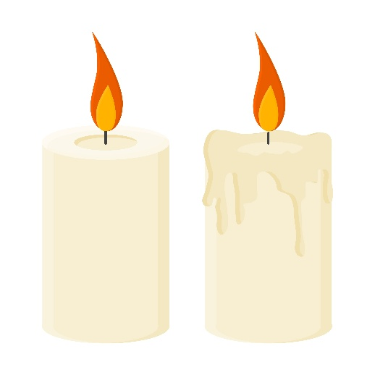
Image © Shutterstock/22Ravi22

__________________________________________________________________________________

__________________________________________________________________________________

__________________________________________________________________________________

__________________________________________________________________________________

__________________________________________________________________________________

__________________________________________________________________________________

__________________________________________________________________________________

__________________________________________________________________________________

