Interpreting chemical equations

Introduction

These questions are designed to help you to develop mental models (pictures in your head) of what is represented by a balanced chemical equation.

 | Macroscopic: what we can see. Think about the properties that we can observe, measure and record.
 | Sub-microscopic: smaller than we can see. Think about the particle or atomic level.
 | Symbolic: representations. Think about how we represent chemical ideas including symbols and diagrams.


Questions
- A chemical equation can represent the physical state of each reactant and product. The state of each substance is shown by a state symbol in brackets.
- Match each state symbol to the state that it represents.

(s) |  | liquid state
(g) |  | solid state
(l) |  | gas state

- The diagram below shows the reaction between copper carbonate and sulfuric acid. A product of the reaction is carbon dioxide.

Add the label ${CO}_{2}$(g) to the diagram to show where carbon dioxide is observed.

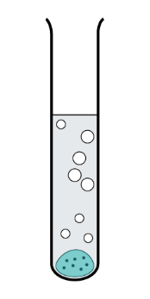

- Explain why the product ${CO}_{2}$(g) cannot be observed in the reaction shown below.

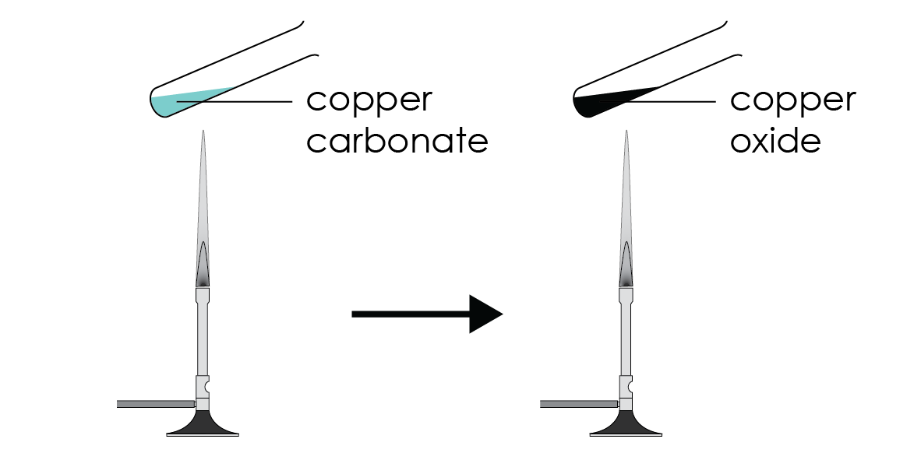

_________________________________________________________________________________

_________________________________________________________________________________

- A balanced chemical equation can be used to work out how many individual atoms and molecules react with each other and how many individual atoms and molecules are produced.

The equation for the reaction of sulfur with oxygen is:

$$S(s) + O_{2}(g)→{SO}_{2}(g)$$

This could be written as 1S(s) + 1$O_{2}$(g) → 1${SO}_{2}$(g) but it is normal to miss out the

ones.
- Give the symbol or formula that represents:
- an atom of sulfur _________
- a molecule of oxygen _________
- a molecule of sulfur dioxide _________

- Thinking about individual atoms and molecules allows the drawing of a simple particle diagram.

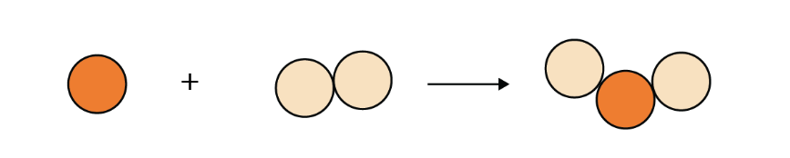

Writing this as a sentence gives:

One atom of sulfur reacts with one molecule of oxygen to produce one molecule of

sulfur dioxide.

Complete the sentences to describe what is represented by the following equations.
- C(s) + $O_{2}(g)→{CO}_{2}(g)$

One atom of carbon reacts with _________________________________________________

_________________________________________________________________________________
- ${CH}_{4}$(g) + 2$O_{2}(g)$ → ${CO}_{2}(g)$ + ${2H}_{2}O (g)$

One molecule of methane reacts with____________________________________________

_________________________________________________________________________________
- Carbon has a giant covalent structure. Oxygen and carbon dioxide are made up of separate covalent molecules.
- Label the diagram that represents the structure of carbon, oxygen and carbon dioxide.

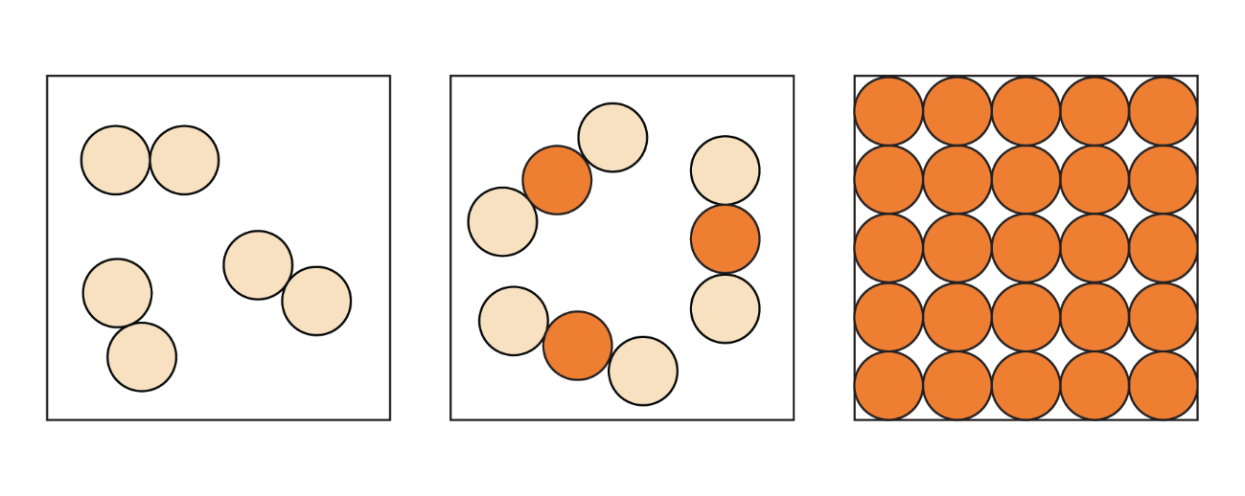
________________________ | ________________________ | ________________________

- When carbon reacts with oxygen a huge number of atoms of carbon react with an equal number of molecules of oxygen.

C(s) + $O_{2}(g)→{CO}_{2}(g)$

A chemical equation can also represent the very large number of atoms and

molecules that are involved in a chemical reaction.

It can be more useful in chemistry to think of an equation as meaning: “Each atom

of carbon reacts with one molecule of oxygen to form one molecule of carbon

dioxide.”

- Complete the table to show the number of oxygen molecules that react with different numbers of carbon atoms.
- Then add the number of molecules of carbon dioxide that would be made.
Number of carbon atoms | Number of oxygen molecules | Number of carbon dioxide molecules
1 | 1 | 1
2
100
1 billion

- Explain why 2 billion molecules of carbon dioxide could not be made from 1 billion carbon atoms.

_________________________________________________________________________________

_________________________________________________________________________________
- Methane burns in oxygen to form carbon dioxide and water.

The balanced chemical equation for the reaction is:

${CH}_{4}$(g) + 2$O_{2}(g)$ → ${CO}_{2}(g)$ + ${2H}_{2}O (g)$

- Give the state of
- methane _______
- oxygen _______
- carbon dioxide _______

- Suggest why water ${(H}_{2}O)$ is not in the expected liquid state.

_________________________________________________________________________________

_________________________________________________________________________________

- Complete the sentence to describe what the equation represents.

Each molecule of methane reacts with _________ molecules of oxygen forming

_________ molecule of carbon dioxide and _________ molecules of water.
- Complete the table to show the number of molecules oxygen, carbon dioxide and water.
Number of methane molecules | Number of oxygen molecules | Number of carbon dioxide molecules | Number of water molecules
1 | 2 | 1 | 2
2 | 4
10
1 billion


- The number of atoms or molecules that react in a real-life chemical reaction is so large that chemists use a special number called the mole. One mole is equal to 6.02 x 10²³ atoms or molecules.

Methane burns in oxygen to form carbon dioxide and water.

The chemical equation for the reaction is:

${CH}_{4}$(g) + 2$O_{2}(g)$ → ${CO}_{2}(g)$ + ${2H}_{2}O (g)$

- Give the number of moles of carbon dioxide that can be formed from
- One mole of methane molecules _________
- Two moles of methane molecules _________

- Explain why the water is also formed as a product.

_________________________________________________________________________________

_________________________________________________________________________________
- Chemists are able to calculate the mass of one mole of an element or compound. A chemical equation can therefore be used to work out the mass of reactants that will react or the mass of product that could be produced.

The mass of one mole of methane is 16 g. Give the mass of two moles of methane.

_________
- The mass of one mole of carbon dioxide is 44 g. Give the mass of two moles of carbon dioxide. _________

- The mass of one mole of water is 18 g.

- Give the mass of two moles of water. ________________
- Give the mass of four moles of water. ________________

- Give the mass of carbon dioxide that would be formed from 32 g of methane. _________

- Give the mass of water that would be formed from 32 g of methane. _________

