Iron and sulfur reaction: Johnstone’s triangle

This resource is from the Johnstone’s triangle series which can be viewed at: rsc.li/43jMfSn. It will help learners to understand the different ways you need to think in chemistry, and to build their mental models and understanding.

Learning objectives
- Recognise that the properties of a product are different to the reactants.
- Identify the diagram that represents the arrangement of atoms in each reactant and product.
- Write a word and symbol equation for the reaction.

How to use Johnstone’s triangle

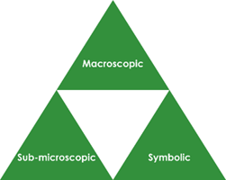
Use Johnstone’s triangle to develop learners’ thinking about scientific concepts at three different conceptual levels:
- Macroscopic – what we can see. Think about the properties you can observe, measure and record.
- Sub-microscopic – smaller than we can see. Think about the particle or atomic level.
- Symbolic – representations. Think about how we represent chemical ideas including symbols and diagrams.

For learners to gain a deeper awareness of a topic, they need to understand it at all three levels.

When introducing a topic, don't introduce all three levels of thinking at once. This will overload working memory. Instead complete the triangle over a series of lessons, beginning with the macroscopic level and then introducing other levels, in turn, once secure.

The levels are interrelated. For example, learners need visual representation of the sub-microscopic in order to develop mental models of the particle or atomic level.

Find further reading about Johnstone’s triangle and how to use it in your teaching at rsc.li/4q4xiNl.

Scaffolding

Share the structure of the triangle with learners prior to use. Tell them why you are using it and how it will help them to develop their understanding. Use an ‘I try, we try, you try’ approach when introducing Johnstone’s triangle for the first time.

It may support learners to carry out or observe the reaction between iron and sulfur. See our Iron and sulfur reaction class experiment for guidance (rsc.li/3LVXGeC).

More resources

To further develop learner’s thinking in all areas of Johnstone’s triangle, try our Developing understanding of reactant and product substances worksheet (rsc.li/4jnuV6E).

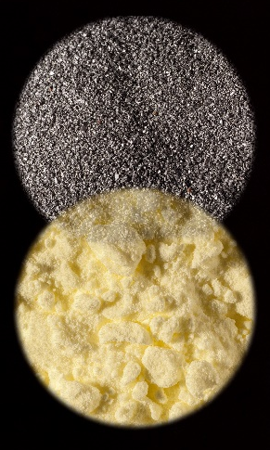
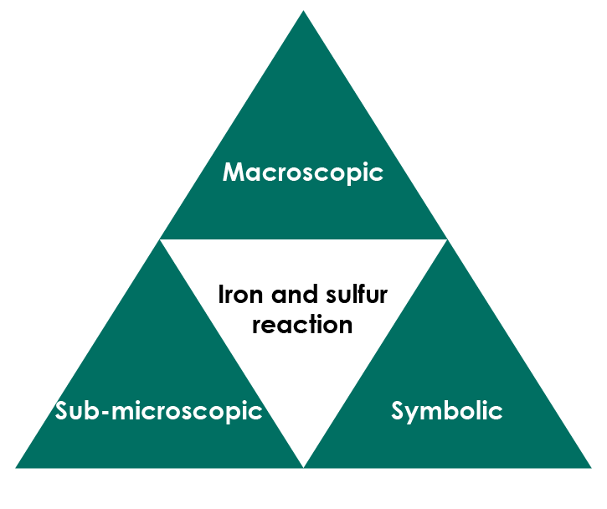

Macroscopic – what we can see

Sulfur is a yellow non-metal. Iron is a shiny grey, magnetic metal.

Name the product of the reaction between iron and sulfur.

iron sulfide

Explain why the product is not magnetic, even though one of the reactants is.

The product of the reaction is a compound and therefore has different properties to the reactants.



© Martyn F Chillmaid / Science Photo Library

Symbolic – representations

Write the word equation for the reaction to show the two reactants and the product. Iron + sulfur → iron sulfide

Draw lines to connect the element symbol and chemical formula with the correct reactant or product.

iron FeS

sulfur Fe

iron sulfide S

Suggest why the symbol for iron is not I.

The symbol for iron is based on its Latin name and not its English name. (I is the symbol for iodine).

Add the element symbols and a chemical formula to complete the chemical symbol equation for the reaction.

Fe + S → FeS

<

If you need to use diagrams please provide an example and we will redraw these in-house.>

Sub-microscopic – smaller than we can see

The arrangement of atoms in a reactant or product can be shown using a diagram.

This key shows the colour used to represent each type of atom.

iron atom sulfur atom

Name which reactant and product (iron, sulfur or iron sulfide) is represented by each diagram.

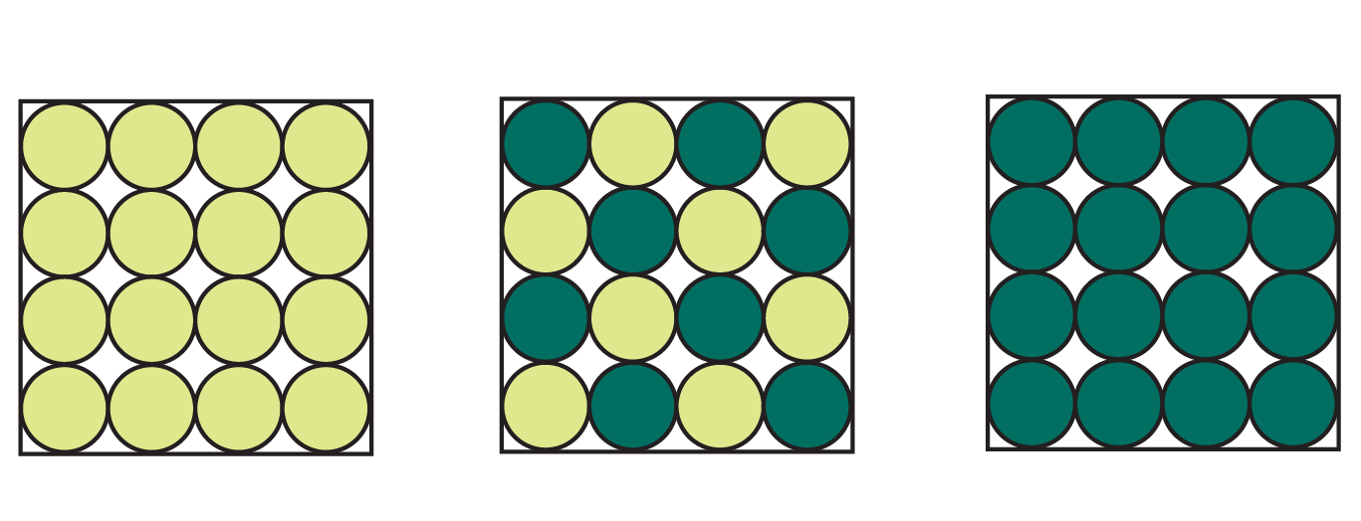

sulfur iron sulfide iron

