Symbols and formulas

Introduction

These questions are designed to help you to develop your mental models (pictures in your head) of symbols and formulae. Use the icon in the margin to find out which level of understanding the question is developing.
 | Macroscopic: what we can see. Think about the properties that we can observe, measure and record.
 | Sub-microscopic: smaller than we can see. Think about the particle or atomic level.
 | Symbolic: representations. Think about how we represent chemical ideas including symbols and diagrams.

Questions
- All elements have a symbol. Most symbols start with the first letter of the element name in English. If more than one element starts with the same letter, it will be followed by a second letter found later in the element name.
- Match the symbol to the element. You may use a periodic table to help you.

C |  | cobalt
Ca |  | californium
Cd |  | carbon
Cf |  | cadmium
Co |  | calcium

- Some element symbols are based on the name of the element in Latin. The Latin for copper is cuprum.

Give the symbol of copper. ____________


- The table below lists the formula of some substances that are made up of individual molecules.
- Complete the table to show the number of each type of atom present in a molecule of the substances listed.
Formula | Number of atoms
Formula | O | C | H
$$O_{2}$$
$${CO}_{2}$$
$$H_{2}O$$
$$H_{2}O_{2}$$
$$C_{6}H_{12}O_{6}$$

- The formula $H_{2}O$ only gives some information about a water molecule. The picture below shows a student’s incorrect diagram of a molecule with the formula $H_{2}O$.

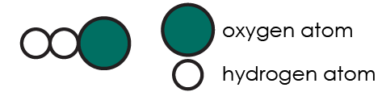

The next picture shows the correct diagram of a water molecule.



Give one feature of a molecule that the formula $H_{2}O$ does not show.

__________________________________________________________________________________


- A test tube of methane gas contains a huge number of separate methane molecules.

The formula of methane (${CH}_{4}$) can be used to represent:
- a single molecule of methane
- or the whole test tube of methane molecules.
- Complete the table to give the number of carbon and hydrogen atoms in each diagram.

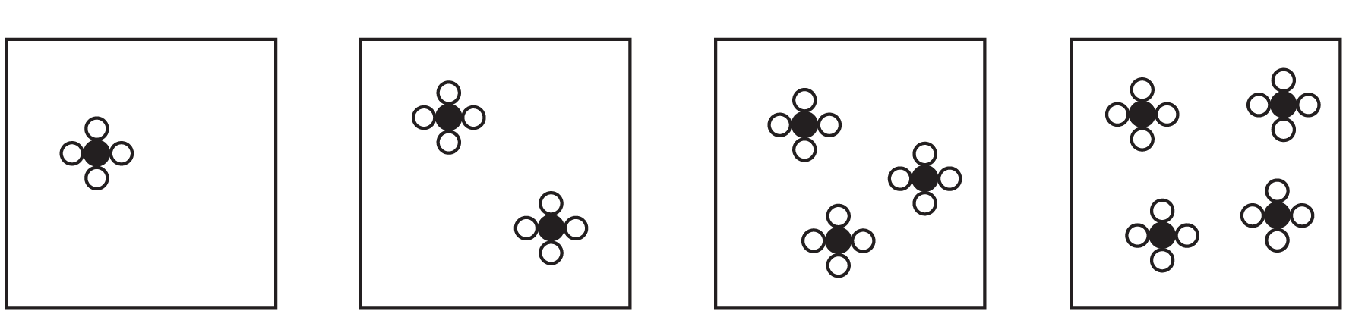
1 | 2 | 3 | 4

Diagram | Number of atoms
Diagram | C | H
1
2
3
4

- Look at the numbers in your table. Complete the mathematical rule below:

number of carbon atoms x ________________ = number of hydrogen atoms

- A sample of methane contains a very large number of molecules. Complete the sentence to describe the rule that connects the number of carbon atoms and the number of hydrogen atoms.

For every carbon atom there are always ___________ hydrogen atoms.

- Not all substances are made up of separate molecules.

The chemical formula of silicon dioxide is SiO_{2.}

At room temperature, silicon dioxide is in the solid state. All the atoms in silicon dioxide are connected to make one giant molecule. There are a huge number of silicon and oxygen atoms in one crystal of silicon dioxide.

Complete the sentence to describe the rule that connects the number of silicon atoms and the number of oxygen atoms.

For every silicon atom…___________________________________________________________

