C, O and Co: Johnstone’s triangle

This resource is from the Johnstone’s triangle series which can be viewed at: rsc.li/43jMfSn. It will help learners to understand the different ways you need to think in chemistry, and to build their mental models and understanding.

Learning objectives
- Select appropriate substance names to complete a description.
- Name the element or compound represented by diagrams showing the arrangement of atoms.
- Recognise how upper and lower case letters are used to form element symbols and chemical formulas.

How to use Johnstone’s triangle

Use Johnstone’s triangle to develop learners’ thinking about scientific concepts at three different conceptual levels:
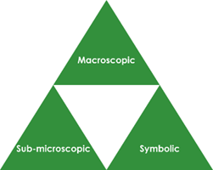
- Macroscopic – what we can see. Think about the properties you can observe, measure and record.
- Sub-microscopic – smaller than we can see. Think about the particle or atomic level.
- Symbolic – representations. Think about how we represent chemical ideas including symbols and diagrams.

For learners to gain a deeper awareness of a topic, they need to understand it at all three levels.

When introducing a topic, don't introduce all three levels of thinking at once. This will overload working memory. Instead complete the triangle over a series of lessons, beginning with the macroscopic level and then introducing other levels, in turn, once secure.

The levels are interrelated, for example, learners need visual representation of the sub-microscopic in order to develop mental models of the particle or atomic level.

Find further reading about Johnstone’s triangle and how to use it in your teaching at rsc.li/4rnSS0z.

Scaffolding

Share the structure of the triangle with learners prior to use. Tell them why you are using it and how it will help them to develop their understanding. Use an ‘I try, we try, you try’ approach when introducing Johnstone’s triangle for the first time.

More resources

To further develop learner’s thinking in all areas of Johnstone’s triangle, try our Developing understanding of symbols and formulas worksheets (rsc.li/44UUtSG).

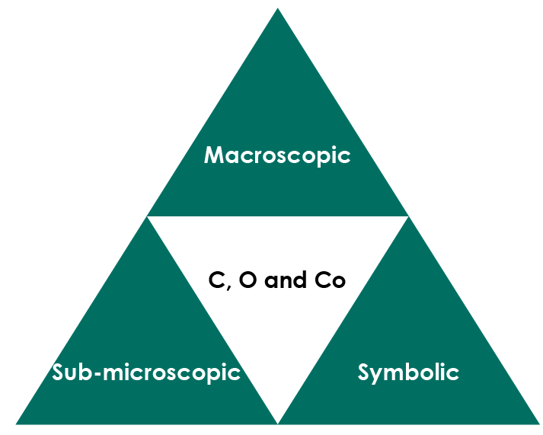


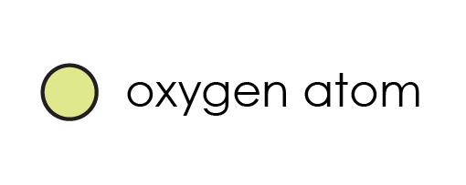

© Vitalii Stock/Shutterstock

Macroscopic – what we can see

Steam engines used to burn large amounts of coal. Electric cars do not directly burn any type of fuel. The batteries often contain a compound of the blue-grey metal cobalt. Complete the sentences:

Black coal is made of the element carbon. When coal burns carbon dioxide gas is formed. If there is not enough oxygen then carbon monoxide gas is formed which is dangerous.

.

Symbolic – representations

Name the elements and compounds represented by the following element symbols and formula.

C carbon Co cobalt CO carbon monoxide

Explain why it is important not to write two letter element symbols with two capital letters.

Each new element symbols starts with a capital letter. If you use two capital letters then you are showing two element symbols (e.g. C and O) rather than one (Co)

A carbon dioxide molecule is made up of one carbon atom joined to two oxygen atoms.

Explain why the formula for carbon dioxide (CO₂) contains the number 2.

To give the number of oxygen atoms in the molecule.

Sub-microscopic – smaller than we can see

The arrangement of atoms in an element or compound can be shown using a diagram

This key shows the colour used to represent each type of atom.

carbon atom oxygen atom cobalt atom

Give the name and symbol (or formula) of the element or compound represented by each diagram.

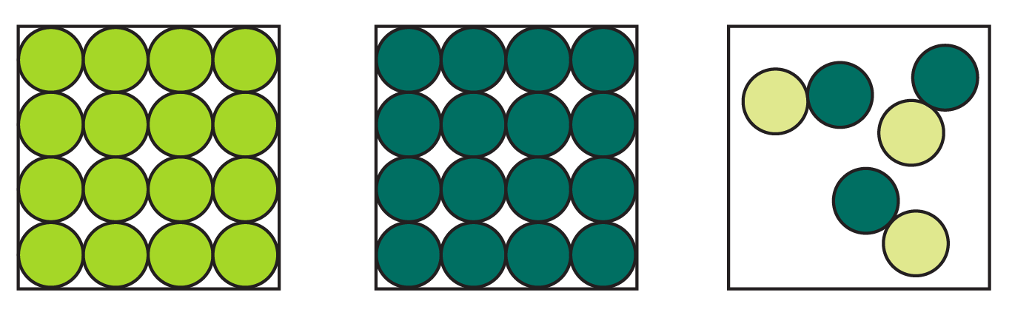
cobalt | carbon | carbon monoxide
Co | C | CO

