C, O and CO: Johnstone’s triangle

Learning objectives
- Select appropriate substance names to complete a description.
- Name the element or compound represented by diagrams showing the arrangement of atoms.
- Recognise how upper and lower case letters are used to form element symbols and chemical formulas.

Introduction

Elements are represented by symbols made up of one or two letters. Each symbol starts with an upper case (capital) letter. Chemical formulas are made up of two or more element symbols.

Johnstone’s triangle

In chemistry we make sense of the things that we can see by representing what we can’t see using formulas, equations, diagrams and models.

Johnstone’s triangle is a way of thinking about these different concepts as different corners of a triangle:
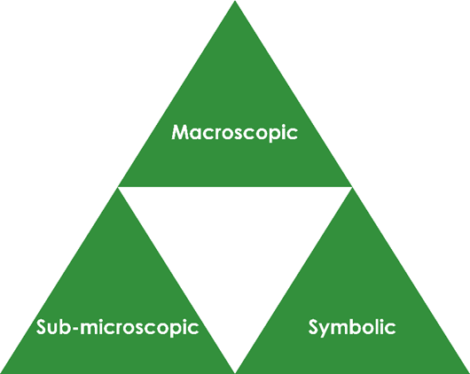

- Macroscopic – what we can see. Think about the properties we can observe, measure and record.
- Sub-microscopic – smaller than we can see. Think about the particle or atomic level.
- Symbolic – representations. Think about how we represent chemical ideas, including symbols and diagrams.

Being able to connect and move between these three different levels is important for scientific understanding.


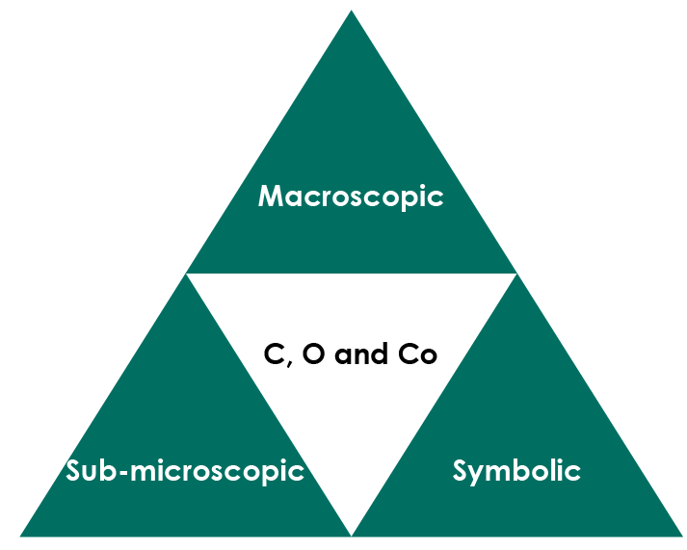

Macroscopic – what we can see

Steam engines used to burn large amounts of coal. Electric cars do not directly burn any type of fuel. The batteries often contain a compound of the blue-grey metal cobalt. Complete the sentences:

Black coal is made of the element ____________________. When coal burns ______________________ gas is formed. If there is not enough oxygen then ______________________ gas is formed which is dangerous.


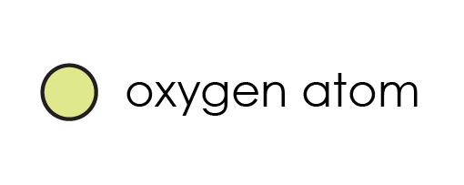

© Vitalii Stock/Shutterstock

Symbolic – representations

Name the elements and compounds represented by the following element symbols and formula.

C _________________ Co ____________ CO ________________________

Explain why it is important not to write two letter element symbols with two capital letters.

__________________________________________________________

__________________________________________________________

A carbon dioxide molecule is made up of one carbon atom joined to two oxygen atoms.

Explain why the formula for carbon dioxide (CO₂) contains the number 2.

__________________________________________________________

__________________________________________________________

Sub-microscopic – smaller than we can see

The arrangement of atoms in an element or compound can be shown using a diagram

This key shows the colour used to represent each type of atom.

carbon atom oxygen atom cobalt atom

Give the name and symbol (or formula) of the element or compound represented by each diagram.



  

  

