Interpreting chemical equations: ionic compounds

Introduction

These questions are designed to help you to develop mental models (pictures in your head) of what is represented by a balanced chemical equation that includes the formula of an ionic compound.

 | Macroscopic: what we can see. Think about the properties that we can observe, measure and record.
 | Sub-microscopic: smaller than we can see. Think about the particle or atomic level.
 | Symbolic: representations. Think about how we represent chemical ideas including symbols and diagrams.


Questions
- Select the formula and state symbol of the products that are described.

Choose from ${CuSO}_{4}$(s), ${CuSO}_{4}$(aq) or MgO(s).
- Magnesium burns in oxygen to form a white solid.

__________________________________________________________________________________
- Magnesium burns in oxygen to form a white smoke that is made up of tiny fragments of a white solid.

__________________________________________________________________________________
- Copper carbonate powder is added to sulfuric acid to form a clear blue solution.

__________________________________________________________________________________
- A clear blue solution is allowed to evaporate forming blue crystals.

__________________________________________________________________________________


- Sodium chloride is an ionic compound with the formula NaCl. Sodium chloride’s structure is made up of a lattice of positively charged sodium ions (Na⁺) and negatively charged chloride ions (Cl⁻).
- Select which diagram best represents the structure of sodium chloride. Give a reason for your answer.

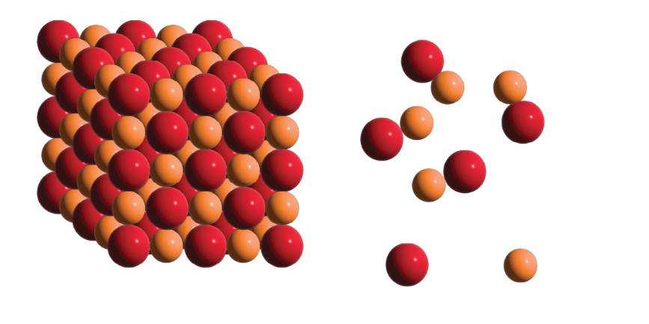
Diagram A | Diagram B
${Na}^{+}$ion
${Cl}^{-}$ion

_________________________________________________________________________________

_________________________________________________________________________________

- The formula for sodium chloride is NaCl. This could be written ${Na}_{1}{Cl}_{1}$but the ones are not normally written. Complete the sentence to describe the meaning of the formula.

For every sodium ion in a sodium chloride lattice there is ______ chloride ion.

- Explain in terms of overall charge why the formula for sodium chloride cannot be ${NaCl}_{2}$.

_________________________________________________________________________________

_________________________________________________________________________________

- The formula of an ionic compound shows which ions make up the ionic lattice.
- Complete the table to show which ions make up the ionic lattice of each compound. The first row is completed as an example.

Ionic compound | Formula | Metal ions | Non-metal ions
sodium chloride | NaCl | $${Na}^{+}$$ | $${Cl}^{-}$$
magnesium chloride | $${MgCl}_{2}$$ | $${Mg}^{2+}$$
magnesium oxide | MgO |  | $$O^{2-}$$
sodium oxide | $${Na}_{2}O$$

- Complete the sentences to describe the meaning of each formula.

For each sodium ion in a sodium chloride lattice, there is _______ chloride ion.

- For each magnesium ion in a magnesium chloride lattice, there are _______ chloride ions.

- For each magnesium ion in a magnesium oxide lattice, there is _______ oxide ion.

- For every two sodium ions in a sodium oxide lattice, there is _______ oxide ion.
- The chemical equation for the reaction between sodium and chlorine is:

2Na(s) + ${Cl}_{2}$(g) → 2NaCl(s)
- State whether each substance is an element, non-metal compound or a metal/non-metal compound.

- Na(s) ______________________
- ${Cl}_{2}$(g) ______________________
- NaCl(s) ______________________

- Give the structure of each substance as being a giant covalent structure, separate covalent molecules, metallic or ionic lattice.

- Na(s) ______________________
- ${Cl}_{2}$(g) ______________________
- NaCl(s) ______________________

- State whether each substance is made up of atoms, molecules or ions.

- Na(s) ______________________
- ${Cl}_{2}$(g) ______________________
- NaCl(s) ______________________

- Complete the table to show the relative number of atoms, molecules and ions that react.
Number of Mg atoms | Number of chlorine molecules | Number of  ${Mg}^{2+}$ ions | Number of  ${Cl}^{-}$ ions
1 | 1 | 1 | 2
2
10
1 billion


- The number of atoms or molecules that react in a real-life chemical reaction is so large that chemists use a special number called the mole. One mole is equal to 6.02 x 10²³ atoms or molecules.
- For the chemical equation Mg(s) + ${Cl}_{2}$(g) → ${MgCl}_{2}$(s)

Give the number of moles of magnesium chloride that can be formed from
- One mole of magnesium atoms _________
- Two moles of magnesium atoms _________
- Chemists are able to calculate the mass of one mole of an element or compound. A chemical equation can therefore be used to work out the mass of product that could be produced from the given mass of a reactant.

The mass of one mole of magnesium is 24 g. Give the mass of two moles of

magnesium. _________

- The mass of one mole of magnesium chloride is 95 g. Give the mass of two moles of magnesium chloride. _________

- Give the mass of magnesium chloride that would be formed from

- 24 g of magnesium __________
- 48 g of magnesium __________

