Finding the formula of copper(II) oxide

This investigation is part of the Nuffield practical collection, developed by the Nuffield Foundation and the Royal Society of Chemistry. Delve into a wide range of chemical concepts and processes with this collection of over 200 step-by-step practicals: rsc.li/43bjGql

Learning objectives
- Safely heat copper oxide with methane to reduce copper oxide to copper metal.
- Accurately record the change in mass.
- Explain the observed mass changes.
- Calculate the relative formula mass using experimental data.

Success criteria
- Use the mass balance correctly to record masses by using the tare function correctly (LO2).
- Safely heat the glass tube and burn the excess methane (LO1).
- Explain mass change by linking to knowledge of conservation of mass and balanced equations (LO3).
- Link knowledge of conservation of mass with moles to calculate the relative formula mass (LO4).

Introduction

In this experiment, learners heat copper(II) oxide in a glass tube while passing methane over it, reducing the copper(II) oxide to copper. If they measure the mass of the reactants and products carefully, learners can then deduce the formula of the copper oxide. This can also be used simply as an example of reduction.

Always demonstrate this experiment to learners before they attempt it themselves, so you can highlight all the associated risks and the safety precautions that need to be taken.

The practical will take up to an hour, perhaps more to analyse the results. It is not suitable as a class practical for learners under the age of 14 but is a useful demonstration.

Scaffolding

As mentioned above, this practical is not easy to do, so consider doing the experiment only as a demo if, having considered the risks, you feel this is not appropriate for your group.

There is a scaffolded and unscaffolded version of the question sheet. If calculating moles is not something you would teach to some classes, the scaffolded student sheet allows the key points to be explored anyway.

Answers to the student worksheet questions are at the end of these teacher notes.

Technician notes

Read our standard health and safety guidance (rsc.li/3zyJLkx) and carry out a risk assessment before running any live practical.

Equipment

Apparatus
- Safety glasses
- Reduction tube (hard glass test tube with small hole near closed end)
- One-hole bung with glass tube to fit the reduction tube
- Rubber tubing
- Clamp stand, boss and clamp
- Bunsen burner
- Heat resistant mat
- Spatula
- Balance (must be accurate to at least 0.01 g)

Each pair or group of learners will need access to two gas taps.

Light a few Bunsen burners around the room for learners to light their own using a splint.

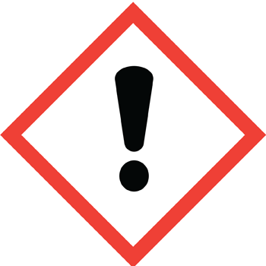
Chemicals
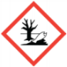
- Copper(II) oxide, 2 spatulas (HARMFUL, DANGEROUS FOR THE ENVIRONMENT)
For best results, use analytical grade copper(II) oxide which has been dried by heating in an open dish at 300–400°C for 10 minutes and then stored in a desiccator.

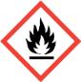
- Methane (natural gas) (EXTREMELY FLAMMABLE)
It is likely that most schools will use a class gas tap for this experiment. This gas forms explosive mixtures in the air.

Safety and hazards
- Wear safety glasses throughout.
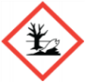
- Copper(II) oxide, CuO(s), (HARMFUL, DANGEROUS FOR THE ENVIRONMENT)
See CLEAPSS Hazcard HC026, refer to SSERC or contact your local safety advisory body.
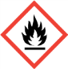
- Methane (natural gas), CH₄(g), (EXTREMELY FLAMMABLE)
See CLEAPSS Hazcard HC045a, refer to SSERC or contact your local safety advisory body.

Disposal
- To dispose of small amounts of excess copper oxide, react no more than 24 g in 1 litre of warm 1 M ethanoic acid before pouring the solution and fine copper precipitate down a foul-water drain.

Method

A full method is provided in the student worksheet, available at: rsc.li/3PeeO0d

Teaching notes

Learners should complete the results table below throughout the practical. While this practical is focused on the mass and how this changes, ask learners to also write observations as the copper oxide (black) changes colour when it is reduced to copper (reddish/orange). Make sure that learners heat the copper oxide until all the copper is this colour. Asking questions about the colour and why this is important will help learners with some of the later questions on their sheet.

Answers
- Copper oxide started black but changed colour to reddish/orange.
- A change in colour suggests that a chemical reaction has occurred.
- mass 2 (______) – mass 1 (_______) = ________ g
- mass 3 (______) – mass 1 (_______) = ________ g
- ans Q3 (______) – ans Q4 (_______) = ________ g
- The mass decreased as the oxygen atoms which were bonded to the copper are removed and bond with carbon to form carbon dioxide which is a gas and escapes.
- copper oxide + methane → copper + water + carbon dioxide

Finding the formula of copper oxide
- Number of moles of copper = $\frac{(ans to Q4)}{65.5}$

Number of moles of oxygen =$\frac{(ans to Q5)}{16}$

Divide by the smallest number of moles to give an approximate ratio of 1:1.

Therefore, this would suggest the formula of copper oxide is CuO.

- 4$CuO + CH_{4}→ 4Cu + 2H_{2}O + CO_{2}$

- Each group started with a different mass* of copper oxide.

Each group heated the copper oxide for a different length of time and potentially some of the copper oxide did not react with the methane.

Guidance note: *Do not accept ‘amount’ as this word choice does not give enough information about the measurements that were taken.

