
Johnstone’s triangle template

This resource is from the Johnstone’s triangle series which can be viewed at: rsc.li/4dOJigo. Here you will find pre-made Johnstone’s triangle worksheets which help learners to understand the different ways you need to think in chemistry, building their mental models and understanding.

How to use Johnstone’s triangle

Use Johnstone’s triangle to develop learners’ thinking about scientific concepts at three different conceptual levels:
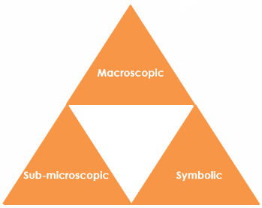
- Macroscopic – what we can see. Think about the properties you can observe, measure and record.
- Symbolic – representations. Think about how we represent chemical ideas including symbols and diagrams.
- Sub-microscopic – smaller than we can see. Think about the particle or atomic level.

For learners to gain a deeper awareness of a topic, they need to understand it at all three levels.

When introducing a topic, do not try to introduce all of the levels of thinking at once. This will overload working memory. Instead complete the triangle over a series of lessons, beginning with the macroscopic level and introducing other levels, in turn, once secure.

All of the levels are interrelated, for example, learners need visual representation of the sub-microscopic in order to develop mental models of the particle or atomic level.

Find further reading about Johnstone’s triangle and how to use it in your teaching at rsc.li/3DjoUqN.

How to use this resource

Use this template to create your own Johnstone’s triangle worksheet, or get your learners to add their own ideas to a blank version.

Scaffolding

It is important to share the structure of the triangle with learners prior to use. Tell them why you want them to use the triangle and how it will help them to develop their understanding. Use an ‘I try, we try, you try’ approach when you are introducing Johnstone’s triangle for the first time.

More resources

To further develop learner’s thinking in all areas of Johnstone’s triangle, try our Developing understanding worksheets (rsc.li/4tfOOAd). These include icons in the margin referring to the conceptual level of thinking needed to answer the question.

Macroscopic - what we can see

Think about the properties you can observe, measure and record.

Sub-microscopic - smaller than we can see

Think about the particle or atomic level.

Symbolic - representations

Think about how we represent chemical ideas, including symbols, equations and diagrams.

