Concentration and moles

Introduction

These questions are designed to help you to develop mental models (pictures in your head) of solutions with different concentrations. These mental models can then support understanding of the formulae used to calculate concentrations in moles/dm³. Use the icon in the margin to find out which level of understanding the question is developing.
 | Macroscopic: what we can see. Think about the properties that we can observe, measure and record.
 | Sub-microscopic: smaller than we can see. Think about the particle or atomic level.
 | Symbolic: representations. Think about how we represent chemical ideas including symbols and diagrams.

Questions
- Concentration can be measured in g/dm³. Concentration can also be given as the number of moles of solute per dm³ (mol/dm³).

- Determine the concentration (in mol/dm³) of each solution.
- ______ mol/dm³

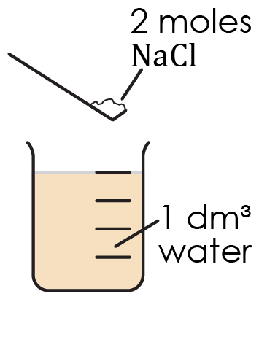
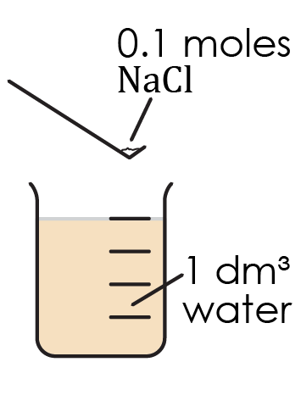
- ______ mol/dm³

- Two solutions have different concentrations.

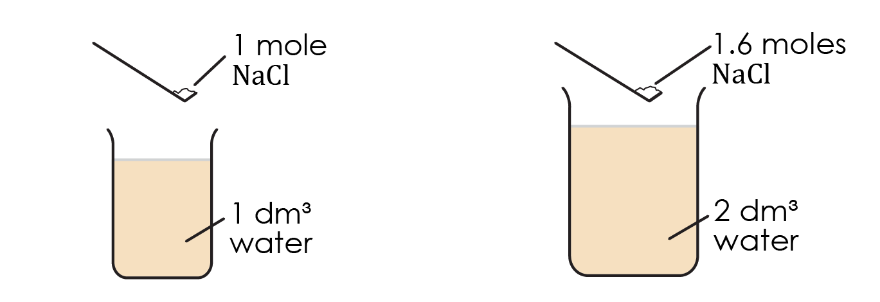
solution A | solution B

Give the concentration of solution A. _________mol/dm³

- Determine the number of moles in 1dm³ of solution B. _________ moles

- Determine the concentration of solution B. _________mol/dm³

- State which solution is more concentrated. _________

- The formula unit of an ionic compound can be determined from its formula.

For example, the formula unit of $NaCl$ contains one ion of sodium and one ion of chloride. The formula unit of ${Na}_{2}O$ contains two ions of sodium and one ion of oxygen. One mole of an ionic compound is made up of one mole of the formula unit.

- Give the number of ${Cu}^{2+}$ ions and ${Cl}^{-}$ ions in one formula unit of $Cu{Cl}_{2}$.

- ${Cu}^{2+}$ ______
- ${Cl}^{-}$ ______

- Calculate the mass of sodium chloride that must be dissolved in 1 dm³ of water to make up a solution with a concentration of 1 mol/dm³.

The relative atomic mass (RAM) of sodium is 23 and the RAM of chlorine is 35.5.

_________________________________________________________________________________

_________________________________________________________________________________
- Calculate the mass of copper chloride that must be dissolved in 1 dm³ of water to make up a solution with a concentration of 1 mol/dm³.

The RAM of copper is 63.5.

_________________________________________________________________________________

_________________________________________________________________________________
- Explain why a 1 mol/dm³ solution of copper chloride contains two moles of ${Cl}^{-}$ ions.

_________________________________________________________________________________

_________________________________________________________________________________
- A mathematical formula can be used to calculate concentration.

$$concentration (in moles/{dm}^{3})=\frac{number of moles}{volume (in {dm}^{3})}$$

Volumes are often given in cm³. To convert from cm³ to dm³ divide by 1000.
- Complete the table determine the concentration of each solution of copper sulfate.

Solution | Number of moles of copper sulfate | Volume in cm³ | Volume in dm³ | Concentration in mol/dm³
X | 2 | 1000
Y | 2 | 2000
Z | 2 | 500

- The solutions in the table are represented in the diagram below.

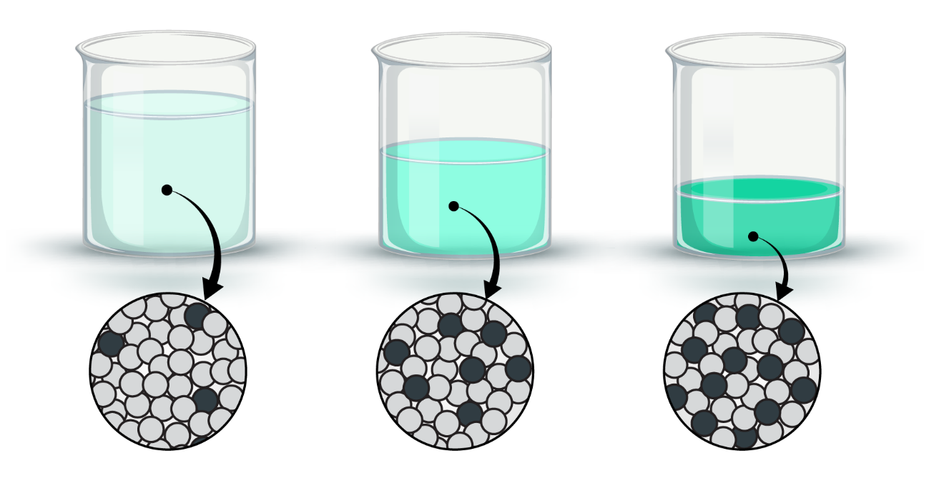
2000 cm³ | 1000 cm³ | 500 cm³
solution X | solution Y | solution Z

In the particle diagrams state what each type of circle represents.

- light grey circles: _____________ molecules
- blue circles: _____________ ions and_____________ ions
- Complete the sentences to explain why solution Z is more concentrated than solution X.

Solution X and Z contain the same number of copper __________________ and sulfate __________________.

Solution Z contains fewer water __________________ than solution Z.

This means that solution Z has more copper and sulfate __________________ compared to the number of water __________________. Therefore solution Z is more concentrated.

- The number of moles of solute in a given volume of solution can be determined if the concentration of the solution is known.

- Determine the number of moles of sodium chloride in each volume of 0.1 mol/dm³ solution.

- 1 dm³ _____moles
- 2 dm³ _____moles
- 0.5 dm³ _____moles
- The number of moles of a solute in a given volume of solution of a known concentration can be calculated using the mathematical formula:

$$number of moles=concentration (in moles/{dm}^{3}) x volume (in {dm}^{3})$$

Complete the table to determine the number of moles of solute in each volume of

solution.
concentration mol/dm³ | volume in cm³ | volume in dm³ | Number of moles of solute
0.5 | 10
0.1 | 5
0.2 | 25
- Hydrochloric acid reacts with sodium hydroxide to produce sodium chloride and water. Both hydrochloric acid and sodium hydroxide are aqueous solutions (solutions where the solvent is water).

The balanced chemical equation for the reaction is:

HCl (aq) + NaOH (aq) → NaCl (aq) + $H_{2}O$(l)

This reaction can use hydrochloric acid of known concentration to determine the

concentration of a solution of sodium hydroxide with unknown concentration.
- Complete the sentence to show what this equation means.

Each mole of hydrochloric acid reacts with ______ mole of sodium hydroxide to form

______ mole of sodium chloride.
- A beaker contains 10 cm³ of hydrochloric acid with a concentration of 0.1 mol/dm³. Give the mathematical formula that can be used to calculate the number of moles of HCl in 10 cm³ of hydrochloric acid.

number of moles =

- Calculate the number of moles of HCl in 10 cm³.

number of moles =

- 10 cm³ of the hydrochloric acid reacts exactly with 5 cm³ of a solution of sodium hydroxide solution. Give the number of moles of NaOH that react with the number of moles of HCl in 10 cm³ of hydrochloric acid.

________________________________________________________________________________
- Give the mathematical formula that calculates the concentration of a solution.

concentration (in mol/dm³) =

- Calculate concentration of the sodium hydroxide solution.

concentration (in mol/dm³) =

- Explain why 10 cm³ of 0.1 mol/dm³ hydrochloric acid does not react exactly with the same volume of sodium hydroxide.

_________________________________________________________________________________

_________________________________________________________________________________

