Word equations

Introduction

These questions are designed to help you to develop your mental models (pictures in your head) of word equations. Use the icon in the margin to find out which level of understanding the question is developing.
 | Macroscopic: what we can see. Think about the properties that we can observe, measure and record.
 | Sub-microscopic: smaller than we can see. Think about the particle or atomic level.
 | Symbolic: representations. Think about how we represent chemical ideas including symbols and diagrams.


Questions
- Some powdered iron is heated with some yellow sulfur powder. Black iron sulfide is formed.
- In the sentence above:
- Underline the two substances that react (reactants).
- Circle the substance that is produced (product).
- Complete the word equation for the reaction.

______________________ | + | ______________________ | $$→$$ | ________________________
reactant 1 |  | reactant 2 |  | product

- State two pieces of information about sulfur from the question that are not included in the word equation.

__________________________________________________________________________________
- Explain why ‘heat’ is not included as a reactant on the left hand side of the equation.

__________________________________________________________________________________

- In maths the equals sign is used. For example 2 + 2 = 4.

Explain why an arrow is used in the word equation and not an equals sign.

__________________________________________________________________________________

__________________________________________________________________________________

__________________________________________________________________________________
- Magnesium burns in air to form magnesium oxide.
- Name the metal reactant.

__________________________________________________________________________________
- Air is a mixture. Give the name of the substance found in the air that magnesium reacts with.

__________________________________________________________________________________
- Name the product of the reaction.

__________________________________________________________________________________
- Complete the word equation for the reaction.

______________________ | + | ______________________ | $$→$$ | ________________________
reactant 1 |  | reactant 2 |  | product

- The diagram below shows a metal being heated in a Bunsen burner flame.

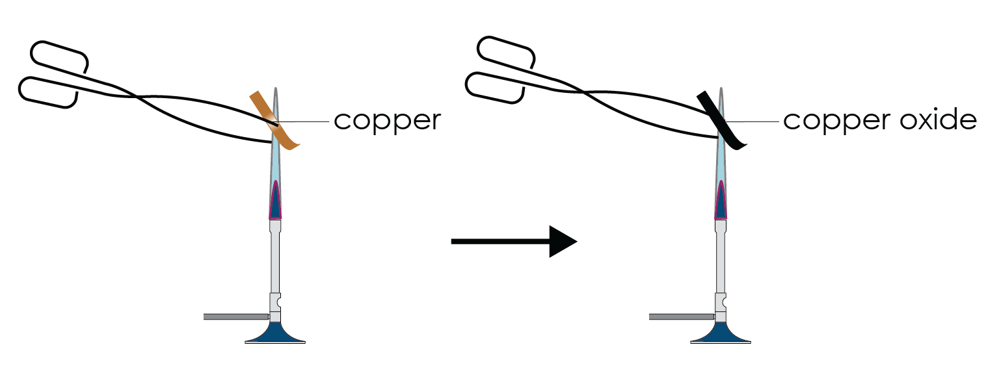

- Name the metal that is being heated.

__________________________________________________________________________________
- Name the new product that is formed.

__________________________________________________________________________________

- Name the other substance that is reacting but cannot be observed.

__________________________________________________________________________________
- Complete the word equation for the reaction.

______________________ | + | ______________________ | $$→$$ | ________________________
reactant 1 |  | reactant 2 |  | product

- The word equation for the chemical reaction when copper carbonate is heated is:

copper carbonate → copper oxide + carbon dioxide

The diagram below shows the observable change that takes place.

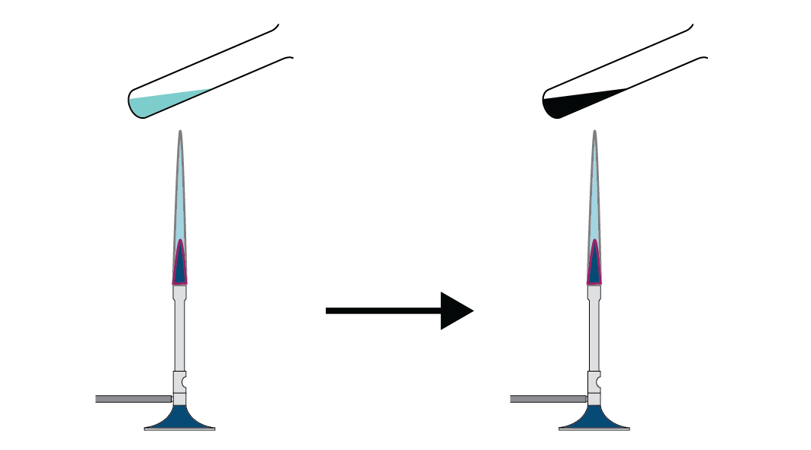
- Give the colour of copper carbonate.

__________________________________________________________________________________
- Give the colour of the copper oxide that is produced.

__________________________________________________________________________________
- Explain why the carbon dioxide produced is not observed.

__________________________________________________________________________________
- When copper carbonate powder is added to sulfuric acid carbon dioxide is also

produced.

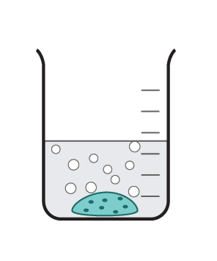

Look at the diagram of the reaction and suggest why the formation of carbon

dioxide can now be observed.

__________________________________________________________________________________

__________________________________________________________________________________
- The word equation for the reaction between sodium metal and chlorine gas is:

sodium + chlorine → sodium chloride

The following observations were made:

A grey solid burned with a bright flame in a yellow-green gas. White smoke was produced. Smoke is made up of many tiny fragments of a white solid.

Name the substance described by its description.

- yellow-green gas ______________________________
- white solid ______________________________
- grey solid ______________________________

