Sodium and chlorine reaction: Johnstone’s triangle

Learning objectives
- Recognise the different parts of a word equation.
- Match observations to reactants and product names.
- Complete the particle diagram for the product.

Introduction

The reaction between sodium metal and chlorine gas can be represented by a word equation.

Johnstone’s triangle

In chemistry we make sense of the things that we can see by representing what we can’t see using formulas, equations, diagrams and models.

Johnstone’s triangle is a way of thinking about these different concepts as different corners of a triangle:

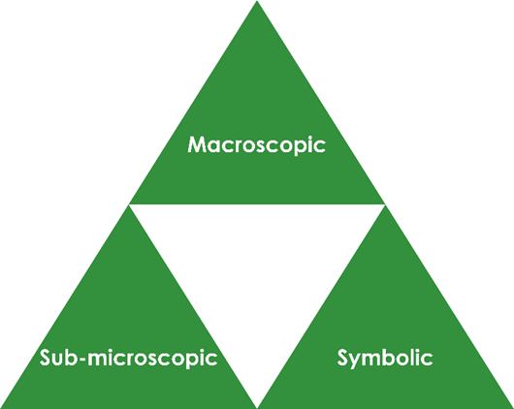

- Macroscopic – what we can see. Think about the properties we can observe, measure and record.
- Sub-microscopic – smaller than we can see. Think about the particle or atomic level.
- Symbolic – representations. Think about how we represent chemical ideas, including symbols and diagrams.

Being able to connect and move between these three different levels is important for scientific understanding.

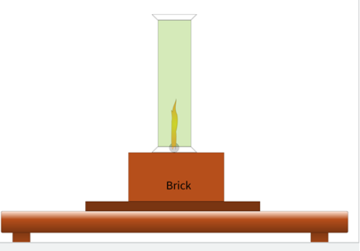
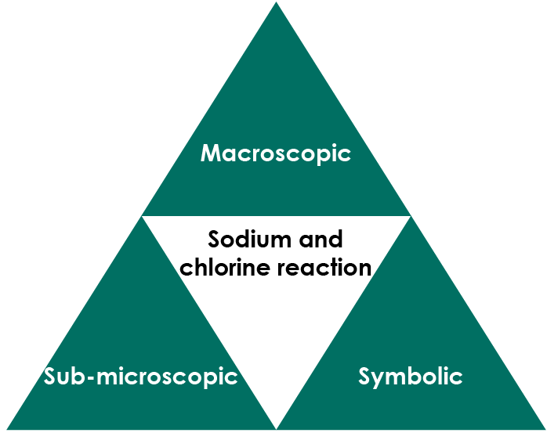
© Declan Fleming

Macroscopic – what we can see

Sodium reacts with chlorine to form sodium chloride.

Name the substances observed from the descriptions.

yellow-green gas __________________
shiny grey solid __________________
A smoke is made up of tiny fragments of a solid. Name the substance that makes up the observed white smoke.

_______________________________________________________
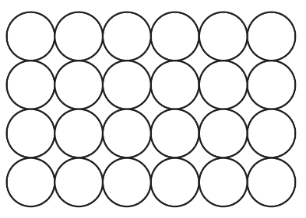
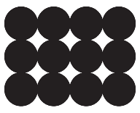
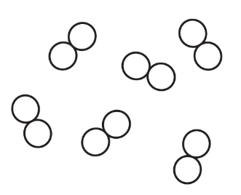
This reaction between sodium and chlorine is carried out in a fume cupboard

Symbolic – representations

The word equation for the reaction between sodium and chlorine is:

sodium + chlorine → sodium chloride

Name the two reactants

___________________________________________________________Name the product

___________________________________________________________Explain why the maths sign = is not used in a chemical equation.

___________________________________________________________

___________________________________________________________

___________________________________________________________

Give the meaning of the sign → in words.

___________________________________________________________

Sub-microscopic – smaller than we can see

Label the two particle diagrams to show which reactant each represents.

__________________ __________________

Colour the particle diagram to represent the product of the reaction (sodium chloride).

