Determining an unknown concentration: Johnstone’s triangle

This resource is from the Johnstone’s triangle series which can be viewed at: rsc.li/43jMfSn. It will help learners to understand the different ways you need to think in chemistry, and to build their mental models and understanding.

Learning objectives
- Recognise and read volume from titration apparatus.
- Calculate the number of moles of sodium hydroxide.
- Calculate the concentration of hydrochloric acid with unknown concentration.

How to use Johnstone’s triangle

Use Johnstone’s triangle to develop learners’ thinking about scientific concepts at three different conceptual levels.
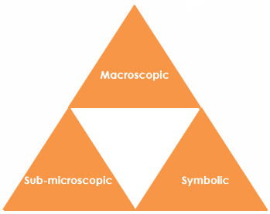
- Macroscopic – what we can see. Think about the properties you can observe, measure and record.
- Sub-microscopic – smaller than we can see. Think about the particle or atomic level.
- Symbolic – representations. Think about how we represent chemical ideas including symbols and diagrams.

For learners to gain a deeper awareness of a topic, they need to understand it at all three levels.

When introducing a topic, don't try to introduce allthree levels of thinking at once. This will overload working memory. Instead complete the triangle over a series of lessons, beginning with the macroscopic level, then symbolic and then sub-microscopic.

The levels are interrelated. For example, learners need visual representation of the sub-microscopic in order to develop mental models of the particle or atomic level.

Find further reading about Johnstone’s triangle and how to use it in your teaching at: rsc.li/4brRDbJ.

Scaffolding

Share the structure of the triangle with learners prior to use. Tell them why you are using it and how it will help them to develop their understanding. Use an ‘I try, we try, you try’ approach when introducing Johnstone’s triangle for the first time.

More resources

To further develop learner’s thinking in all areas of Johnstone’s triangle, try our Developing understanding of concentration and moles worksheets (rsc.li/4aLcZAH). These include icons in the margin referring to the conceptual level of thinking needed to answer the question.
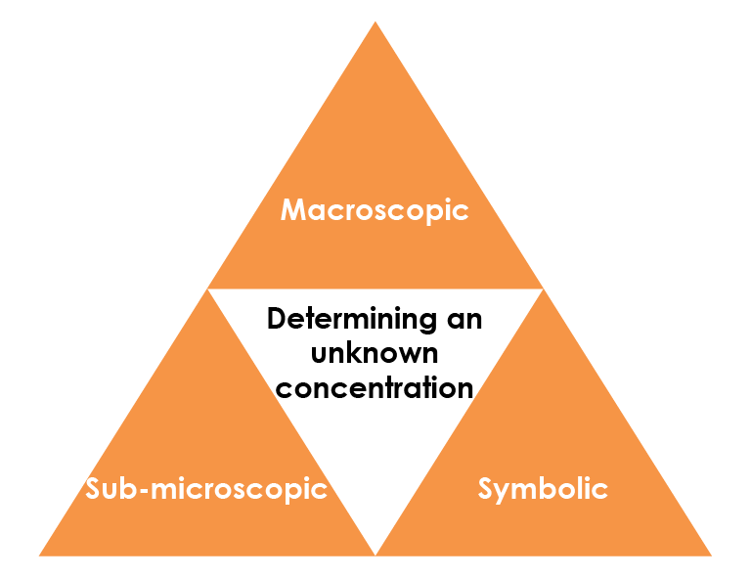
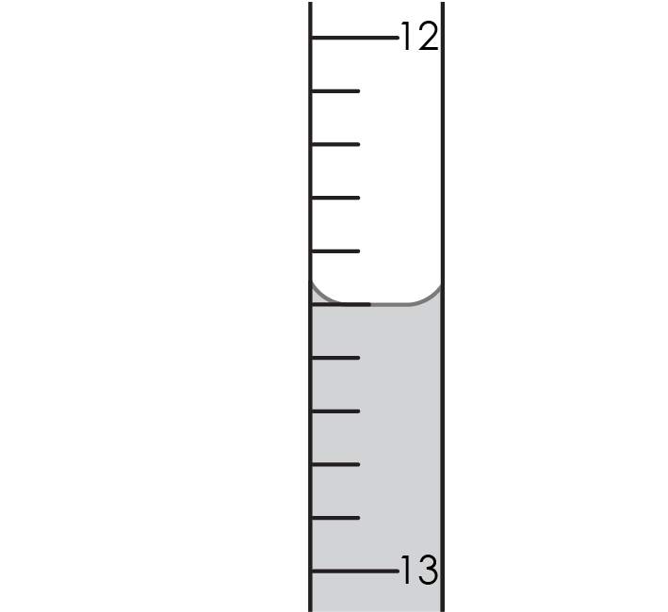

Macroscopic – what we can see

Name the apparatus used in a titration to:

contain 25 cm³ of 0.1 mol/dm³ sodium hydroxide solution.

conical flask

to add hydrochloric acid of unknown concentration.

burette

Give the volume of acid added when the end point is reached. 12.5 cm³

Sub-microscopic – smaller than we can see

The equation for the titration reaction is:

HCl(aq) + NaOH(aq) → NaCl(aq) + $H_{2}O$(l)

Complete the sentence:

Each mole of sodium hydroxide in the conical flask reacts with one mole of hydrochloric acid from the burette.

Use the number of moles of sodium hydroxide to determine the number of moles of hydrochloric acid added. 0.0025 moles

Give the volume of acid added in dm³.

12.5 / 1000 = 0.0125 dm³

Calculate the concentration of the hydrochloric acid.

Concentration = number of moles / volume in dm³ = 0.0025 / 0.0125 = o.2 mol/dm³

Symbolic – representations

There is 25 cm³ of sodium hydroxide in the conical flask, which is equal to 0.025 dm³ (divide by 1000 to convert from cm³ to dm³).

The formula for calculating concentration is:

$$concentration = \frac{number of moles}{ volume (in {dm}^{3})}$$

Rearrange the formula to calculate the number of moles of sodium hydroxide in the flask.

(The concentration of sodium hydroxide solution is 0.1 mol/dm³.)

number of moles = concentration x volume (in dm³) = 0.1 x 0.025 = 0.0025 moles of sodium hydroxide

<Fill in the model answer using Bradley Hard ITC, font size 14, font colour #4F81BD.

If you need to use diagrams please provide an example and we will redraw these in-house.>

