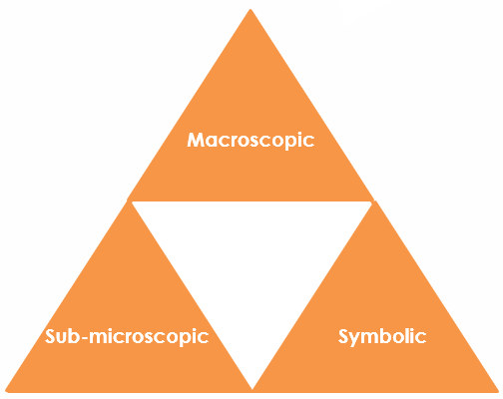
Determining an unknown concentration: Johnstone’s triangle

Learning objectives
- Recognise and read volume from titration apparatus.
- Calculate the number of moles of sodium hydroxide.
- Calculate the concentration of hydrochloric acid with unknown concentration.

Introduction

The unknown concentration of some hydrochloric acid can be calculated. To do this it is essential to know the volume of hydrochloric acid that reacts with an exact volume of sodium hydroxide solution of known concentration. This volume can be determined experimentally using a practical technique called titration.

Johnstone’s triangle

In chemistry we make sense of the things that we can see by representing what we can’t see using formulas, equations, diagrams and models.

Johnstone’s triangle is a way of thinking about these different concepts as different corners of a triangle:

- Macroscopic – what we can see. Think about the properties we can observe, measure and record.
- Sub-microscopic – smaller than we can see. Think about the particle or atomic level.
- Symbolic – representations. Think about how we represent chemical ideas, including symbols and diagrams.

Being able to connect and move between these three different levels is important for scientific understanding.

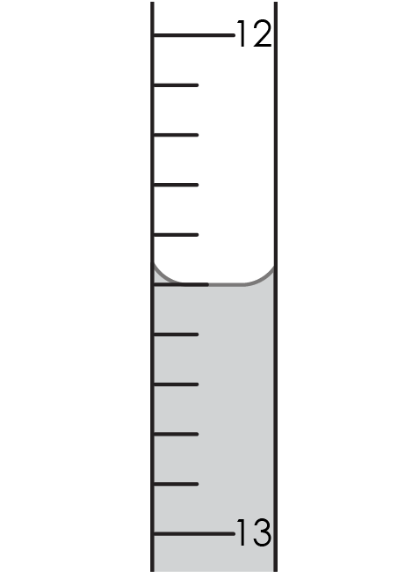
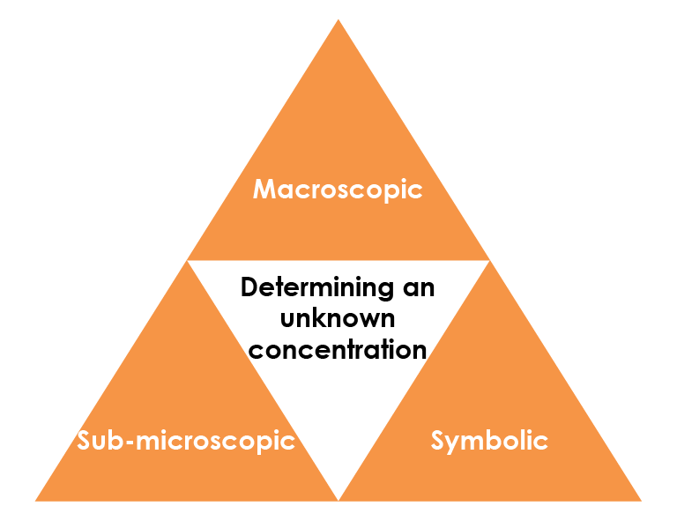

Macroscopic – what we can see

Name the apparatus used in a titration to:
- contain 25 cm³ of 0.1 mol/dm³ sodium hydroxide solution.

______________________________________________________________
- add hydrochloric acid of unknown concentration.

______________________________________________________________

Give the volume of acid added when the end point is reached.

______________________________________________________________

Sub-microscopic – smaller than we can see

The equation for the titration reaction is:

HCl(aq) + NaOH(aq) → NaCl(aq) + $H_{2}O$(l)

Complete the sentence:

Each mole of sodium hydroxide in the ______ reacts with

_____ mole of hydrochloric acid from the ________________.

Use the number of moles of sodium hydroxide to determine the number of moles of hydrochloric acid added.

Give the volume of acid added in dm³.

___________________________________________________________________

Calculate the concentration of the hydrochloric acid.

___________________________________________________________________

___________________________________________________________________

Symbolic – representations

There is 25 cm³ of sodium hydroxide in the conical flask, which is equal to 0.025 dm³ (divide by 1000 to convert from cm³ to dm³).

The formula for calculating concentration is:

$$concentration = \frac{number of moles}{ volume (in {dm}^{3})}$$

Rearrange the formula to calculate the number of moles of sodium hydroxide in the flask.

(The concentration of sodium hydroxide solution is 0.1 mol/dm³.)

_______________________________________________________

_______________________________________________________

_______________________________________________________

_______________________________________________________

