Limiting and excess reactants

Introduction

These questions are designed to help you to develop mental models (pictures in your head) of limiting and excess reactants. Use the icon in the margin to find out which level of understanding the question is developing.
 | Macroscopic: what we can see. Think about the properties that we can observe, measure and record.
 | Sub-microscopic: smaller than we can see. Think about the particle or atomic level.
 | Symbolic: representations. Think about how we represent chemical ideas including symbols and diagrams.


Questions
- An ice-cream seller sells ice creams made up of one cone and one scoop of ice cream. On a busy day she wants to sell as many complete ice cream cones as possible.
- Give the number of complete ice creams the seller could make if she has five cones and five scoops of ice cream.




- The ice cream seller drops one cone on the floor. Give the number of complete ice creams that she can now make.

- One sunny day, the van is stocked with 100 cones and 200 scoops of ice cream. Give the maximum number of complete ice creams that the seller can make.

- Name the ingredient that is limiting the number of complete ice creams that the seller can make.

__________________________________________________________________________________
- Give the number of excess scoops ice cream that will be left at the end of the day.

- The next week the van is stocked with 250 cones and 200 scoops of ice cream. Name the ingredient that is now limiting the number of complete ice creams that the seller can make.

__________________________________________________________________________________
- Give the number of excess cones that will be left if all the scoops of ice cream are used.

- Magnesium reacts with hydrochloric acid forming magnesium chloride solution and hydrogen gas.

The diagram below shows the reaction at different stages.

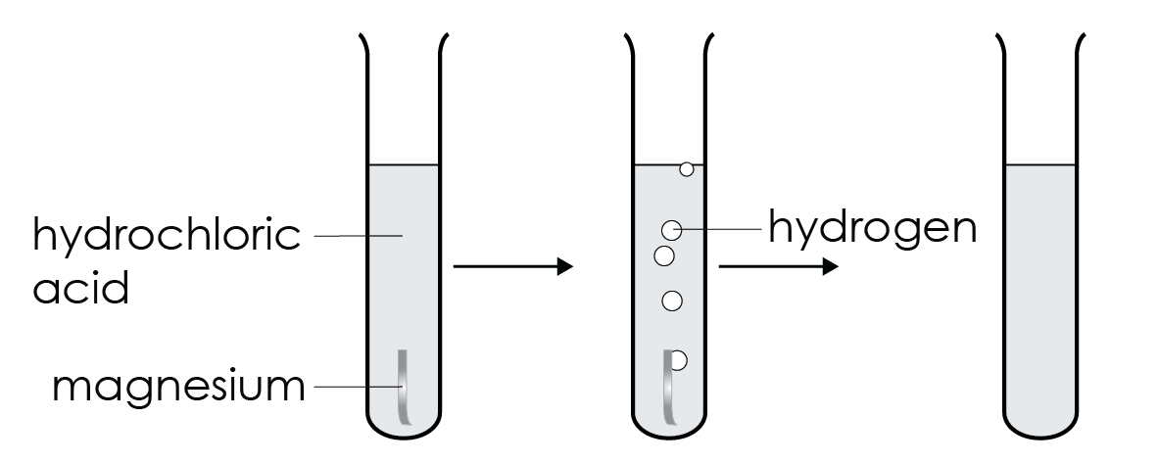

- Name the reactants in the test tube at the start.

__________________________________________________________________________________
- Name the product in the test tube at the end of the reaction.

__________________________________________________________________________________
- Explain why the other product is not in the test tube.

__________________________________________________________________________________
- The solution in the test tube at the end turns litmus paper red.

Name the other substance in the test tube at the end of the reaction.

__________________________________________________________________________________
- Explain why some of this reactant is still present at the end of the reaction.

__________________________________________________________________________________
- If a reactant is still present at the end of a reaction then it is said to be 'in excess'.

The diagram below shows the reaction of magnesium and hydrochloric acid but

with different quantities of reactants.

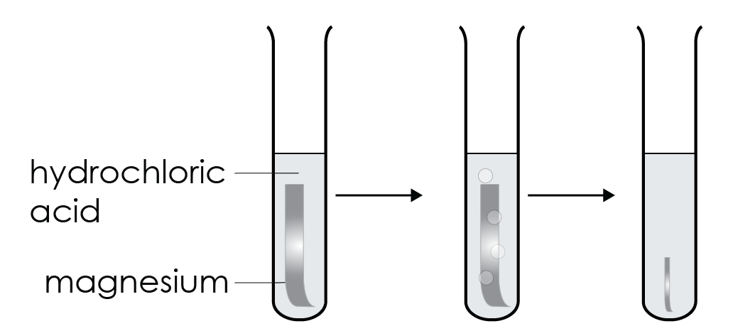

Explain how the observations shown in this figure show which reactant is in excess.

__________________________________________________________________________________


__________________________________________________________________________________
- Observations and a balanced chemical equation with state symbols can be used to help identify which reactant is in excess.

- Calcium carbonate reacts with hydrochloric acid to form calcium chloride, carbon dioxide and water.

The balanced chemical equation for the reaction is:

${CaCO}_{3}$(s) + 2HCl(aq) → ${CaCl}_{2}$(aq) + ${CO}_{2}$(aq) + $H_{2}O$(l)

The diagram shows what is observed at the end of the reaction.

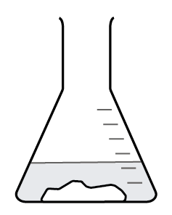

Explain how the observation and the state symbols in the equation show that

calcium carbonate is in excess and not hydrochloric acid.

__________________________________________________________________________________

__________________________________________________________________________________

- The diagram shows what is observed when the reaction between copper oxide and sulfuric acid has ended.

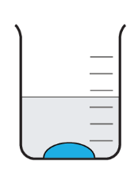

The balanced chemical equation for the reaction is:

CuO(s) + $H_{2}{SO}_{4}$(aq) → ${CuSO}_{4}$(aq) + $H_{2}O$(l)

Give the chemical formula and state symbol of the excess and limiting reactants.
- Excess reactant ____________________
- Limiting reactant ____________________
- The balanced chemical equation for the reaction between sodium hydroxide solution and hydrochloric acid is:

NaOH(aq) + HCl(aq) → NaCl(aq) + $H_{2}O$(l)

Explain why litmus paper is needed to determine the excess reactant in the reaction.

__________________________________________________________________________________

__________________________________________________________________________________

__________________________________________________________________________________
- The diagram shows what is observed.

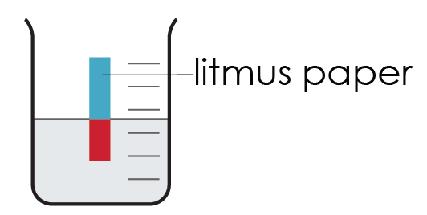

State whether the excess reactant is an acid or an alkali.

__________________________________________________________________________________
- Name the excess and limiting reactants.
- Excess reactant ____________________
- Limiting reactant ____________________


- When carbon burns in oxygen each atom of carbon reacts with one molecule of oxygen to form one molecule of carbon dioxide.

This is represented by the balanced chemical equation:

C(s) + $O_{2}$(g) → ${CO}_{2}$(g)

- Complete the diagram below to show how many molecules of carbon dioxide can be made from four carbon atoms.

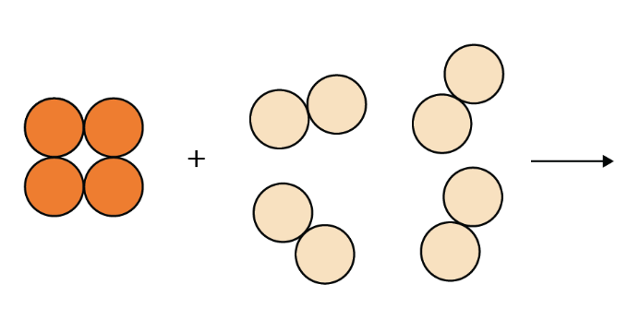

- The diagram shows six carbon atoms and eight molecules of oxygen.

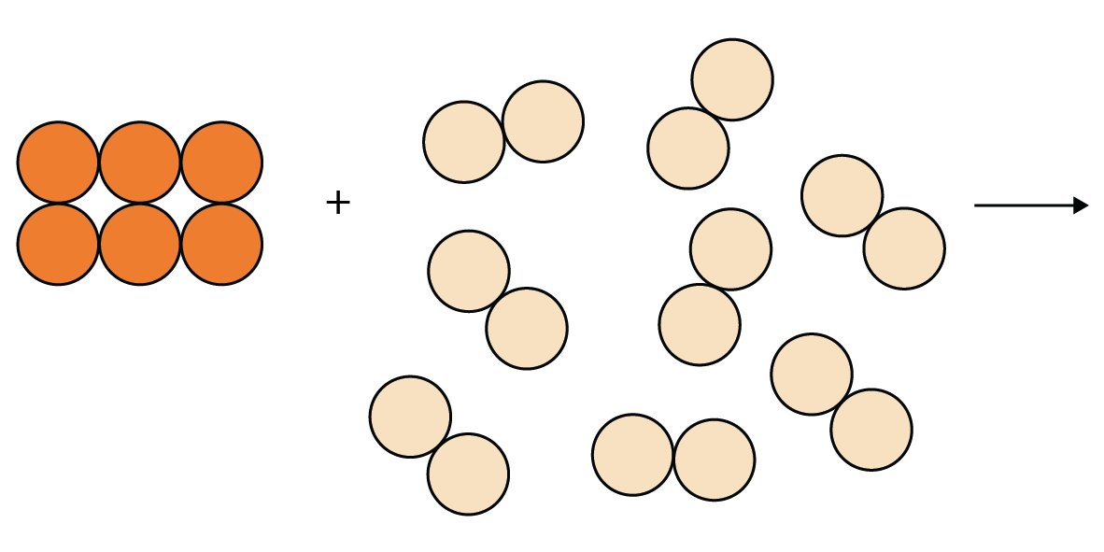

Determine how many molecules of carbon dioxide can be made from the reactant atoms and molecules (use the diagram to help).

__________________________________________________________________________________
- Explain how this shows that carbon is the limiting reactant.

__________________________________________________________________________________

__________________________________________________________________________________
- Explain why oxygen is often in excess when carbon burns.

__________________________________________________________________________________

__________________________________________________________________________________

- Copper sulfate is a salt that can be made by adding copper carbonate to a beaker containing sulfuric acid.

The balanced chemical equation for the reaction is:

${CuCO}_{3}$(s) + $H_{2}{SO}_{4}$→ ${CuSO}_{4}$(aq) + ${CO}_{2}$(g) + $H_{2}O$(l)

- A student adds copper carbonate to sulfuric acid. At the end of the reaction the solution is still acidic.

List the substances that are present in the beaker at the end of the reaction.

__________________________________________________________________________________
- Name the reactant that is in excess.

__________________________________________________________________________________
- Explain why the formula for the excess substance is not shown on the right of the chemical equation.

__________________________________________________________________________________
- The reactant that limits the amount of product made is called the limiting reactant. Name the limiting reactant.

__________________________________________________________________________________
- Describe what the student would see if copper carbonate was in excess.

__________________________________________________________________________________
- Explain how excess copper carbonate can be removed and why this method would not remove excess sulfuric acid.

__________________________________________________________________________________

__________________________________________________________________________________
- Explain why copper carbonate is added in excess when making copper sulfate.

__________________________________________________________________________________

__________________________________________________________________________________

