Relative mass

Starch is a type of carbohydrate found in many foods such as pasta, potatoes, bread and rice.



Source: © Shutterstock

When we eat starchy foods, the enzymes in our bodies break the large starch molecules into smaller molecules called simple sugars.
- One example of a simple sugar is glucose, C₆H₁₂O₆.
- Calculate the relative formula mass of glucose. Use the periodic table to help you.

__________________________________________________________________________________

__________________________________________________________________________________

Glucose can be used in our bodies to make energy through a process called cellular respiration.

If there is plenty of oxygen, aerobic respiration occurs where glucose reacts with the oxygen to produce carbon dioxide gas and liquid water.
- Write the word equation to represent the process of aerobic respiration.

__________________________________________________________________________________
- What is the balanced chemical equation to represent the process of aerobic respiration? Circle the correct answer.
A | C₆H₁₂O₆ + 9O₂ → 6CO₂ + 6H₂O
B | C₆H₁₂O₆ + O₂ → 6CO₂ + 6H₂O
C | C₆H₁₂O₆ + 12O₂ → 6CO₂ + 6H₂O
D | C₆H₁₂O₆ + 6O₂ → 6CO₂ + 6H₂O

During high-intensity exercise the body’s demand for oxygen is higher. If the body does not have enough oxygen to meet this increased demand, a process called anaerobic respiration happens where the glucose is broken down to produce lactic acid.

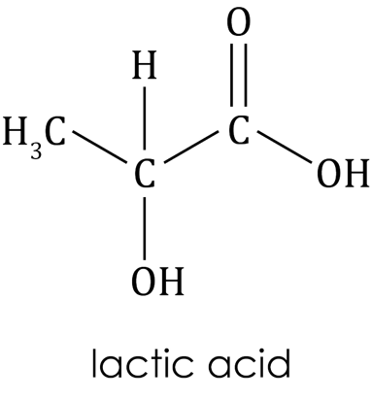
- Use the image provided to deduce the chemical formula of lactic acid.

Hint: Remember to include any subscript numbers needed to show the number of atoms of the different elements present. For example, in the formula $H_{2}O$ the subscript number 2 shows that there are two hydrogen atoms present.

__________________________________________________________________________________
- Use your answer to calculate the relative formula mass of lactic acid.

Hint: Remember to multiply any atomic masses by the number of atoms of that element present in the compound.

__________________________________________________________________________________

__________________________________________________________________________________
- Starch can be broken down to produce a simple sugar called maltose by enzymes in the mouth and small intestine.

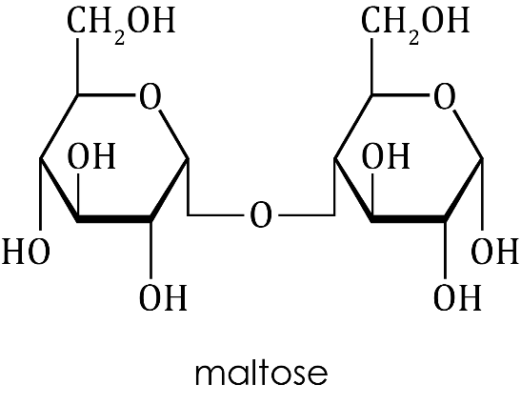
- The chemical formula of maltose is C₁₂H₂₂O₁₁. Calculate the relative formula mass of maltose.

$A_{r}$ carbon $=$12 $A_{r}$ hydrogen $=$1 $A_{r}$ oxygen $=$16

__________________________________________________________________________________

__________________________________________________________________________________

The percentage of an element present in a compound can be determined using the equation:

$$Percentage of element in compound \left(\%\right)= \frac{relative atomic mass of element }{relative formula mass of compound} ×100$$
- Use your answer to part (a), along with the equation above, to calculate the percentage of carbon in maltose.

Hint: Remember to multiply the relative atomic mass by the number of atoms of that element present in the compound.

__________________________________________________________________________________

__________________________________________________________________________________

__________________________________________________________________________________

__________________________________________________________________________________

__________________________________________________________________________________
- Scientists use a measure known as atom economy to assess the efficiency of an industrial process by comparing the relative formula masses of the reactants and products for the reactions used.
- Which statement correctly describes atom economy? Circle the correct answer.
A | A higher atom economy shows the process produces more waste.
B | Atom economy is a measure of the amount of the reactants used to produce the waste product.
C | Atom economy is a measure of the amount of the reactants used to produce the useful product.
D | An atom economy of 100% shows that no desired products have been formed.

Maltose can be broken down, using water and an enzyme called maltase, to make glucose.

The chemical equation for this reaction is:

C₁₂H₁₁O₁₁ + H₂O → 2C₆H₁₂O₆
- Use some of the words provided to complete the sentences to state and explain the atom economy of this reaction.

some 50 waste

all 100 desired

The atom economy for this reaction is ___________%. This is because ___________ of the atoms of the reactants are used to make the ___________ product and there is no ____________ product.

The atom economy of any chemical reaction can be calculated using the equation:

$$Atom economy \%= \frac{total formula mass of the useful product}{total formula mass of all reactants} ×100$$

Maltose can also be used in a process called fermentation where the maltose reacts with water to produce ethanol, C₂H₅OH, and carbon dioxide gas.

The ethanol produced can be used as a biofuel to power vehicles such as cars and buses.

The balanced chemical equation for this reaction is:

C₁₂H₂₂O₁₁ + H₂O → 4C₂H₅OH + 4CO₂
- Calculate the atom economy for the fermentation of maltose to produce ethanol.

Total formula mass of all reactants =

______________________________________________________________________________

Formula mass of ethanol =

Hint: Remember to calculate the formula mass for one molecule of ethanol.

______________________________________________________________________________

Total mass of desired product =

Hint: Remember to look at the number of molecules of ethanol produced in the balanced equation.

______________________________________________________________________________

$$Atom economy \%=(________________________÷ ____________________)×100$$

Atom economy = ___________%

Another way to produce ethanol is through the fermentation of glucose using yeast, which also produces carbon dioxide.

The word equation for this reaction is:
Yeast

glucose ethanol + carbon dioxide

The balanced chemical equation for the reaction is:
Yeast

C₆H₁₂O₆ 2C₂H₅OH + 2CO₂
- Calculate the atom economy for this process.

Hint: Follow the steps used in the calculation in part (c).

__________________________________________________________________________________

__________________________________________________________________________________

__________________________________________________________________________________

__________________________________________________________________________________

__________________________________________________________________________________

__________________________________________________________________________________
- Compare the two methods of producing ethanol and suggest why the use of glucose, rather than maltose, may be the better of the two methods to use for the production of ethanol on a large-scale basis.

Hint: Consider other reactants needed and the amount of waste product formed as well as the atom economy.

__________________________________________________________________________________

__________________________________________________________________________________

__________________________________________________________________________________

__________________________________________________________________________________

__________________________________________________________________________________


Which question(s) did you get wrong? Why?

What will you do next time you’re asked a similar question?

