Measuring vitamin C in fruit using a microscale titration

Learning objectives
- Safely carry out a simple microscale titration reaction.
- Make inferences from experimental data and compare the amount of vitamin C levels present in different fruits.
- Evaluate the results of the practical in terms of errors.
- Plan an experiment to determine how vitamin C levels are affected by different conditions.

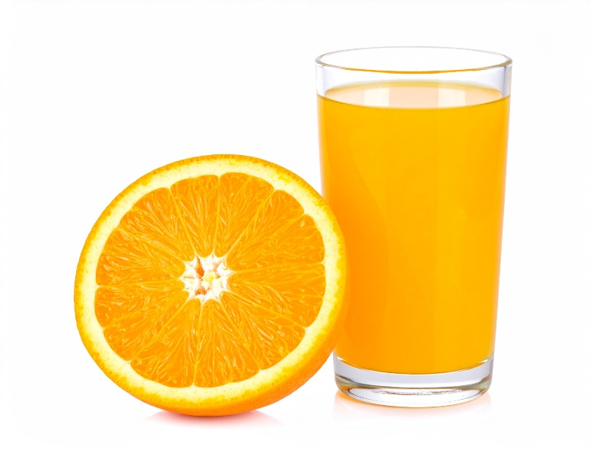
Introduction

Ascorbic acid, the compound we call vitamin C, dissolves in water. It is easy to take into our bodies via a solution of the compound, such as that found in fresh fruit juice. It is a key nutrient required in the body for wound healing and iron absorption. It also acts as an antioxidant to protect cells and helps support the immune system to fight infection. A deficiency in vitamin C can cause scurvy.
© Shutterstock/OkiWorks Studio

In this practical activity, you will work in groups to analyse different samples of fresh fruits and juices, using a simple titration with iodine to determine the amount of vitamin C present.

When ascorbic acid reacts with iodine, dehydroascorbic acid and hydrogen iodide are formed.

ascorbic acid + iodine $→$ dehydroascorbic acid + hydrogen iodide

By adding starch to iodine, we can observe when all the iodine has fully reacted with the ascorbic acid.

Iodine and starch molecules combine to make a blue−black complex. This allows us to determine when all the iodine has reacted with the ascorbic acid, as there will be no blue−black coloured complex left.

This is called the endpoint of the reaction.

Equipment

Apparatus
- Safety glasses
- Droppers or plastic pipettes, one for each juice
- Test tubes, one per test, allowing six per group
- Test tube rack
- 10 cm x 10 cm white card for background
- Juice extractor and beakers for juice if fresh fruit is used

Chemicals
- Fruit juices to test, with packaging if the fruit is not fresh
- Water, about 100 cm³ per group
- A solution of 0.05 mol dm⁻³ iodine in potassium iodide
- Starch solution
- Vitamin C solution

Health and safety

Wear safety glasses throughout.

Method
- Put 1 cm³ of starch solution in a test tube.

- Add 5 cm³ of water and mix by gently shaking the tube.

- Add 1 drop of iodine solution. A blue−black colour will appear.

- Hold a white piece of paper behind the test tube. This will help you see the colour change.

- Add the vitamin C solution drop by drop counting the number of drops added. Shake the mixture after every 5−10 drops.

- Keep adding the vitamin C solution dropwise until the blue−black colour disappears. This will produce a grey−white colour in the tube.

- Record the number of drops added in your results table.

- Keep this tube to check for the same final colour in all the tests.

- Take a clean dry test tube and repeat steps 1, 2 and 3.

- Add the fruit juice drop by drop until the colour is the same as that in the first test tube, counting the drops added. Check the final colour is the same as the initial solution.

- Repeat steps 9 and 10 with at least two different juices.

Results
Fruit juice/vitamin tablet | Number of drops needed to react with all the iodine

100 mg vitamin C tablet in 100 cm³ water

Follow-up questions
- Identify the juice which has the most vitamin C of the ones you tested. Explain how you can tell.

__________________________________________________________________________________________________________________________________________________________________________________________________________________________________________
- Identify the juice which has the most vitamin C in the whole class.

______________________________________________________________________________
- Explain why the juice must be added drop by drop.

__________________________________________________________________________________________________________________________________________________________________________________________________________________________________________
- Describe any sources of error in this investigation.

__________________________________________________________________________________________________________________________________________________________________________________________________________________________________________
- Look at the labels on the juice packaging. Rank the juices from most to least vitamin C per volume.

____________________________________ Most

____________________________________

____________________________________

____________________________________

____________________________________

____________________________________ Least

- Compare the results from your experiment to the information from the juice packaging (Q5).

__________________________________________________________________________________________________________________________________________________________________________________________________________________________________________

- Explain why there might be a difference between your results and those provided by the company on the packaging.

________________________________________________________________________________________________________________________________________________________________________________________________________________________________________________________________________________________________________________________
- Give some factors that may affect the amount of vitamin C in the juices.

____________________________________________________________________________________________________________________________________________________________________________________________________________________________________________________________________________________________________________________________________________________________________________________________________________________________________________________________________________________

Investigating conditions affecting vitamin C levels

Plan an investigation to explore how vitamin C levels are affected by different conditions. Your teacher will give you a choice of research questions to investigate.

Write your research question below:

______________________________________________________________________________________________________________________________________________________________________________________________________________________________________________________

The space provided below is for you to plan your investigation (you will need to continue on a separate sheet). Consider the following:
- Independent, dependent and control variables
- Chemicals
- Equipment
- Method
- Results
- Analysis

______________________________________________________________________________________________________________________________________________________________________________________________________________________________________________________________________________________________________________________________________________________________________________________________________________________________________________________________________________________________________________________________________________________________________________________________________________________________________________________________________________________________________________________________________________________________________________________________________________________________________________________________________________________________________________________________________________________________________________________________________________________________________________________________________________________________________________________________________________________________________________________________________________________________________________________________________________

Extension questions

Use the results table provided below to answer these questions.

Fruit juice/vitamin tablet | Number of drops needed to react with all the iodine
‘Standard’ solution − 100 mg vitamin C tablet in 100 cm³ water | 15
Lemon juice | 30
Lime | 35
Orange juice from one- day open carton | 40
Kiwi | 15
Melon | 20
Mango | 30

- Use the results for the 'standard' solution to work out how much vitamin C is in 1 cm³ of the juices.

________________________________________________________________________________________________________________________________________________________________________________________________________________________________________________________________________________________________________________________________________________________________________________________________________________________________________________________________________________________________________________________________________________________________________________________________________________________________________________________________________________________________________________________________________________________________________________________________________________________________________________________________________________________________________________________________________________________________________________________________________________________
- The NHS suggests that the recommended daily allowance for adults aged 19 to 64 is 40 mg of vitamin C. Determine which juice(s) give the 'recommended daily allowance' in one 100 cm³ glass.

Fruit juice/vitamin tablet | Mass of vitamin C in mg in 1 cm³ | Mass of vitamin C in mg in 100 cm³

Lemon juice

Lime

Orange juice from one-day open carton

Kiwi

Melon

Mango

______________________________________________________________________________________________________________________________________________________________________________________________________________________________________________________
- Suggest which fruits you would recommend sailors take on board ships to protect themselves from scurvy. Explain your answer.

______________________________________________________________________________________________________________________________________________________________________________________________________________________________________________________

- Advise the Navy:
It is 1793. The Royal Navy is busy making sure Britain is not invaded. Every ship is needed with a full crew. Sailors are dying every day from scurvy. The Admirals think that to prevent the disease, they need to keep the ships clean and tidy, keep good morale and feed the sailors a healthy diet.
Write a report advising the Admirals what the diet should include, including evidence. Remember – the Admirals are tough and take a lot of persuading, so any evidence must be good!

__________________________________________________________________________________________________________________________________________________________________________________________________________________________________________________________________________________________________________________________________________________________________________________________________________________________________________________________________________________________________________________________________________________________________________________________________________________________________________________________________________________________________________________________________________________________________________________________________________________________________________________________________________________________

________________________________________________________________________________________________________________________________________________________________________________________________________________________________________________________________________________________________________________________

________________________________________________________________________________________________________________________________________________________________________________________________________________________________________________________________________________________________________________________

__________________________________________________________________________________________________________________________________________________________________________________________________________________________________________

__________________________________________________________________________________________________________________________________________________________________________________________________________________________________________

