Measuring vitamin C in fruit using a microscale titration

Learning objectives
- Safely carry out a simple microscale titration reaction.
- Make inferences from experimental data and compare the amount of vitamin C levels present in different fruits.
- Evaluate the results of the practical in terms of errors.
- Plan an experiment to determine how vitamin C levels are affected by different conditions.

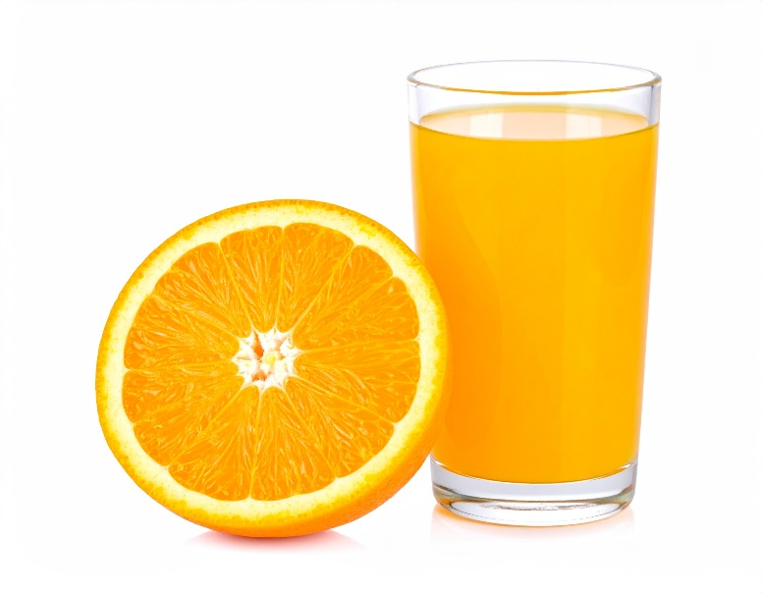
Introduction

Ascorbic acid, the compound we call vitamin C, dissolves in water. It is easy to take into our bodies via a solution of the compound, such as that found in fresh fruit juice. It is a key nutrient required in the body for wound healing and iron absorption. It also acts as an antioxidant to protect cells and helps support the immune system to fight infection. A deficiency in vitamin C can cause scurvy.
© Shutterstock/OkiWorks Studio

In this practical activity, you will work in groups to analyse different samples of fresh fruits and juices, using a simple titration with iodine to determine the amount of vitamin C present.

When ascorbic acid reacts with iodine, dehydroascorbic acid and hydrogen iodide are formed.

ascorbic acid + iodine $→$ dehydroascorbic acid + hydrogen iodide

By adding starch to iodine, we can observe when all the iodine has fully reacted with the ascorbic acid.

Iodine and starch molecules combine to make a blue−black complex. This allows us to determine when all the iodine has reacted with the ascorbic acid, as there will be no blue−black coloured complex left.

This is called the endpoint of the reaction.

Equipment

Apparatus
- Eye protection
- Droppers or plastic pipettes, one for each juice
- Test tubes, one per test, allowing six per group
- Test tube rack
- 10 cm x 10 cm white card for background
- Juice extractor and beakers for juice if fresh fruit is used

Chemicals
- Fruit juices to test, with packaging if the fruit is not fresh
- Water, about 100 cm³ per group
- A solution of 0.05 mol dm⁻³ iodine in potassium iodide
- Starch solution
- Vitamin C solution

Health and safety

Wear safety glasses throughout.

Method
- Put 1 cm³ of starch solution in a test tube.

- Add 5 cm³ of water and mix by gently shaking the tube.

- Add 1 drop of iodine solution. A blue−black colour will appear.

- Hold a white piece of paper behind the test tube. This will help you see the colour change.

- Add the vitamin C solution drop by drop counting the number of drops added. Shake the mixture after every 5−10 drops.

- Keep adding the vitamin C solution dropwise until the blue−black colour disappears. This will produce a grey−white colour in the tube.

- Record the number of drops added in your results table.

- Keep this tube to check for the same final colour in all the tests.

- Take a clean dry test tube and repeat steps 1, 2 and 3.

- Add the fruit juice drop by drop until the colour is the same as that in the first test-tube, counting the drops added. Check the final colour is the same as the initial solution.

- Repeat steps 9 and 10 with at least two different juices.

Results
Fruit juice/vitamin tablet | Number of drops needed to react with all the iodine

100 mg vitamin C tablet in 100 cm³ water

Follow-up questions
- Identify the juice which has the most vitamin C of the ones you tested.
Hint: This will be the juice that reacted completely with the iodine solution by adding the lowest amount.

__________________________________________________________________________________
- Identify the juice which has the most vitamin C in the whole class.

__________________________________________________________________________________
- Explain why the juice must be added drop by drop rather than a few drops at a time.

______________________________________________________________________________________________________________________________________________________________________________________________________________________________________________________
- Describe any sources of error in this investigation, i.e. things that may not be controlled each time you do the experiment.

______________________________________________________________________________________________________________________________________________________________________________________________________________________________________________________
- Look at the labels on the juice packaging. Rank the juices from most to least vitamin C per volume.

____________________________________ Most

____________________________________

____________________________________

____________________________________

____________________________________

____________________________________ Least

- Compare the results from your experiment to the information from the juice packaging (Q5). Consider both similarities and differences.

__________________________________________________________________________________________________________________________________________________________________________________________________________________________________________

- Why might there be a difference between your results and those provided by the company on the packaging? Select one answer.

The company tested more than one type of fruit juice

The company’s tests are more accurate

Your test is more accurate

The company used the same test as you

- What factors might affect the amount of vitamin C in the juices? Select one or more answers.

Temperature

Type of fruit juice

Colour

Oxygen exposure

Smell

Investigating conditions affecting vitamin C levels

Plan an investigation to explore how vitamin C levels are affected by different conditions. Your teacher will give you a choice of research questions to investigate.

Write your research question below:

______________________________________________________________________________________________________________________________________________________________________________________________________________________________________________________

The space provided below is for you to plan your investigation. You need to consider the following:
- Independent, dependent and control variables
- Chemicals
- Equipment
- Method
- Results
- Analysis

Independent variable (what you are changing) __________________________________

Dependent variable (what you are measuring) ____________________________________

Control variables (what you are keeping the same to make it a fair test)

____________________________________________________________________________________________________________________________________________________________________Chemicals Equipment

Method (step by step instructions)

____________________________________________________________________________________________________________________________________________________________________________________________________________________________________________________________________________________________________________________________________________________________________________________________________________________________________________________________________________________________________________________________________________________________________________________________________________________________________________________________________________________________________________________________________________________________________________________________________________________________________________________

Results table

Analysis (what the results tell you)

__________________________________________________________________________________________________________________________________________________________________________________________________________________________________________________________________________________________________________________________________________________________________________________________________________________________________________________________________________________________________________________________________________________________________________________________________________________________________________________________________________________________________________________________________________________________________

