Calculating and comparing solution concentrations

This resource is from the Assessment for learning series which can be viewed at: rsc.li/44jTX18. This series offers lesson plans and associated resources to actively involve students in their learning.

Resource components
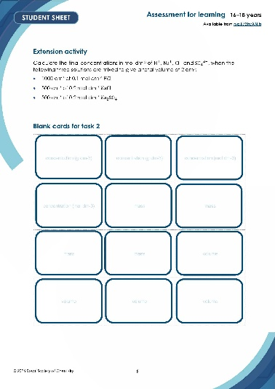  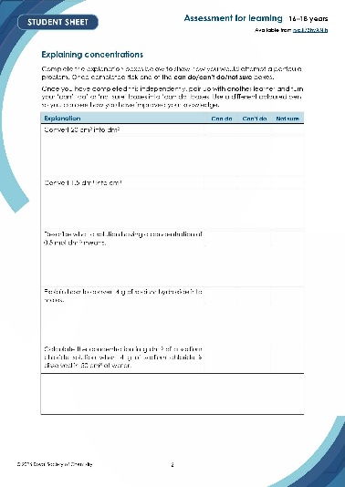 | 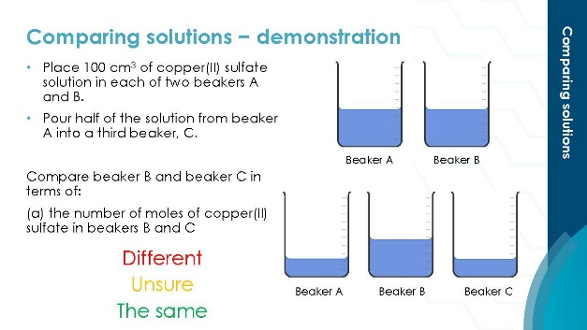
Student sheet: worksheets including independent, pair and group tasks. Also includes the blank concentration cards for learners to write in task 2. | Presentation: lesson slides including learning objectives, instructions for each task and worked answers for self-assessment.

Learning objectives
- Recall how to convert between volumes in cm³ and dm³.
- Define the word ‘concentration’ from a given numerical value.
- Calculate the concentration of a solution in both g dm⁻³ and mol dm⁻³.
- Convert the concentration of a solution from g dm⁻³ to mol dm⁻³ and vice versa.

Introduction

In chemistry, concentration describes how much of a substance (the solute) is present in a given volume of solution. Concentration is most commonly expressed in two ways: grams per cubic decimetre (g dm⁻³) and moles per cubic decimetre (mol dm⁻³).

Both units relate the amount of solute to the volume of solution, and being confident in using each is essential for quantitative chemistry, including titrations and stoichiometric calculations.

In this activity, learners begin by comparing the concentrations of several solutions and reflecting on their current level of understanding. They then work in pairs using cards to link a mass of solute, volume of water and concentration of a solution, exploring the process of calculating concentration.

The lesson plan includes an extension activity, giving learners additional practise calculating the concentration of solutions.

Equipment

Read our standard health and safety guidance (rsc.li/3zyJLkx) and carry out a risk assessment before running any live practical.

Demonstration
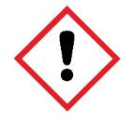
- Beakers, 250 cm³ x 3
- Copper(II) sulfate solution, 0.1 mol dm⁻³, 200 cm³

WARNING: irritant (skin, eyes)
- Water, 50 cm³
- Safety glasses

Other equipment
- A set of traffic light cards for each learner (optional)
- Scissors, to cut out the concentration cards in task 2

Teaching sequence

Demonstration
- Issue ‘traffic light’ cards to all learners. You could also use thumbs up/down or another appropriate hand signal to indicate responses.
- Explain that they are going to:
- compare the concentration and number of moles of solute in solutions
- use the ‘traffic light’ cards to indicate their view: green for ‘the same’, red for ‘different’ and yellow for ‘unsure’.
- Wear safety glasses. Pour 100 cm³ of copper(II) sulfate solution into each of two beakers A and B. Pour half of the solution from beaker A into a third beaker, C.
- Ask the learners to give their view on the following comparisons:
- The number of moles of copper(II) sulfate in beakers B and C.
- The concentration of copper(II) sulfate in beakers B and C.
- After adding water to beaker C to make the total volume 100 cm³ again, ask learners for a second time to give their view on:
- the number of moles of copper(II) sulfate in beakers B and C
- the concentration of copper(II) sulfate in beakers B and C
- Use their indications as an aid to share the learning objective.

Explaining concentrations

Ask learners to work through the first section of the student sheet which assesses the key knowledge needed to calculate and compare concentrations.

Organise learners to:
- Work individually to complete the explanations and the ‘can do’/‘can’t do’/‘not sure’ boxes.
- Join with another student.
- Compare responses and convert any ‘can’t do’ or ‘not sure’ responses to ‘can do’.
- Join with another pair of learners if there are still any ‘can’t do’ or ‘not sure’ responses.

Card matching

Task 1
- Move learners back into pairs.
- Give a set of the concentration cards shown below to each pair. Ask them to match the correct mass and volume to each concentration.
- Circulate and support with prompts while pairs of learners:
- group cards together showing the mass of sodium hydroxide and volume of water needed to produce the concentration shown on one of the cards
- record their answers on the student sheet
- explain the general approach to calculating concentrations

Task 2

When pairs have recorded and shown the correct answers, give them a set of blank concentration cards and a solute chosen from:
- sodium carbonate
- sulfuric acid
- potassium hydroxide
- calcium bromide
- copper(II) sulfate

Task 3

Circulate and support with prompts while pairs:
- Devise their own set of concentration cards using the solute given to them so that all cards are used up when the mass of solute, volume of water and concentration of solute or ions in solution are matched up.
- Join up with another pair.
- Exchange the cards they have devised.
- Match up and record the cards devised by the other pair on the student sheet.
- Help each other to select appropriate cards where this is necessary.

Extension activity

As an extension, set the following problem and work through the solution in a plenary.

Calculate the final concentrations in mol dm⁻³ of $H^{+}$, ${Na}^{+}$, ${Cl}^{-}$ and ${SO_{4}}^{2-}$, when the

following three solutions are mixed to give a total volume of 2 dm³:
- 1000 cm³ of 0.1 mol dm⁻³ $HCl$
- 500 cm³ of 0.2 mol dm⁻³ $NaCl$
- 500 cm³ of 0.2 mol dm⁻³ ${Na}_{2}SO_{4}$

Scaffolding

As learners are paired up for this task, change the level of scaffolding by choosing the pairs appropriately and supporting learners while circulating.

If learners struggle to get started with the creation of their own set of cards, provide them with four concentrations and allow them to work more independently from that point, or to make it even more simple, give learners four masses.

For copper(II) sulfate for example, give learners the following concentrations:

Concentration | Mass of $CuSO_{4}$ | Volume of water
16 g dm⁻³ $CuSO_{4}$
0.2 mol dm⁻³ $CuSO_{4}$
0.5 mol dm⁻³ $CuSO_{4}$
0.05 mol dm⁻³ ${Cu}^{2+}$ ions

Some learners may also benefit from having an additional column on their table to calculate the moles of each substance, especially when making the cards. A template is provided below.

Concentration | Mass of _______ | Moles of _______ | Volume of water

Concentration cards
2 g $NaOH$ | 4 g $NaOH$ | 10 g $$NaOH$$
40 g $NaOH$ | 100 cm³  water | 0.5 dm³  water
250 cm³  water | 2 dm³  water | 4 g dm⁻³ $$NaOH$$
0.4 mol dm⁻³ $NaOH$ | 0.5 mol dm⁻³ $NaOH$ | 2.5 mol dm⁻³ ${Na}^{+}$ ions

Answers

Explaining concentration
Explanation | Can do | Can’t do | Not sure
Convert 20 cm³ into dm³
To convert from cm³ to dm³ you must divide by 1000.
Therefore $\frac{20}{1000}=0.02 {dm}^{3}$
Convert 1.5 dm³ into cm³
To convert from dm³ to cm³ you must multiply by 1000.
Therefore $1.5×1000=1500 {cm}^{3}$
Describe what a solution having a concentration of 0.5 mol dm⁻³ means.
A solution of 0.5 mol dm⁻³ means that there is 0.5 mol of a solute dissolved in every 1 dm³ (one litre) of the total solution.

Explain how to convert 4 g of sodium hydroxide into moles.
First, you must calculate the molar mass of NaOH.
$23 + 16 + 1 = 40$
Then substitute this into the equation below
$$moles \left(mol\right)= \frac{mass (g)}{molar mass (g {mol}^{-1})}$$
$$moles \left(mol\right)= \frac{4}{40}=0.1 mol$$

Calculate the concentration in g dm⁻³ of a sodium chloride solution when 4 g of sodium chloride is dissolved in 50 cm³ of water.
The first step is to convert from cm³ to dm³ by dividing by 1000.
$$\frac{50}{1000}=0.05 {dm}^{3}$$
Then you can substitute the numbers into the below equation:
$$concentration \left(g {dm}^{-3}\right)= \frac{mass (g)}{volume ({dm}^{3})}$$
$$concentration \left(g {dm}^{-3}\right)= \frac{4}{0.05}=80 g {dm}^{-3}$$

Card matching
Concentration | Mass of $NaOH$ | Volume of water
4 g dm⁻³ NaOH | 2 g | 0.5 dm³
0.4 mol dm⁻³ NaOH | 4 g | 250 cm³
0.5 mol dm⁻³ NaOH | 40 g | 2.0 dm³
2.5 mol dm⁻³ Na⁺ ions | 10 g | 100 cm³

Answers to task 2 and 3 will be dependent on learner’s own

Extension activity

Total volume = 2 dm³ (i.e. 2000 cm³)

Assume all species are strong electrolytes and are fully dissociated in aqueous solution.

Calculate the moles from each solution

1000 cm³ of 0.1 mol dm⁻³ $HCl$
To convert from cm³ to dm³ you must divide by 1000.

$$\frac{1000}{1000}=1 {dm}^{3}$$
$$concentration \left(mol {dm}^{-3}\right)= \frac{moles (mol)}{volume ({dm}^{3})}$$
$$0.1= \frac{moles (mol)}{1 ({dm}^{3})}$$
$$moles=0.1 ×1=0.1 mol$$
So, $H^{+}$ = 0.1 mol and ${Cl}^{-}$ = 0.1 mol

500 cm³ of 0.2 mol dm⁻³ $NaCl$
To convert from cm³ to dm³ you must divide by 1000.

$$\frac{500}{1000}=0.5 {dm}^{3}$$
$$concentration \left(mol {dm}^{-3}\right)= \frac{moles (mol)}{volume ({dm}^{3})}$$
$$0.2= \frac{moles (mol)}{0.5 ({dm}^{3})}$$
$$moles=0.2 ×0.5=0.1 mol$$
So, ${Na}^{+}$ = 0.1 mol and ${Cl}^{-}$ = 0.1 mol

500 cm³ of 0.2 mol dm⁻³ ${Na}_{2}SO_{4}$
To convert from cm³ to dm³ you must divide by 1000.

$$\frac{500}{1000}=0.5 {dm}^{3}$$
$$concentration \left(mol {dm}^{-3}\right)= \frac{moles (mol)}{volume ({dm}^{3})}$$
$$0.2= \frac{moles (mol)}{0.5 ({dm}^{3})}$$
$$moles=0.2 ×0.5=0.1 mol$$
So, ${Na}^{+}$ = 2 x 0.1 = 0.2 mol and $S{O_{4}}^{2-}$ = 0.1 mol

Total moles of each ion
- Moles of $H^{+}$ = 0.1 mol
- Moles of ${Cl}^{-}$ = 0.1 + 0.2 = 0.3 mol
- Moles of ${Na}^{+}$ = 0.1 + 0.1 = 0.2 mol
- Moles of $S{O_{4}}^{2-}$ = 0.1 mol

Concentration of ions in the final volume of 2 dm³
$$concentration \left(mol {dm}^{-3}\right)= \frac{moles (mol)}{volume ({dm}^{3})}$$

Ion | Final concentration (mol dm⁻³)
H⁺ | $$\frac{0.10}{2.0}=0.050$$
Na⁺ | $$\frac{0.30}{2.0}=0.150$$
Cl⁻ | $$\frac{0.20}{2.0}=0.100$$
SO₄²⁻ | $$\frac{0.10}{2.0}=0.050$$

