Representing elements and compounds
- (a) Some elements exist as molecules. Write the chemical formula for each of the following:
- a molecule of chlorine

________________________________________________________________ (1 mark)
- a molecule of nitrogen

________________________________________________________________ (1 mark)
- a molecule of oxygen

________________________________________________________________ (1 mark)

(b) This is a molecule of sulfur. The spheres are sulfur atoms.

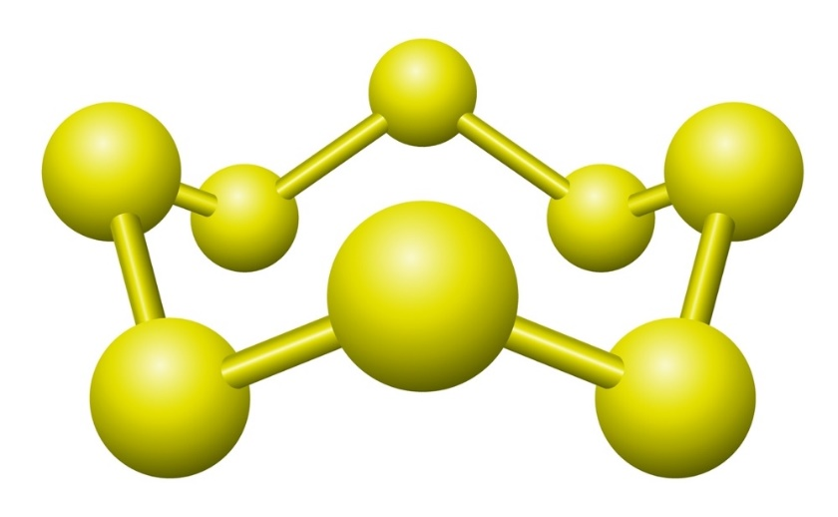

Source: © Shutterstock

What is the chemical formula for this molecule of sulfur?

__________________________________________________________________________ (1 mark)

- This question is about the formulas of molecular compounds.
  - The image shows a ball and stick model.

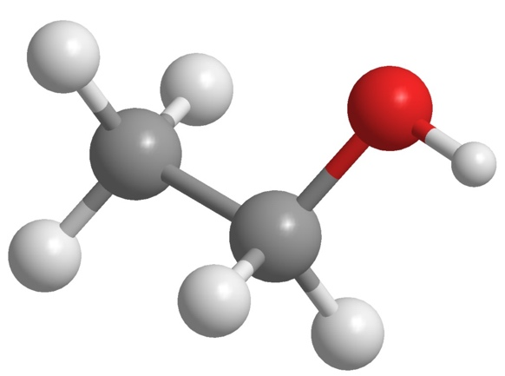

The spheres are colour coded: grey represents carbon, light grey represents hydrogen and black represents oxygen.

What is the chemical formula of the molecule shown in the image?

_______________________________________________________________________ (1 mark)
  - The table shows the chemical formulas of some carbon molecular compounds.

Complete the table with the names and numbers of atoms in each compound. The first row has been completed for you.
Chemical formula of compound | Name of atoms in the compound | Number of each type of atom in the compound
$$C_{2}H_{6}$$ | carbon, hydrogen | 2 carbon atoms  6 hydrogen atoms
$$CO_{2}$$
$$CH_{3}COOH$$

(4 marks)

- This question is about the chemical formulas of ionic compounds.
  - The formula of sodium chloride is $NaCl$. What type of formula is $NaCl$?

Circle the correct answer. (1 mark)
- empirical formula
- molecular formula
- relative formula
- structural formula
  - Sodium is in group 1 and forms the ion ${Na}^{+}$. Chlorine is in group 7 and forms the ion ${Cl}^{-}$. The formula of sodium chloride is $NaCl$.

Deduce the chemical formulas of each of the following compounds containing group 1 and group 7 elements.
- potassium bromide

_____________________________________________________________________ (1 mark)
- lithium fluoride

_____________________________________________________________________ (1 mark)
- sodium iodide

_____________________________________________________________________ (1 mark)
  - The table gives information about the ions formed by different elements and the group they are in. Use this information to answer the question.
Element | Group | Ion formed
magnesium | 2 | $${Mg}^{2+}$$
calcium | 2 | $${Ca}^{2+}$$
oxygen | 6 | oxide, $O^{2-}$
sulfur | 6 | sulfide, $S^{2-}$

Deduce the chemical formula of each of the following compounds formed from these elements.
- magnesium oxide

_____________________________________________________________________ (1 mark)
- calcium sulfide

_____________________________________________________________________ (1 mark)
- magnesium chloride

_____________________________________________________________________ (1 mark)
- calcium fluoride

_____________________________________________________________________ (1 mark)
- This question is also about the formulas of ionic compounds.

Use the formulas for the positive and negative ions provided to deduce the chemical formula of each of the ionic compounds listed.

Formulas of positive ions | Formulas of negative ions
$${Na}^{+}$$ | $$N{O_{3}}^{-}$$
$${Li}^{+}$$ | $${CO_{3}}^{2-}$$
$${Ca}^{2+}$$ | $${SO_{4}}^{2-}$$
  - sodium nitrate

_____________________________________________________________________ (1 mark)
  - lithium sulfate

_____________________________________________________________________ (1 mark)
  - calcium carbonate

_____________________________________________________________________ (1 mark)

- State symbols are used in chemical equations to tell us whether a substance is a solid, liquid, gas or whether it has been dissolved in water. Which equation shows a substance dissolving in water and reacting to form a gas?

Circle the correct answer. (1 mark)
- $2Na(s) + 2H_{2}O(l) ⟶ 2NaOH(aq) + H_{2}(g)$
- ${Fe}_{2}O_{3}(s) + 3CO(g) ⟶ 2Fe(s) + 3CO_{2}(g)$
- $CuCO_{3}(s) + 2HCl(aq) ⟶ Cu{Cl}_{2}(aq) + H_{2}O(l) + CO_{2}(g)$
- $2NaOH(aq) + H_{2}SO_{4}(aq) ⟶ {Na}_{2}SO_{4}(aq) + H_{2}O(l)$

[Total: 21 marks]


Which question(s) did you get wrong? Why?

What will you do next time you’re asked a similar question?

