Representing elements and compounds

Scientists have analysed samples of lunar dust brought back from the moon.
They discovered the six most common elements found in compounds in lunar dust. The graph shows the percentage composition by mass of these elements.
- Silicon occurs in lunar dust as silicon dioxide. The formula for silicon dioxide is $SiO_{2}$.
  - What type of structure does silicon dioxide have? Circle the correct answer.

giant ionic giant covalent simple molecular metallic

  - Calculate the relative formula mass of silicon dioxide.
A_{r} silicon $=$ 28; A_{r} oxygen = 16

Relative formula mass $= _________ + (2 × _________)$
$$= __________________$$
  - Calculate the percentage by mass of silicon in silicon dioxide.

Percentage by mass of silicon in silicon dioxide $= \frac{ }{ } × 100$
$= _________ \%$
- For a long time, scientists thought the moon had no atmosphere. They now know that the moon has a very thin atmosphere consisting of noble gases, ammonia, methane and carbon dioxide.

Methane is a molecule. Here are three ways of representing a molecule of methane.
$$CH_{4}$$ | 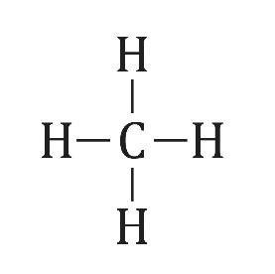 | 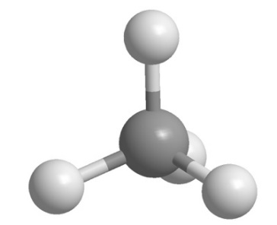
A | B | C

Which representations show:
  - the types of atom in a molecule of methane?

  - the number of each type of atom in a molecule of methane?

  - the order in which the atoms are bonded together in a molecule of methane?

  - how the atoms are arranged in three dimensions in a molecule of methane?

- When humans live on the moon, they will need a plentiful supply of oxygen. Oxygen is the most abundant element in lunar dust, but it is combined in compounds such as iron(II) oxide, FeO, and aluminium oxide.

One suggestion is that iron(II) oxide could be reduced to give a supply of oxygen.
  - Calculate the relative formula mass for iron(II) oxide, FeO.
A_{r} iron $=$ 56; A_{r} oxygen $=$ 16

  - 144g of iron(II) oxide produces 32g of oxygen.

Calculate the mass of oxygen produced from 200 g iron(II) oxide.

- Lunar rocks may provide a valuable source of metals for human life on the moon. Titanium is present in the compound titanium oxide, $TiO_{2}$.

(a) Titanium is extracted in two steps. The reactions take place at 1000 °C.
Step 1: $TiO_{2}$ is converted to $Ti{Cl}_{4}$.
Step 2: Liquid $Ti{Cl}_{4}$ is heated with molten magnesium to produce solid titanium and liquid magnesium chloride, $Mg{Cl}_{2}$.
Add state symbols to the equation representing the reaction in step 2.
Two have been done for you.
$Ti{Cl}_{4}$(I) + $2Mg$(I) $⟶$ Ti (____) + $2Mg{Cl}_{2}$(____)

(b) Calculate the relative formula mass of $Ti{Cl}_{4}$.
A_{r} titanium $=$ 48; A_{r} chlorine $=$ 35.5

