What is stuff made of? Exploring matter, atoms and elements

Learning objectives
- Recall that matter is made from atoms
- Compare the size of atoms with small objects that we can see and other objects which are too small to see with the naked eye
- Describe that atoms are the smallest parts of an element and that they retain the properties of that element using observations from a demonstration
- Make deductions about the nature of atoms from a series of observations

Introduction
Look around you. Everything you can see, touch or hold, from the air you breathe to the phone in your hand, is made of matter. Matter is the name scientists give to anything that has mass and takes up space. Matter is made of tiny building blocks called atoms that make up everything in the universe.
Atoms are incredibly small. So small that you cannot see them with the naked eye. However, they combine in different ways to create all the materials around us.

It’s a small world task
- Find out how small an atom is. Draw a line about 1 cm long in the box below. Guess the number of hydrogen atoms that could be placed side by side along it.

I think the number of hydrogen atoms is _______________

The actual number of hydrogen atoms is _______________

- When your teacher has revealed the answer, complete the following questions.

- Compare your estimate with the actual number of hydrogen atoms. State whether it is larger or smaller.

__________________________________________________________________________________

__________________________________________________________________________________
- Explain what this tells you about atoms.

__________________________________________________________________________________

__________________________________________________________________________________

- Here is a list of some small objects.
- Write the objects in the table in order of size, from largest to smallest.
- Ribosome | - Grain of sand
- Red ant | - Grain of table salt
- Skin cell | - Water molecule
- Atom | - Human hair (diameter)
- Red blood cell | - Dust mite
- Pin head | - DNA (width of double helix)
- Pollen grain | - Mitochondrion
- Human egg cell | - Virus
- Bacterium | - Poppy seed
- Next to each object, write yes, no, or barely visible to state whether or not you can see the object with the naked eye.
Small object | Can it be seen with the naked eye? | Size
Your teacher will now show you a table giving the correct answers for task 3. Use the table to help you to answer the following questions.
- Name the smallest thing your eyes can see. State the size of this.

__________________________________________________________________________________

__________________________________________________________________________________

__________________________________________________________________________________
- Explain why our eyes cannot see some of the other small objects listed in the table.

__________________________________________________________________________________

__________________________________________________________________________________
- Describe what all these small objects are made from.

__________________________________________________________________________________

__________________________________________________________________________________
- Explain what this tells you about the sizes of atoms.

__________________________________________________________________________________

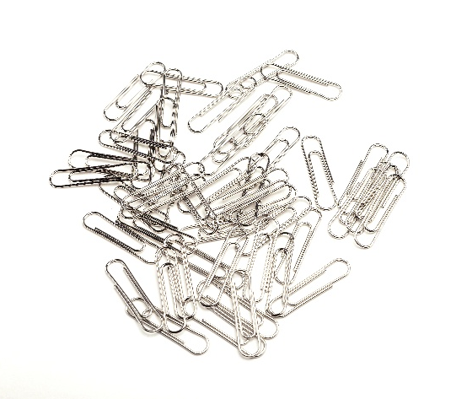
__________________________________________________________________________________

Atomic paperclips

Watch the demonstration and use your observations and your own knowledge to answer the following questions.
© Shutterstock/Early Spring

- Name the smallest 'particle' you could take from the paper clip pile.

______________________________________________

______________________________________________
- Explain whether or not one paper clip would still function as a paper clip.

__________________________________________________________________________________

__________________________________________________________________________________
- Make up names for the two parts of the broken paper clip. Name the parts of an atom.

__________________________________________________________________________________

__________________________________________________________________________________

__________________________________________________________________________________

__________________________________________________________________________________

- Explain whether or not the broken paper clip is useable. Use your answer to explain whether or not a broken-up atom is useable.

__________________________________________________________________________________

__________________________________________________________________________________

__________________________________________________________________________________
- Name the smallest particle in the metal.

__________________________________________________________________________________
- Explain why the metal sheet cannot be torn into the smallest possible particles.

__________________________________________________________________________________

__________________________________________________________________________________

__________________________________________________________________________________
- Will the smallest particle in the metal still be made of the metal? Explain your answer.

__________________________________________________________________________________

__________________________________________________________________________________

__________________________________________________________________________________
- Describe how we could see the smallest particle in a piece of metal.

__________________________________________________________________________________

__________________________________________________________________________________

__________________________________________________________________________________
- Explain whether the smallest particles in metal can be broken apart.

__________________________________________________________________________________

__________________________________________________________________________________

__________________________________________________________________________________
- Explain whether the broken pieces of metal particles would still be metal.

__________________________________________________________________________________

__________________________________________________________________________________

__________________________________________________________________________________

Tasty particles practical activity

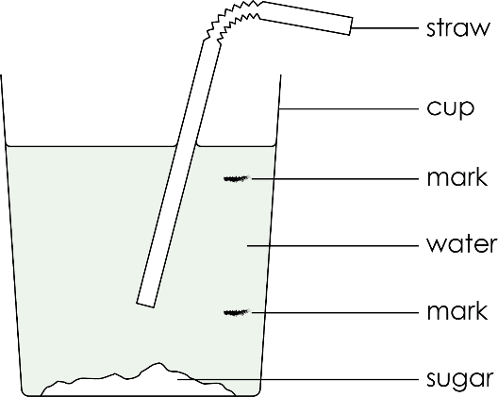
Apparatus

Each group needs:
- One glass or plastic drinking cup
- Drinking straws
- Tap water
- About 20 drops lemon juice – enough to taste in water
- One teaspoon of sugar
- One dropping pipette
- Eye protection

Method
- Taste the water | - Fill the cup with water to 1 cm from the top.  - Use the straw to taste the water in the three sections of the cup  – above the top mark, between the two marks and below the bottom mark.  - Write down what it tastes like at each level.  - Refill the cup.
- Add lemon juice | - Add about 10 drops of lemon juice to the water.  - Taste the water again at the three levels.  - Write down what it tastes like at each level.  - Keep the water for the next step.
- Add sugar | - Add one teaspoon of sugar to the water.  - Don’t stir. Let the sugar settle.  - Taste the water again at the three levels.  - Write down what it tastes like at each level.  - Keep for the next step.
- Wait and taste again | - Wait for 2 minutes.  - After waiting, taste the water at the three levels.  - Write down what it tastes like at each level.  - If you can, wait even longer and taste again.

Results

Use the following table to record your observations during the practical.
Level | Water alone | Water and lemon juice | Water, lemon juice and sugar | Water, lemon juice and sugar after waiting
Top
Middle
Bottom

Follow-up questions
- Use the test results to explain whether water, lemon juice and sugar particles are all the same.

__________________________________________________________________________________

__________________________________________________________________________________

__________________________________________________________________________________
- Describe how particles can behave, using the results from your investigation.

__________________________________________________________________________________

__________________________________________________________________________________

__________________________________________________________________________________
- Summarise what you have learned about particles (and atoms) in this lesson.

__________________________________________________________________________________

__________________________________________________________________________________

__________________________________________________________________________________

__________________________________________________________________________________

__________________________________________________________________________________

__________________________________________________________________________________

