Solubility

Some students are preparing the soluble salt sodium chloride using hydrochloric acid and sodium hydroxide solution. The image shows some of the apparatus they use.

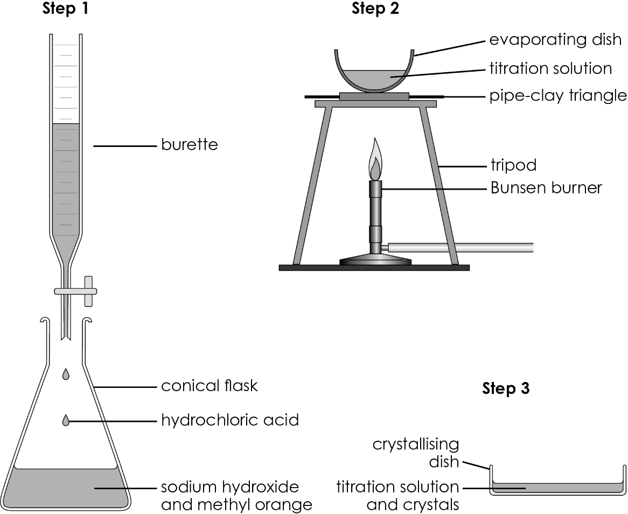
- (a) What is the method in Step 1 called?

  - The students’ first step is to accurately measure 25 cm³ sodium hydroxide solution into the conical flask. Circle the most accurate piece of equipment to use to measure this volume.
- beaker
- conical flask
- measuring cylinder
- volumetric pipette
  - The concentration of the sodium hydroxide solution is 4.00 g/dm³. Calculate the mass of sodium hydroxide dissolved in 25 cm³ of the solution.
Hint: $concentration = \frac{mass}{volume}$

  - What is the role of methyl orange?

  - Methyl orange is red in acidic solution and yellow in alkaline solution. What colour is methyl orange in sodium hydroxide solution?

- The students add the dilute hydrochloric acid, 1 cm³ at a time, to the conical flask until the methyl orange starts to turn orange. They then continue to add the acid drop by drop until the orange colour just persists.
  - What is contained in the flask when the orange colour just persists?
Circle the correct answer.
- sodium hydroxide solution and sodium chloride solution
- methyl orange and sodium chloride solution
- dilute hydrochloric acid, sodium hydroxide solution and methyl orange
- dilute hydrochloric acid, sodium chloride solution and methyl orange

  - The image shows the initial and final burette readings observed by the students.

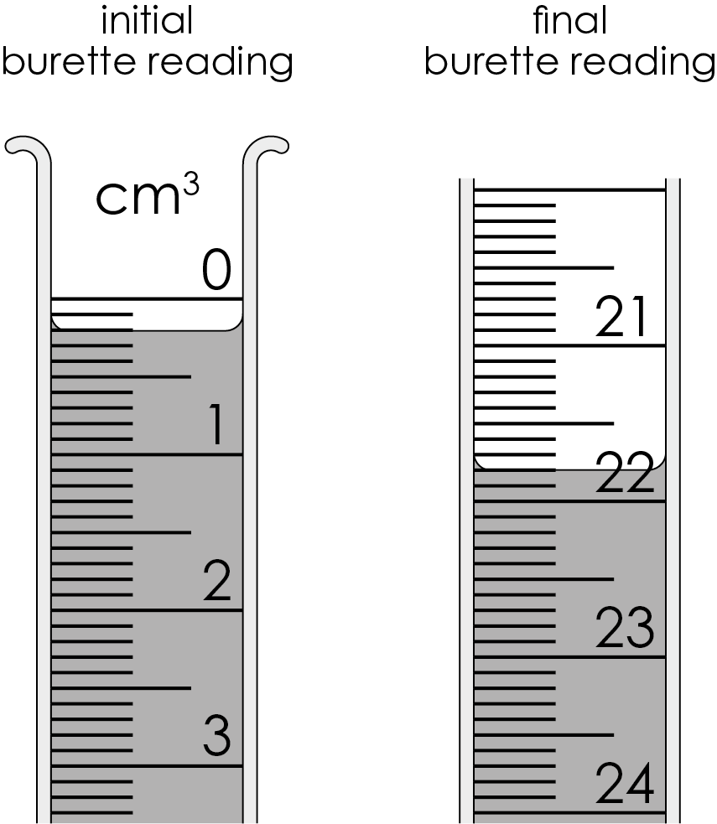
- What was the initial burette reading?

- What was the final burette reading?

- What volume of acid was used?

- (a) The students then repeated the process, adding the same volume of acid to 25 cm³ sodium hydroxide solution, but omitting the methyl orange.

Describe how the students use the resulting solution to prepare crystals of sodium chloride.
Hint: look back at Step 2 in the apparatus at the start of the sheet.

  - Which best explains why the students omitted the methyl orange?
Circle the correct answer.
  - Methyl orange would contaminate the sodium chloride.
  - Methyl orange is insoluble.
  - Methyl orange is soluble.
  - This was an error and methyl orange was added later.
  - The students weighed their sodium chloride crystals.

Mass of sodium chloride crystals $=$ 0.07 g

Their teacher tells them the maximum mass of sodium chloride crystals they could make is 0.15 g.

Calculate the percentage yield to three significant figures.

Hint: $percentage yield= \frac{mass of product actually made}{maximum theoretical mass of product} ×100$

Percentage yield $=$ _____________ × 100

$=$ _______________%

  - The reaction between sodium hydroxide and hydrochloric acid used to prepare sodium chloride can be represented by the chemical equation:

$NaOH(aq)$ + $HCl(aq)$ ⟶ $NaCl(aq)$ + $H_{2}O(l)$

Calculate the percentage atom economy to produce sodium chloride.

Give your answer to three significant figures.

A_{r} sodium 23 A_{r} chlorine 35.5 A_{r} oxygen 16 A_{r} hydrogen 1

Hint: $percentage atom economy= \frac{total M_{r} of the desired product}{total M_{r} of all reactants} ×100$

M_{r} $NaCl$ _________ $+$__________$=$_________ (the total M_{r} of the desired product)

M_{r} $NaOH$_________ $+$__________$+$__________$=$_________

M_{r} $HCl$__________$+$__________$=$_________

M_{r} $NaOH$ + M_{r} $HCl$_________$+$__________$=$_________ (the total M_{r} of all reactants)

percentage atom economy $=$ $×$100

percentage atom economy $=$_______%


Which question(s) did you get wrong? Why?

What will you do next time you’re asked a similar question?

