Solubility

Some students are preparing the soluble salt sodium chloride through titration using hydrochloric acid and sodium hydroxide solution. The image shows some of the apparatus they use.

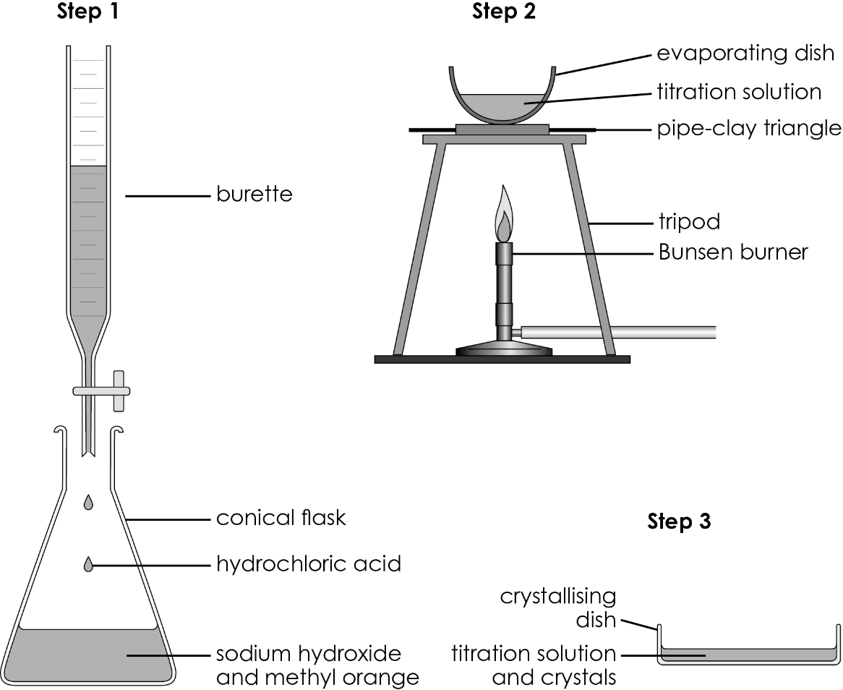
- (a) Explain why the students added methyl orange to the conical flask.

(b) Describe the procedure used in Step 1 to produce a neutral solution.

(c) Describe an alternative method the students could have used to detect the end point.

(d) These are the initial and final burette readings from the students’ titration.

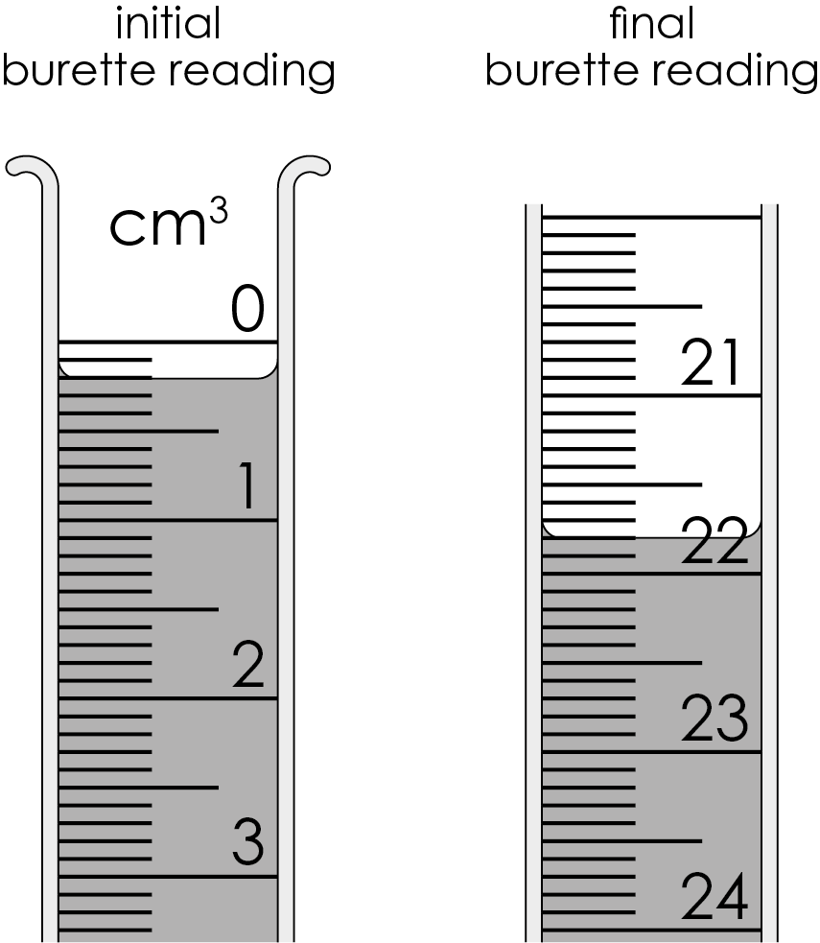

Calculate the volume of acid used to neutralise the sodium hydroxide solution.

- (a) Explain why students repeated the procedure in Step 1 using the same volumes of reactants, but without methyl orange.

(b) Describe how sodium chloride crystals are obtained from the neutral solution from Step 1.

- (a) Complete the equation representing the reaction.

$NaOH(aq)$ + $HCl(aq)$ ⟶ _______________ + _______________

(b) The concentration of the sodium hydroxide solution is 0.10 mol/dm³. Calculate the number of moles of sodium hydroxide in 25 cm³ of solution.

(c) Calculate the maximum number of moles of sodium chloride that can be produced using 25 cm³ of 0.10 mol/dm³ sodium hydroxide. Use the equation in question 3(a), and your answer to question 3(b).

(d) Calculate the maximum mass in grams of sodium chloride that can be produced. Give your answer to three significant figures.

A_{r} sodium 23 A_{r} chlorine 35.5

(e) i. The students measured the mass of their dry sodium chloride product as 0.070 g. Use this value, and your answer to question 3(d), to calculate the percentage yield of the reaction.

Give your answer to three significant figures.

ii. Explain why the percentage yield is less than 100%.

(f) Calculate the percentage atom economy of the reaction to produce sodium chloride.

A_{r} sodium 23 A_{r} chlorine 35.5 A_{r} oxygen 16 A_{r} hydrogen 1

- The students suggest they can use the same method to prepare iron(II) chloride (FeCl₂). The chemical equation representing their suggested reaction is:

$Fe(OH)_{2}(s)$ + $2HCl(aq)$ ⟶ $FeCl_{2}(aq)$+ $2H_{2}O(l)$
  - Explain why titration cannot be used to prepare crystals of iron(II) chloride.

  - Suggest a suitable alternative method the students could use to prepare crystals of iron(II) chloride.


Which question(s) did you get wrong? Why?

What will you do next time you’re asked a similar question?

