Solubility

The table summarises whether common ionic compounds are soluble or insoluble in water. You will need to refer to this information to answer questions 1(b), 2(d) and 3(d).

Soluble | Insoluble
all common sodium, potassium and ammonium salts
all nitrates
most common chlorides | silver chloride, lead chloride
most common sulfates | lead sulfate, barium sulfate, calcium sulfate
sodium carbonate, potassium carbonate, ammonium carbonate | most common carbonates
sodium hydroxide, potassium hydroxide, ammonium hydroxide | most common hydroxides
- (a) Complete the table to show the names of the salts produced from the reactants.
Acid | Alkali or base | Name of salt produced
hydrochloric acid | potassium hydroxide
sulfuric acid | magnesium hydroxide
nitric acid | copper(II) oxide
ethanoic acid | calcium carbonate

(4 marks)

(b) Which statement is true? Circle the correct answer. (1 mark)
- all ammonium salts are insoluble
- all group 1 chlorides are insoluble
- all group 1 salts are soluble
- all nitrates are insoluble
- This question is about preparing a soluble salt from an acid and an insoluble reactant. The image shows the first two stages in the method used to prepare copper sulfate crystals from dilute sulfuric acid and copper(II) oxide:
A | 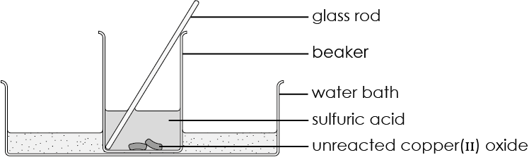
B | 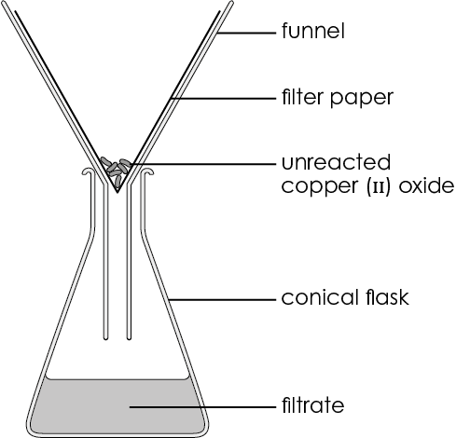
  - Write a balanced symbol equation, including state symbols, to represent the reaction.

__________________________________________________________________________ (2 marks)
  - The limiting reactant is the one that determines the amount of copper (II) sulfate produced. Name the limiting reactant in this reaction.

__________________________________________________________________________ (1 mark)
  - Give one reason why the reaction mixture is filtered.

__________________________________________________________________________ (1 mark)
  - Identify the pair of reactants that can be used to prepare salts using this method. Circle the correct answer. (1 mark)
- ammonium hydroxide and dilute sulfuric acid
- copper(II) carbonate and dilute nitric acid
- lead(II) oxide and dilute hydrochloric acid
- potassium hydroxide and dilute nitric acid
- As shown in the image, some metal ions are identified by the colour of the insoluble hydroxides formed when sodium hydroxide solution is added.

A B C

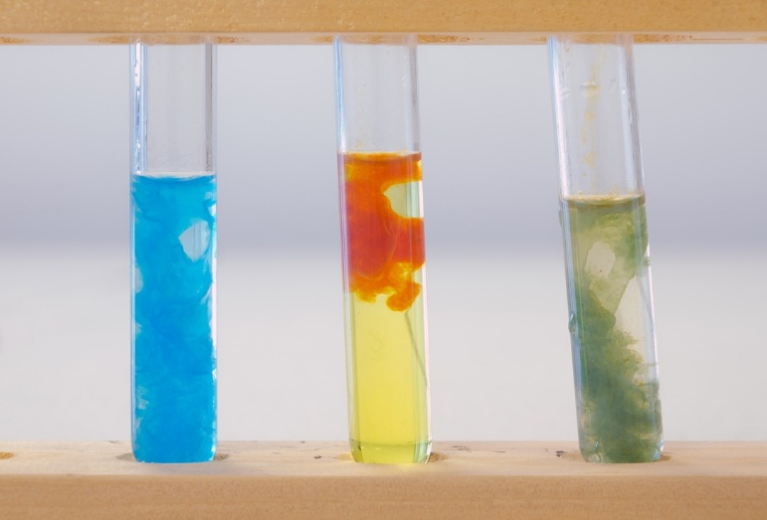

Source: © Science Photo Library
  - Give the general term for the solid formed in the test tubes.

__________________________________________________________________________ (1 mark)
  - Complete and balance the ionic equations for the reactions in which these solids are formed.
- $Cu^{2+}(aq)$ + _______$OH^{-}(aq)$ ⟶ _______________ (s) (2 marks)
- $Fe^{3+}(aq)$ + _______$OH^{-}(aq)$ ⟶ _______________ (s) (2 marks)
- $Fe^{2+}(aq)$ + _______$OH^{-}(aq)$ ⟶ _______________ (s) (2 marks)
  - Explain why potassium ions cannot be detected by adding sodium hydroxide solution.

__________________________________________________________________________________

__________________________________________________________________________________ (2 marks)
  - In the reaction in test tube A, sodium hydroxide solution has been added to copper(II) sulfate solution. Why is the solid formed in test tube A not sodium sulfate?

__________________________________________________________________________________

__________________________________________________________________________________ (2 marks)
- The concentration of a solution can be measured in g/dm³ or mol/dm³. A solution of sodium hydroxide contains 2.00 g sodium hydroxide in 1 dm³ of solution.
  - Calculate the concentration of the solution in $mol/dm^{3}.$

A_{r} sodium 23; A_{r} oxygen 16; A_{r} hydrogen 1

__________________________________________________________________________________

__________________________________________________________________________________

(3 marks)
  - Calculate the number of moles of sodium hydroxide contained in $25 cm^{3}$ of solution.

__________________________________________________________________________________

__________________________________________________________________________________ (2 marks)
  - A different solution contains $1.50 x 10^{-3} mols of NaOH in 25 cm^{3}$. Calculate the mass of sodium hydroxide contained in $25 {cm}^{3}$ of this solution.

_________________________________________________________________________________

_________________________________________________________________________________ (2 marks)

[Total: 28 marks]



Which question(s) did you get wrong? Why?

What will you do next time you’re asked a similar question?

