Scaffolding titration calculations

Use this this resource alongside the Education in Chemistry article Explaining titration, which can be viewed at: rsc.li/2GlzFLw

You can find more resources to prepare, deliver, assess or enrich your teaching of Quantitative chemistry at 14−16 in our topic package: rsc.li/3P4r8Au

Learning objectives
- Explore the table method for structuring titration calculations
- Identify values for concentrations and volumes of solution and correctly identify which reactant these values apply to
- Use $n=\frac{cV}{1000}$ to carry out calculations involving moles ($n$), concentration (in mol/dm³) and volume (in cm³)

Resource components
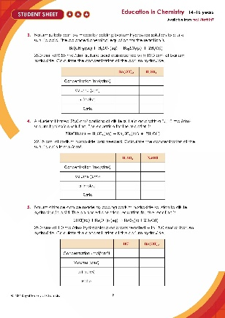  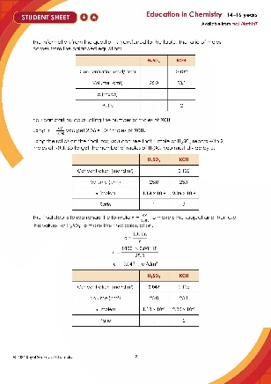  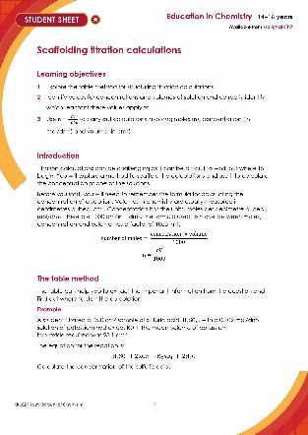 | 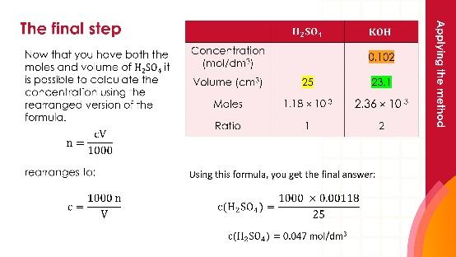
Student sheets: three different levels of write-on worksheet with support through scaffolding. The amount of support is indicated by the number of starts in the header. | Presentation: lesson slides to guide learners through the questions and self-assess the answers

Using this resource

You can use these during a lesson when teaching titration calculations, or in a revision or intervention lesson. The resource can be used with or without the printed question sheets as the questions and answers are also found in the lesson slides.

Scaffolding

This resource focuses on using the table method for scaffolding calculations involving reacting solutions. This method is useful for learners who find calculations in quantitative chemistry difficult to carry out. When learners have become more confident, you can remove the scaffolding. You should aim to do this for learners who are likely to study chemistry beyond 14–16.

There are three versions of this resource.
- Sheet 1 () is fully scaffolded with the key information in each question already transferred to the tables.
- Sheet 2 ()has faded scaffolding and leads to learners applying the method independently by question 5.
- Sheet 3 ()has just the tables and is useful for enabling learners to develop fluency with the table method.

Although sheets 1 and 2 contain a reminder of the key formulas, you may find it useful to display these on the board for learners to refer to while they work.

Answers

The following answers show the full working out within the table. Each calculated number can be allocated one mark, leading to three marks per question.

- 0.44 mol/dm³
 | $CH_{3}COOH$ | $NaOH$
Concentration (mol/dm³) | 0.44 | 0.22
Volume (cm³) | 12.5 | 25
$n$ (moles) | 5.5 × 10⁻³ | 5.5 × 10⁻³
Ratio | 1 | 1

 | $$HNO_{3}$$ | $$KOH$$
Concentration (mol/dm³) | 2 | 1.67
Volume (cm³) | 25.0 | 30.0
$n$ (moles) | 0.05 | 0.05
Ratio | 1 | 1
- 1.67 mol/dm³

 | $$Ba{\left(OH\right)}_{2}$$ | $$H_{2}SO_{4}$$
Concentration (mol/dm³) | 1.38 | 0.55
Volume (cm³) | 10.0 | 25.0
$n$ (moles) | 0.01375 | 0.01375
Ratio | 1 | 1
- 1.38 mol/dm³

 | $$H_{2}SO_{4}$$ | $NaOH$
Concentration (mol/dm³) | 0.049 | 0.110
Volume (cm³) | 25.0 | 22.15
$n$ (moles) | 1.22 × 10⁻³ | 2.44 × 10⁻³
Ratio | 1 | 2
- 0.049 mol/dm³

 | $$HCl$$ | $$Ba{\left(OH\right)}_{2}$$
Concentration (mol/dm³) | 1.0 | 0.83
Volume (cm³) | 25.0 | 15.0
$n$ (moles) | 0.025 | 0.0125
Ratio | 2 | 1
- 0.83 mol/dm³

