Atoms and molecules
This resource is part of the Structure strips series of resources, designed to support literacy in science teaching. More resources in this series can be found at: rsc.li/4aXYgzt

Learning objectives
- Recognise and draw diagrams of atoms and molecules.
- Explain the relationship between atoms and molecules.
- Write independently about atoms and molecules, using the suggested key words.

Introduction

Atoms are the building blocks of all substances. They are the simplest unit of matter that retains the properties of the element. Atoms make up everything from the materials we use to build, to the air we breathe and the food we eat.

Very few substances exist as simple atoms, most substances are made up of atoms chemically bonded together to form molecules. In this structure strip, you will explore the relationship between atoms and molecules.

Note: the extension task needs modelling materials, see page 4 for details. If you don’t have access to any modelling materials, ask learners to draw the molecules instead.

How to use structure strips

Structure strips are a type of scaffolding you can use to support learners to retrieve information independently. Use them to take an overview at the start of a topic, to activate prior knowledge, or to summarise learning at the end of a teaching topic. Visit rsc.li/3EszCfr for more ideas on how to use structure strips with your learners.

Structure strips have sections containing prompts, sized to suggest the amount that learners must write. Ask learners to glue the strips into the margin of an exercise book and write their answers next to the sections, in full sentences or in bullet points. When learners have finished using the structure strip, they will have an A4 page set of notes and examples.

Scaffolding
- Encourage learners to use the suggested key words in their answers. These link with our key terms support resources for elements compounds and mixtures (rsc.li/42AcGmK).
- To further support learners, include additional prompts in the structure strip. If learners are struggling to engage with the task, supply them with sentence starters created from the example answers. In prompt three, you could provide a useful hint by asking learners about what the subscript 2 represents.
- As learners grow in confidence, ask them to attempt the extension task first and then use the structure strip to improve or self-assess their attempt.

Metacognition

This resource supports learners to develop their metacognitive skills in three key areas.
- Planning: the strips provide scaffolding to plan the written response. Learners will decide where to gather information from (textbooks, own notes, revision websites). Ask learners: is the source of information you are using reliable?
- Monitoring: learners are prompted by the questions in the structure strip and can check their own answers against the prompts. Ask learners: have you covered all of the prompts in the space provided? Do you need to change anything to complete the task?
- Evaluation: learners can self-assess or ask a peer to check their work against the answers. Ask learners: did you achieve what you meant to achieve? What will you do differently another time?

Example answers for the structure strip are on page 3.

Structure strip  Atoms and molecules | Example answer
What is the difference between molecules and single atoms? | Single atoms exist on their own, but molecules are two or more atoms connected by covalent chemical bonds. The atoms in molecules can be of the same element or of different elements.
This diagram represents five atoms of the same element.  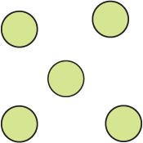  Draw a diagram showing five atoms, three of one element and two of another. What is important to remember when drawing atoms? | 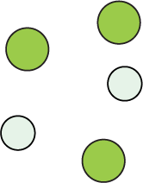  Atoms are usually drawn in diagrams as circles. It is important that atoms of the same element are the same colour and size. Circles of different colours and sizes can show atoms of different elements.
Draw helium, He, which exists as single atoms. Now draw oxygen, $O_{2}$. Describe the difference between your diagrams. | 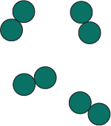  Helium has separate circles to represent the separate atoms. Oxygen has atoms of the same element bonded together to make molecules.
Draw one molecule of water ${(H}_{2}O)$and one of carbon dioxide $({CO}_{2})$. Label the atoms in each diagram. | 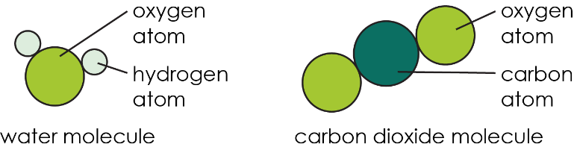  Guidance: At this stage learners do not need to understand the relative sizes of atoms, however their molecule diagrams should clearly show the atoms as different, e.g. they might use different colours, or a key.
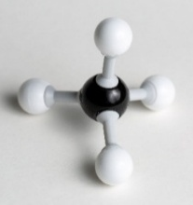  What information does this model show about methane? | The model shows that:  - Methane is a compound molecule. It contains atoms of different elements joined by chemical bonds.  - Each methane molecule is made up of five atoms in total.  - One atom in the centre is different from the four identical atoms it is bonded to.  - The lines between the atoms represent chemical bonds.

Extension task

Get learners to answer the question after they have attempted the structure strip. The structure strip activates the required knowledge which learners then apply to the question.

Suggest molecules learners have come across in other lessons, to empower them to unlock their existing science capital. Visit rsc.li/40FAMLP for more information.

Things to note

The extension task for this structure strip involves learners making models. Provide learners with access to modelling materials. These can be formal molecular models such as Molymod kits, or craft materials such as plasticine and toothpicks.
- Read about creating your own molecular models: rsc.li/4vKpYKH

Assessing the models

The models will vary depending on materials used and choice of molecules. Discuss with learners:
- how they have shown there are bonds between the atoms
- how their model shows that atoms are from different elements

Example answer

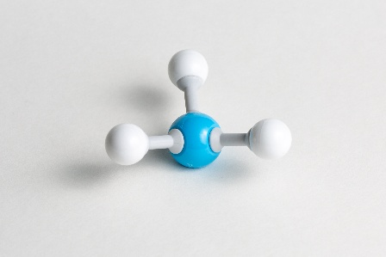

In this model of a molecule of ammonia, four atoms are joined by chemical bonds.
The formula for ammonia is NH₃. This means there is one nitrogen atom and three hydrogen atoms that make up the molecule.

The nitrogen atom is different from the three other atoms because it is bigger and a different colour.

