Tiny crystals, big hydrogen boost

Original article by Tim Wogan. Adapted by Nina Notman.

Five-metal nanocrystals could help overcome a key challenge in hydrogen transport

Scientists in the US and South Korea have grown five-metal nanocrystals with a uniform size and composition. These nanoparticles are promising catalysts for cracking ammonia to produce hydrogen fuel.

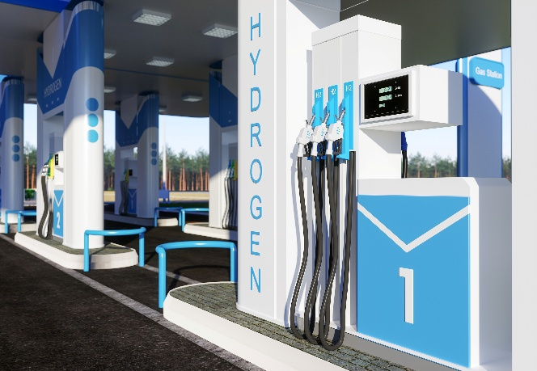
Nanoparticles are popular heterogeneous catalysts because their small size gives them exceptionally high surface areas. This speeds up reaction rates by providing more active sites where reactions can occur. The five-metal nanocrystals are about 20–25 nm in size and have an onion-like structure, with a ruthenium–copper core, layers of cobalt and nickel and an outer coating of iron. For size comparison, an average human hair is 80,000–100,000 nm thick.

Source: © Onurdongel/Getty Images
Could combining five metals make the production of hydrogen fuels more practicable?

Researchers expect hydrogen fuel to play a crucial role in a net-zero future. However, technical challenges remain, including how to transport hydrogen efficiently. One idea is to convert hydrogen into ammonia, transport the ammonia as a liquid, then decompose it back into hydrogen and nitrogen at its destination. The challenge is that the catalysts currently used in this decomposition step – single metal ruthenium nanoparticles – are expensive and not overly robust.

Even better than expected
The US and South Korea team wanted to reduce the amount of ruthenium needed to break down ammonia by substituting it with the cheaper and more abundant metals copper, cobalt, nickel and iron. The researchers grew the nanocrystals from ruthenium nanoparticle seeds in a warm solution containing compounds of the other metals. They were surprised by the uniform structure and shape of the resulting nanocrystals because previous attempts to make multi-metal nanocrystals had proved difficult.
Laboratory tests showed that the five-metal nanocrystals successfully cracked ammonia achieving reaction rates four times higher than rates achieved using ruthenium alone. The German chemical company BASF is now testing the catalysts to assess if they are suitable for industrial scale use.
This is adapted from the article Neat and uniform five-metal nanoparticle synthesis surprises scientists in Chemistry World. Read the full article: bit.ly/3RpQrOz

