Separating mixtures

This resource is part of the Structure strips series of resources, designed to support literacy in science teaching. More resources in this series can be found at: rsc.li/4aXYgzt

Learning objectives
- Link the physical properties of substances to methods of separation.

Success criteria: the written responses to prompts 2−5.
- Recall and draw apparatus set ups for different separation methods.

Success criteria: diagrams drawn for prompts 2−5.
- Explain how separation techniques work to separate mixtures.

Success criteria: written responses for prompts 2−5.
- Write independently about separating mixtures using the key words provided.

Success criteria: the written response to the extension question and the overall approach to the structure strip activity including the use of support resources.

Introduction

A mixture is two or more substances added together in any proportion. The substances are not chemically bonded, so they keep their own properties. This means mixtures can be separated easily by using the different physical properties of the substances in them. There are many separation techniques available. They can be as simple as using a magnet or filtration, or more complex, such as distillation and chromatography.

How to use structure strips

Structure strips are a type of scaffolding you can use to support learners to retrieve information independently. Use them to take an overview at the start of a topic, to activate prior knowledge, or to summarise learning at the end of a teaching topic. Visit rsc.li/3EszCfr for more ideas on how to use structure strips with your learners.

Structure strips have sections containing prompts, sized to suggest the amount that learners must write. Ask learners to glue the strips into the margin of an exercise book and write their answers next to the sections, in full sentences or in bullet points. When learners have finished using the structure strip, they will have an A4 page set of notes and examples.

Scaffolding
- Encourage learners to use the suggested key words in their answers. These link with our corresponding key terms support resources for Elements, compounds and mixtures (rsc.li/42AcGmK).
  - The phrases melting point, boiling point and condense are in the key terms resources for particle model (rsc.li/4cmvSbS).
- To further support learners, include additional prompts in the structure strip. If learners are struggling to engage with the task, supply them with sentence starters created from the example answers.
- As learners grow in confidence, ask them to attempt the extension task first and then use the structure strip to improve or self-assess their attempt.

Metacognition

This resource supports learners to develop their metacognitive skills in three key areas.
- Planning: the strips provide scaffolding to plan the written response. Learners will decide where to gather information from (textbooks, own notes, revision websites). Ask learners: is the source of information you are using reliable?
- Monitoring: learners are prompted by the questions in the structure strip and can check their own answer against the prompts. Ask learners: have you covered all of the prompts in the space provided? Do you need to change anything to complete the task?
- Evaluation: learners can self-assess or ask a peer to check their work against the answers. Ask learners: did you achieve what you meant to achieve? What will you do differently another time?

Example answers

Example answers for the structure strip are on page 3. Learners can write the answers as bullet points or prose.
Separating mixtures | Example answer
Mixtures can be separated due to their physical properties. State three physical properties of substances. | Physical properties of substances include:  - melting and boiling point  - solubility (usually in water), e.g. how much of it dissolves in water  - floating/sinking in water as a measure of density  - magnetism
Draw and label a diagram to show the apparatus in use for filtration.  Explain how the technique works to separate a mixture. | 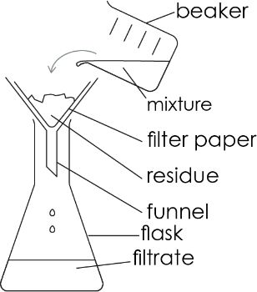  Guidance: Learners can draw any type of flask to receive the filtrate, as long as a funnel can fit in the neck. Examples include a conical flask, a beaker, or a boiling tube.  Filtration works by separating soluble substances from insoluble substances. Insoluble substances are caught in the filter and soluble substances pass through.
Draw and label a diagram to show the apparatus in use for evaporation.  Explain how the technique works to separate a mixture. | 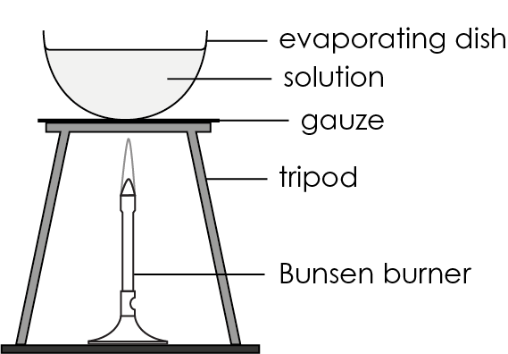  Guidance: Learners could also draw evaporation over a water bath. For more information, look at this Filtration, evaporation and crystallisation poster: rsc.li/4q7co0M.  Evaporation works because the solvent (usually water) in a solution has a lower boiling point than the dissolved substance (the solute). So, as the mixture is heated up, the solvent/water turns to gas and leaves behind the solute.
Draw and label a diagram to show the apparatus in use for distillation.  Explain how the technique works to separate a mixture. | 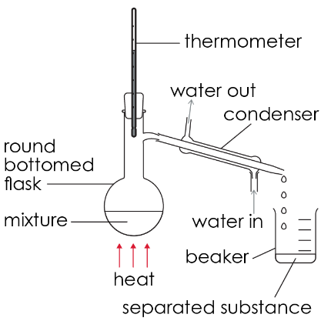  Guidance: Learners may draw a simple distillation diagram with just a delivery tube as a simple air condenser depending on their personal experience.  Distillation works as substances have different boiling points. As the mixture is heated in the flask, the substances change state into gases at different temperatures. So, the substance with the lowest boiling point will turn into a gas first and travel into the condenser where it will cool and condense into a liquid.
Draw and label a diagram to show the apparatus in use for paper chromatography.  Explain how the technique works to separate a mixture. | 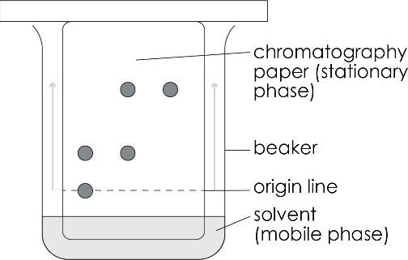  Paper chromatography works because some substances are more soluble in a particular solvent than others. This causes them to travel different distances up the chromatography paper.

Extension question

Get learners to answer the question after they have attempted the structure strip. The structure strip activates the required knowledge which learners then apply to the question.

Consider how you can re-frame the context of this question to one which your learners are more familiar with, to empower them to unlock their existing science capital. Visit rsc.li/40FAMLP for more information.

Example answer to extension question

Dear Sammy,

The seawater you have is a mixture, so you will need to separate out the parts of the mixture to get the salt. First, you should filter the seawater. The seaweed and sand will get caught in the filter, and the salt and water will go through the filter because the salt is dissolved in the water.

Next, you should put your filtered seawater in a suitable container and heat it above 100°C, which is the boiling point of water. The water will change state into a gas and leave behind the salt.

