Titrating sodium hydroxide with hydrochloric acid

Learning objectives
- Set up and carry out a neutralisation reaction by titration.
- Calculate the concentration of hydrochloric acid using experimental results.
- Produce a pure sample of sodium chloride crystals from sodium chloride solution.
- Accurately record experimental observations and data.

Introduction

Table salt is used in cooking. It is also added to our food to make it taste better. The chemical name for table salt is sodium chloride.

Sodium chloride solution can be made in a neutralisation reaction by reacting sodium hydroxide with dilute hydrochloric acid.

Your challenge is to produce a pure sample of sodium chloride crystals, starting with a sample of sodium hydroxide solution and dilute hydrochloric acid.

Equipment

Apparatus
- Safety glasses
- Burette, 30 or 50 cm³
- Conical flask, 100 cm³
- Beaker, 100 cm³
- Pipette, 20 or 25 cm³, with pipette filler
- Stirring rod
- Small (filter) funnel, about 4 cm diameter
- Burette stand and clamp
- White tile or sheet of white paper
- Bunsen burner
- Tripod
- Pipe clay triangle
- Evaporating basin, at least 50 cm³ capacity
- Crystallising dish
- Microscope or hand lens suitable for examining crystals in the crystallising dish


Chemicals
- Sodium hydroxide solution, 0.4 M (IRRITANT)
- Dilute hydrochloric acid, 0.4 M
- Methyl orange indicator solution

Health and safety
- Wear eye protection throughout

Diagram

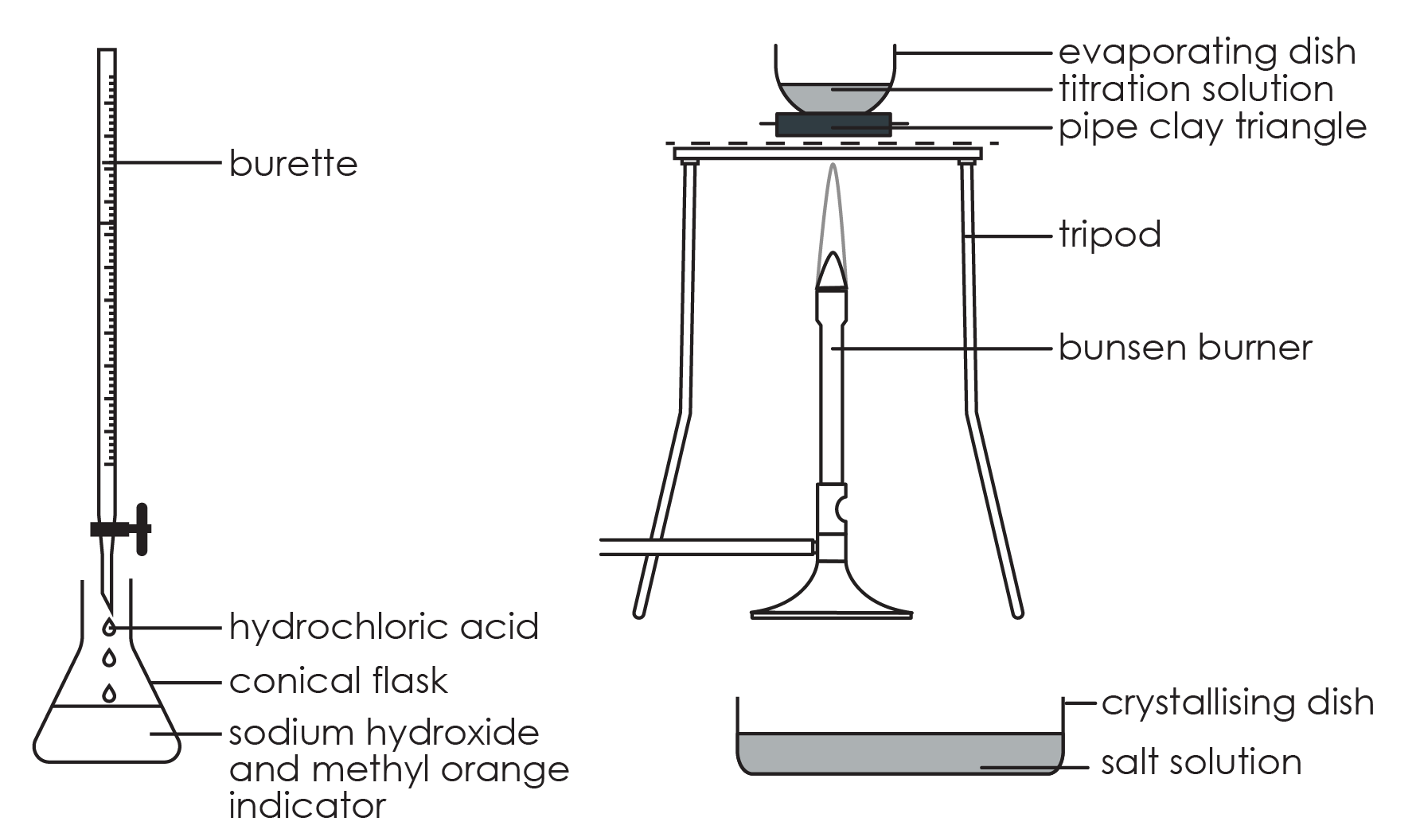

Method

Stage 1
- Using a small funnel, pour a few cubic centimetres of 0.4 M hydrochloric acid into the burette, with the tap open and a beaker under the open tap. Once the tip of the burette is full of solution, close the tap and add more solution up to the zero mark. (Do not reuse the acid in the beaker – this should be rinsed down the sink.)
- Use a pipette with pipette filler to transfer 25 (or 20) cm³ of 0.4 M sodium hydroxide solution to the conical flask and add two drops of methyl orange indicator. Swirl gently to mix. Place the flask on a white tile or piece of clean white paper under the burette tap.
- Add the hydrochloric acid to the sodium hydroxide solution in small volumes, swirling gently after each addition. Continue until the solution just turns from yellow−orange to red and record the reading on the burette. Rinse this coloured solution down the sink.

Stage 2
- Refill the burette to the zero mark.
- Carefully add the same volume of fresh hydrochloric acid as you used in stage 1, step 3, to a fresh 25 (or 20) cm³ of sodium hydroxide solution, to produce a neutral solution, but this time without any indicator.

Stage 3
- Pour this solution into an evaporating basin. Reduce the volume of the solution to about half by heating on a pipe clay triangle or ceramic gauze over a low to medium Bunsen burner flame. The solution spits near the end and you get fewer crystals. Do not boil dry. You may need to evaporate the solution in, say, 20 cm³ portions to avoid overfilling the evaporating basin. Do not attempt to lift the hot basin off the tripod – allow to cool first and then pour into a crystallising dish.
- Leave the concentrated solution to evaporate further in the crystallising dish. This should produce a white crystalline solid in one or two days.
- Record the mass of the sodium chloride crystals.
- Examine the crystals under a microscope.

Questions

Stage 1

In the titration, hydrochloric acid was added dropwise to sodium hydroxide. This produced a solution of sodium chloride and water.
- Name the products formed in this reaction.

__________________________________________________________________________________
- Write a word equation for this reaction.

_______________  _______________ | + | _______________  _______________ | → | _______________  _______________ | + | _______________  _______________
- (a) Match the compounds to the correct formula

$H_{2}O$ sodium hydroxide

HCl sodium chloride

NaCl water

NaOH hydrochloric acid

(b) Now use the formulas to write a balanced symbol equation for the reaction.

__________ + __________ → __________ + __________
- Explain why methyl orange was added to the conical flask.

__________________________________________________________________________________

__________________________________________________________________________________
- State the volume of hydrochloric acid needed to neutralise the sodium hydroxide.

__________________________________________________________________________________

- Concentration can be calculated using the formula:

$$concentration (mol/{dm}^{3}) = \frac{number of moles}{volume ({dm}^{3})}$$

To calculate the concentration of hydrochloric acid used in the titration, we need to work through the following steps:

- Add your answer to question 5 to the table.
 | Volume (cm³) | Volume (dm³) | Concentration (mol/dm³)
Sodium hydroxide | 25 |  | 0.4
Hydrochloric acid

- Rearrange the formula to show how you would calculate the number of moles.

__________________________________________________________________________________
- Substitute the formula to calculate the number of moles of sodium hydroxide used in the titration.

__________________________________________________________________________________

__________________________________________________________________________________
- The symbol equation tells us that sodium hydroxide and hydrochloric acid react in a 1:1 ratio.

Write down the number of moles of hydrochloric acid used in the titration.

__________________________________________________________________________________
- Use your answer to d) and your experimental result to calculate the concentration of hydrochloric acid.

__________________________________________________________________________________

__________________________________________________________________________________

Stage 2
- State the chemicals present after the titration in stage 1.

__________________________________________________________________________________

- State the products that would remain if you evaporated the water from the solution produced in stage 1.

__________________________________________________________________________________

- Using your answers above, explain why you don’t use indicator to produce pure crystals of sodium chloride in stage 2.

__________________________________________________________________________________

__________________________________________________________________________________

__________________________________________________________________________________

- Explain why the same volume of sodium hydroxide is needed for stage 2.

__________________________________________________________________________________

__________________________________________________________________________________

__________________________________________________________________________________

- Explain how you could test to see whether the solution is neutral without using an indicator.

__________________________________________________________________________________

__________________________________________________________________________________

Stage 3
- Complete the sentences by crossing out the incorrect words.

As the water molecules evaporate/condense, a less/more concentrated solution of sodium chloride molecules/ions forms in the basin. Eventually the solution becomes dry/saturated and sodium chloride crystals start to form.

- Record the mass of the crystals.

__________________________________________________________________________________

- Sketch what you see when you look at the salt crystals under the microscope.

- Describe the shape of the crystals.

__________________________________________________________________________________

- Select the diagram that best represents the structure of sodium chloride crystals.

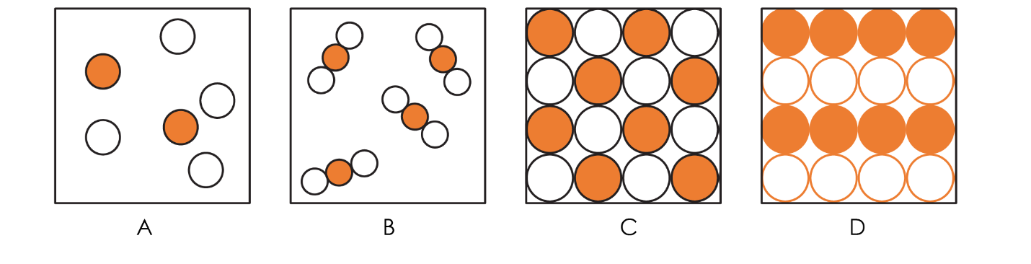

Give a reason for your answer.

__________________________________________________________________________________

__________________________________________________________________________________

