The properties of hydrogen chloride

Learning objectives
- Investigate the properties of hydrogen chloride gas.
- Investigate the properties of dilute hydrochloric acid.
- Compare the structure and bonding of HCl(g) and HCl(aq).
- Explain how the differences in structure and bonding in $HCl(g)$ and $HCl(aq)$ lead to different properties.

Introduction

Hydrogen chloride, HCl(g), exists as a colourless, odourless gas at room temperature and pressure. When it dissolves in water, hydrochloric acid, HCl(aq), is formed.

Teacher demonstration

In this demonstration, you will observe the formation of hydrochloric acid from hydrogen chloride gas as it dissolves in water.
- During the demonstration, label the diagram and then answer the following questions.
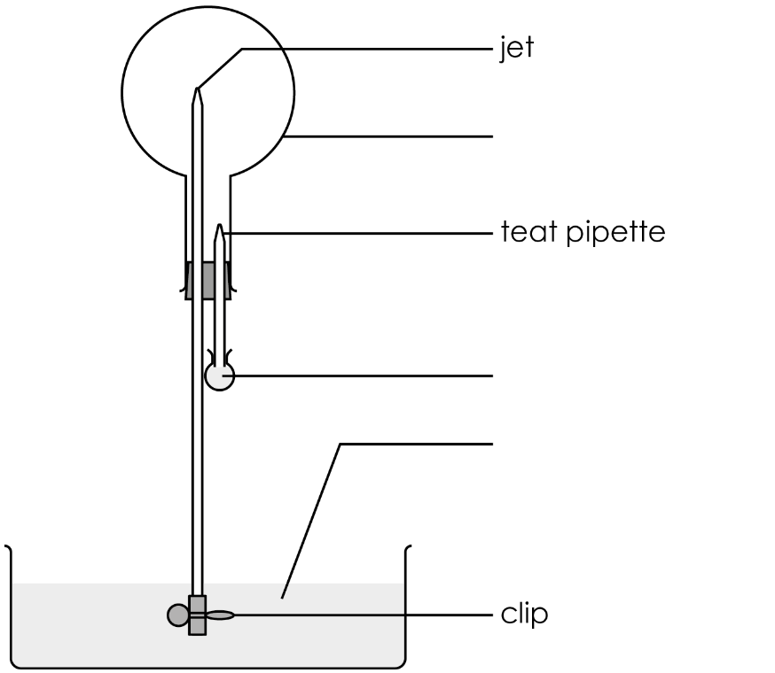

- State the formula of hydrogen chloride.

__________________________________________________________________________________

- Describe the colour of the universal indicator:

- at the start of the demonstration _______________________________________
- during the demonstration _______________________________________
- at the end of the demonstration _______________________________________

- Name the solution formed at the end of the demonstration.

__________________________________________________________________________________

- Write a word equation to represent the changes that have taken place.

_________________________ + _________________________ → _________________________

Class practical: investigating the properties of dilute hydrochloric acid
- Before you start, put on your eye protection.
- Dilute hydrochloric acid is an irritant, so take care not to get it on your skin.
- Carry out the following experiments. Note down your observations in a table.

Testing for pH
- One-third fill a test tube with the hydrochloric acid.
- Add a couple of drops of universal indicator solution.
- Using a pipette, slowly add sodium hydroxide solution. Shake to mix after each addition. Continue adding the alkali until no more changes are observed.

Testing with magnesium
- One-third fill a test tube with the hydrochloric acid.
- Add a strip of magnesium.
- Hold an inverted test tube over the reaction test tube for several seconds, to collect the gas.
- Place a burning splint at the mouth of the inverted test tube.

Testing with marble chips (calcium carbonate)
- One-third fill a test tube with the hydrochloric acid.
- Add a few marble chips.
- Add a few drops of limewater to a clean test tube.
- Using a dropper, transfer some of the evolving gases into the limewater.

Testing for conductivity
- Set up the circuits.
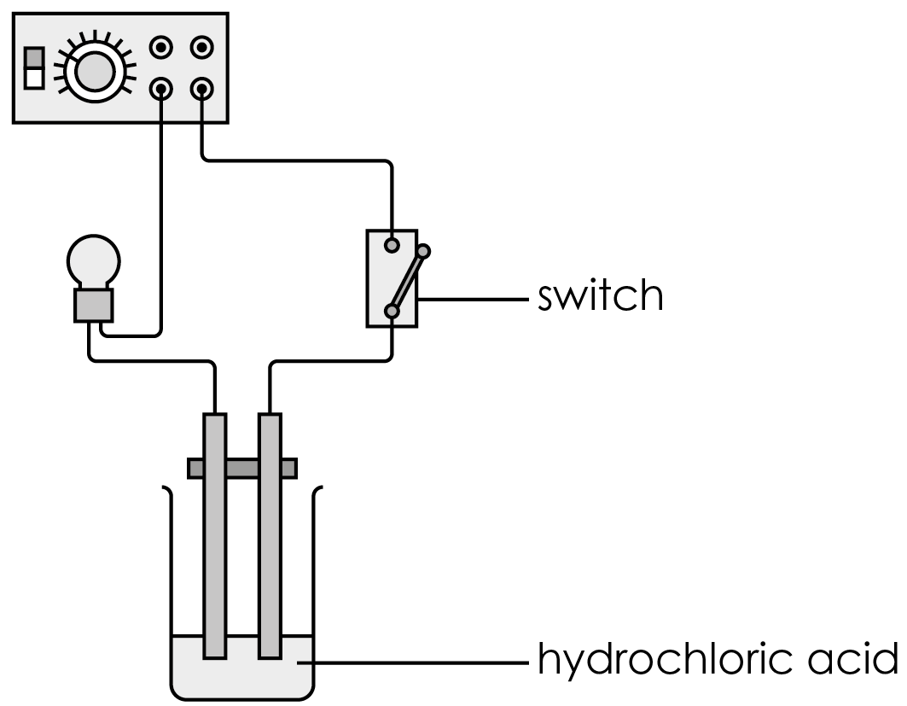

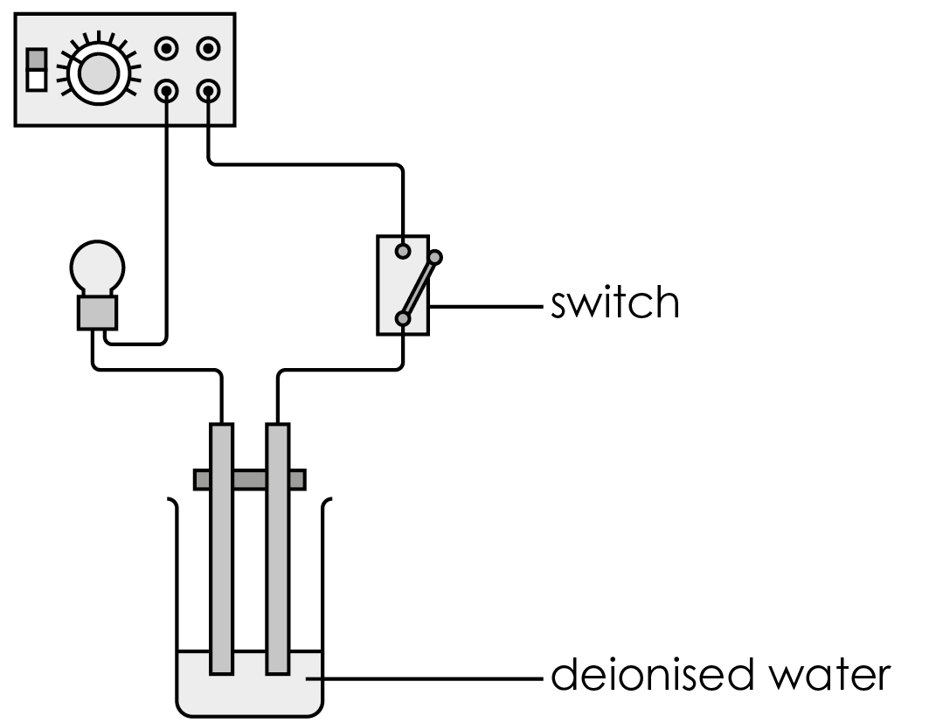

- Press down the switch to complete the electric circuits and note down your observations.

Results table
Test | Observations
Testing for pH
Testing with magnesium
Testing with marble chips
Testing for conductivity

Follow-up questions
- Describe the appearance of hydrogen chloride.

__________________________________________________________________________________

__________________________________________________________________________________

- Draw a dot and cross diagram to show the bonding electrons in a molecule of hydrogen chloride.

- Hydrogen chloride is very soluble in water.
- State the meaning of the term soluble.

__________________________________________________________________________________

__________________________________________________________________________________
- Describe a simple test that would support the above statement.

__________________________________________________________________________________

__________________________________________________________________________________
- Complete the equation.

$$HCl(g) + H_{2}O(l) → _________ (____)$$

- Describe how the chemical bonding in HCl changes as hydrogen chloride molecules dissolve in water.

__________________________________________________________________________________

__________________________________________________________________________________

__________________________________________________________________________________

__________________________________________________________________________________

__________________________________________________________________________________

- When sodium hydroxide is added to hydrochloric acid, a chemical reaction takes place.

- State the type of reaction.

__________________________________________________________________________________
- Write a symbol equation for the reaction.

_____________ + _____________ → _____________ + _____________

- When zinc is added to hydrochloric acid, a gas is produced.
- Name the gas.

__________________________________________________________________________________
- Describe a test that could confirm your previous answer.

__________________________________________________________________________________

__________________________________________________________________________________
- Write a symbol equation for the reaction.

_____________ + _____________ → _____________ + _____________

- When washing soda, $Na_{2}CO_{3}$, is added to hydrochloric acid, a gas is produced.

- Name the gas.

__________________________________________________________________________________
- Describe a test that could confirm your previous answer.

__________________________________________________________________________________

__________________________________________________________________________________
- Write a balanced symbol equation for the reaction.

_____________ + _____________ → _____________ + _____________+ _____________

- Suggest a reason why hydrochloric acid is a good conductor of electricity, but hydrogen chloride is not.

______________________________________________________________________________

______________________________________________________________________________

______________________________________________________________________________

______________________________________________________________________________

______________________________________________________________________________

______________________________________________________________________________

______________________________________________________________________________

