The properties of hydrogen chloride

Learning objectives
- Investigate the properties of hydrogen chloride gas.
- Investigate the properties of dilute hydrochloric acid.
- Compare the structure and bonding of $HCl(g)$ and $HCl(aq)$.
- Explain how the differences in structure and bonding in $HCl(g)$ and $HCl(aq)$ lead to different properties.

Introduction

Hydrogen chloride, $HCl(g)$, exists as a colourless, odourless gas at room temperature and pressure. When it dissolves in water, hydrochloric acid, $HCl(aq)$, is formed.

Teacher demonstration

In this demonstration, you will observe the formation of hydrochloric acid from hydrogen chloride gas as it dissolves in water.
- Use the words to label the diagram:

water hydrogen chloride gas water containing universal indicator

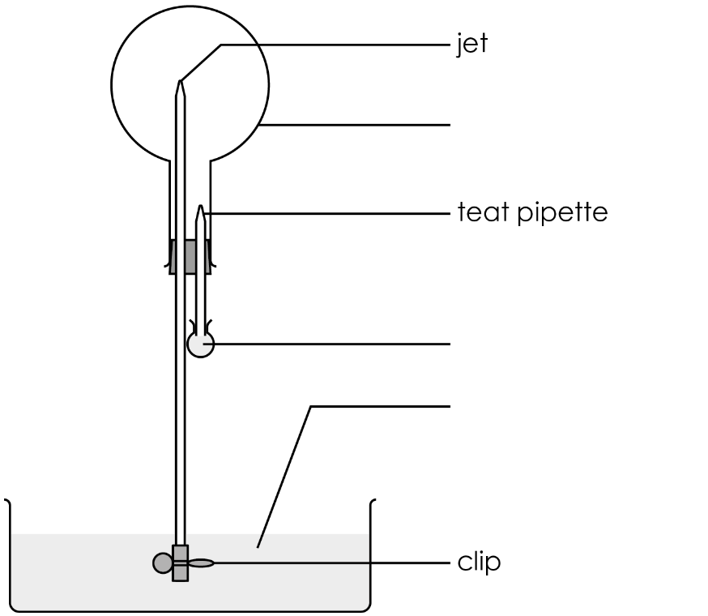
- State the formula of hydrogen chloride. ________________________________

- Tick ✓ the box that best describes the colour of the universal indicator.
at the start at the end
 | red |  | red
 | yellow |  | yellow
 | green |  | green
 | blue |  | blue
- Name the solution formed at the end of the demonstration.

__________________________________________________________________________________

- Complete the word equation to represent the changes that have taken place.

hydrogen chloride + _____________________________ → ______________________________

Class practical: investigating the properties of dilute hydrochloric acid
- Before you start, put on your eye protection.
- Dilute hydrochloric acid is an irritant, so take care not to get it on your skin.
- Carry out the following experiments. Note down your observations in a table.

Testing for pH
- One-third fill a test tube with the hydrochloric acid.
- Add a couple of drops of universal indicator solution.
- Using a pipette, slowly add sodium hydroxide solution. Shake to mix after each addition. Continue adding the alkali until no more changes are observed.

Testing with magnesium
- One-third fill a test tube with the hydrochloric acid.
- Add a strip of magnesium.
- Hold an inverted test tube over the reaction test tube for several seconds, to collect the gas.
- Place a burning splint at the mouth of the inverted test tube.

Testing with marble chips (calcium carbonate)
- One-third fill a test tube with the hydrochloric acid.
- Add a few marble chips.
- Add a few drops of limewater to a clean test tube.
- Using a dropper, transfer some of the evolving gases into the limewater.

Testing for conductivity
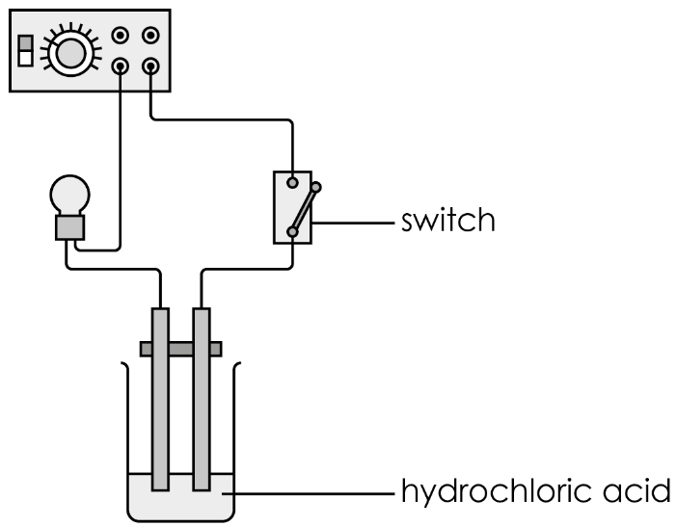
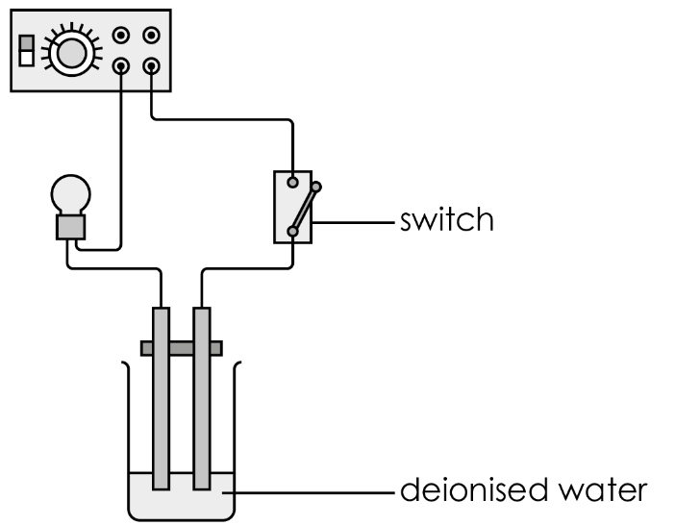
- Set up the circuits as shown:
- Press down the switch to complete the electric circuits and note down your observations.

Results table
Test | Observations
Testing for pH | Colour of the universal indicator:
Testing for pH | At the start | During experiment |  | At the end
Testing with magnesium
Testing with marble chips
Testing for conductivity | With de-ionised water |  | With hydrochloric acid

Follow-up questions
- Choose the correct word to complete the sentence.
solid liquid gas
green red colourless
Hydrogen chloride is a ____________________ at room temperature.
It is ____________________ .
- Hydrogen chloride exists as a covalent molecule. Which dot and cross diagram represents the $HCl$ molecule?

A | 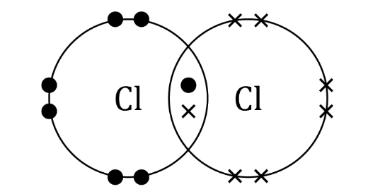 | B | 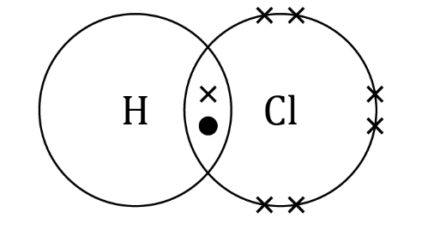
C | 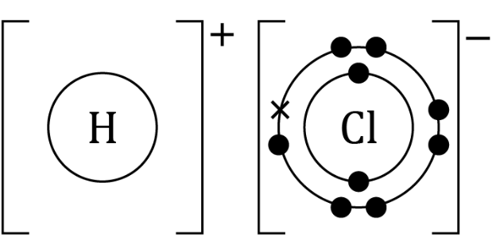 | D | 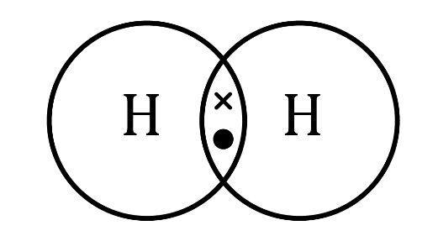
- Hydrogen chloride is very soluble in water.
- State the meaning of the term soluble.

_________________________________________________________________________________

_________________________________________________________________________________
- When hydrogen chloride dissolves, it forms a soluble ionic substance. Which test did you carry out that confirms this?

_________________________________________________________________________________

_________________________________________________________________________________
- Complete the equation by selecting the correct state symbols for $HCl$ gas and $HCl$acid.

l g aq s
$$HCl(g) + H_{2}O(____) → HCl(____)$$
- Choose the correct words to complete the sentences.
A hydrogen chloride molecule consists of a hydrogen atom covalently/ionically bonded to a hydrogen/chlorine atom. They share an electron/neutron/proton pair. When hydrogen chloride dissolves in water, each chlorine atom gives/takes an electron from each hydrogen atom, forming a negatively/positively charged chloride ion and a negatively/positively charged hydrogen ion. The new solution is called hydrochloric/sulfuric acid.
- When sodium hydroxide is added to hydrochloric acid, a chemical reaction takes place.
- State the type of reaction

_____________________________________________________________________________
- Write a word equation for the reaction.

__________________ + ___________________ → __________________ + ___________________

- When zinc is added to hydrochloric acid, a gas is produced.

Hint: zinc behaves in the same way as magnesium did in the class practical.
- Name the gas.

_____________________________________________________________________________
- Describe a test that could confirm your previous answer.

_____________________________________________________________________________

_____________________________________________________________________________
- Write a word equation for the reaction.

__________________ + ___________________ → __________________ + ___________________

- When washing soda, $Na_{2}CO_{3}$, is added to hydrochloric acid, a gas is produced.
Hint: washing soda behaves in the same way as marble chips did in the class practical.
- Name the gas.

__________________________________________________________________________________
- Describe a test that could confirm your previous answer.

__________________________________________________________________________________

__________________________________________________________________________________
- Write a word equation for the reaction.

sodium carbonate | + | ______________  ______________ | → | sodium chloride | + | ______________  ______________ | + | ______________  ______________

- Choose the correct words to complete the sentences:

Hydrogen chloride is a covalently bonded ion/molecule. There are no free electrons/particles in the structure to act as charge carriers. Therefore, it can/cannot conduct electricity.

When hydrogen chloride dissolves in water, ${H^{+}/H}^{-}$ and $Cl^{+}/Cl^{-}$ ions are produced, forming hydrochloric acid. Hydrochloric acid can conduct electricity because the atoms/ions/molecules are free to move in the solution and act as electrical current/charge carriers.

