The properties of hydrogen chloride

This investigation is part of the Nuffield practical collection, developed by the Nuffield Foundation and the Royal Society of Chemistry. Delve into a wide range of chemical concepts and processes with this collection of over 200 step-by-step practicals: rsc.li/43bjGql

Learning objectives
- Investigate the properties of hydrogen chloride gas.
- Investigate the properties of dilute hydrochloric acid.
- Compare the structure and bonding of $HCl(g)$ and $HCl(aq)$.
- Explain how the differences in structure and bonding in $HCl(g)$ and $HCl(aq)$ lead to different properties.

Learners will observe a demonstration where you prepare hydrogen chloride gas and use a fountain experiment to illustrate its solubility in water, forming hydrochloric acid. (LO1) Learners will then investigate some of the properties of hydrochloric acid, either as a class practical or further teacher demonstration, including conductivity and its reactions with sodium hydroxide, magnesium and marble chips (LO2). Completion of the follow-up questions on the learner worksheet, will allow learners to succeed in LO3 and LO4.

Scaffolding

There are two versions of the learner worksheet: scaffolded () and unscaffolded (). The scaffolded sheet offers more support to allow learners to access the questions. For example, on the scaffolded sheet, learners are supported by gap filing activities, sentence starters, hints and multiple-choice questions.

You can find integrated instructions on slide 9 of the presentation.

Depending on the group, carry out the properties of dilute hydrochloric acid either as a class practical or teacher demonstration. Print out the results and conclusion tables on slides 11 and 12 for learners to complete during a class discussion of the experiments.

Technician notes

Read our standard health and safety guidance (rsc.li/3zyJLkx) and carry out a risk assessment before running any live practical.

Equipment
- Eye protection (including goggles for generating and handling hydrogen chloride gas)

Teacher demonstration – the fountain experiment
- Access to a fume cupboard
- Safety screens
- Large round-bottomed flask, 500–1000 cm³ (see safety note below)
- Bung to fit flask, with holes for a teat pipette (with detachable teat) and delivery tube as shown (see safety note below)
- Valve, consisting of a short length of rubber tubing and a Mohr’s clip
- Glass trough or plastic bowl
- Short lengths of rubber tubing
- Clamp stands, bosses and clamps
- Small glass funnel, to fit inside a 250 cm³ beaker
- Beaker, 250 cm³
- Conductivity testing apparatus, including:
  - 3 V DC power supply
  - Graphite electrodes in a bung
  - Leads
  - Clips
  - Torch bulb in holder

Class experiment – testing the properties of pre-prepared dilute hydrochloric acid

For each group
- Test tubes, x4
- Test tube rack
- Plastic dropper pipettes
- Wooden splints

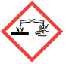
Chemicals
- Concentrated sulfuric acid (CORROSIVE), 10 cm³
- Sodium chloride, 30 g (see note 5 below)
- Universal indicator solution


For class practical, each group to have access to the following:
- Sodium hydroxide solution, 0.1 M (IRRITANT)
- Dilute hydrochloric acid, 0.1 M

- Limewater (IRRITANT), fresh, a few cm³
- Universal indicator solution (HIGHLY FLAMMABLE)
- Universal indicator papers
- Magnesium ribbon, 2 cm lengths
- Small marble chips, a few

Safety and hazards
- Eye protection (including goggles for generating and handling hydrogen chloride gas). Wear eye protection for testing the properties of dilute hydrochloric acid.
- Access to a fume cupboard for the fountain demonstration
- Safety screens – for the fountain demonstration

- Hydrogen chloride gas, $HCl(g)$ is generated (TOXIC, CORROSIVE)
See CLEAPSS Hazcard HC049 and CLEAPSS recipe book, refer to SSERC or contact your local safety advisory body.
- Concentrated sulfuric acid, $H_{2}{SO}_{4}(aq)$ (CORROSIVE), see CLEAPSS Hazcard HC098a, refer to SSERC or contact your local safety advisory body.
- Sodium chloride, $NaCl(s)$, see CLEAPSS Hazcard HC047b, refer to SSERC or contact your local safety advisory body. Powdered rock salt can be used instead of reagent sodium chloride.
- Dilute hydrochloric acid, $HCl(aq)$, see CLEAPSS Hazcard HC047a and CLEAPSS recipe book RB043, refer to SSERC or contact your local safety advisory body.
- Universal indicator solution (HIGHLY FLAMMABLE), see CLEAPSS Hazcard HC032 and CLEAPSS recipe book RB000, refer to SSERC or contact your local safety advisory body.
- Magnesium ribbon, $Mg(s)$, see CLEAPSS Hazcard HC059A, refer to SSERC or contact your local safety advisory body.
- Limewater, $Ca(OH)_{2}(aq)$, (treat as IRRITANT), see CLEAPSS Hazcard HC018 and CLEAPSS recipe book RB020, refer to SSERC or contact your local safety advisory body.
- Sodium hydroxide solution, $NaOH(aq)$, (IRRITANT), see CLEAPSS Hazcard HC091a and CLEAPSS recipe book RB085, refer to SSERC or contact your local safety advisory body.

Demonstration set up

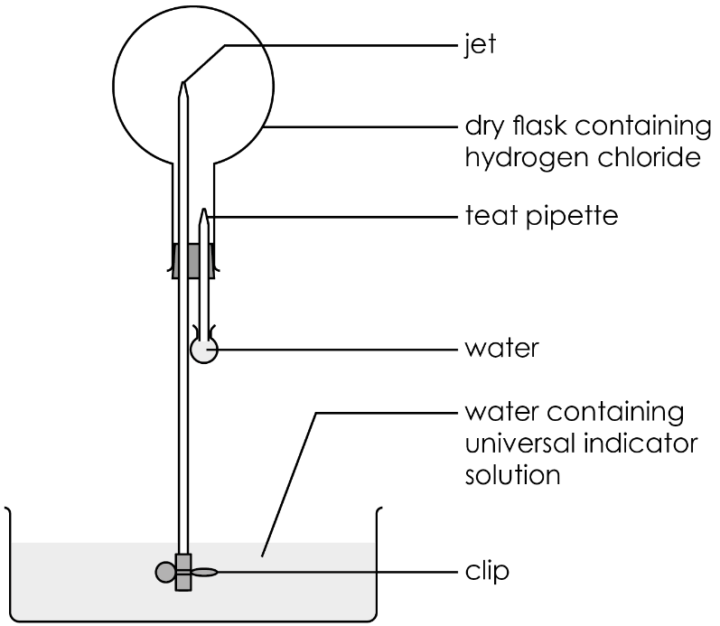
- The round-bottomed flask should be a thick-walled one made of borosilicate (Pyrex) glass and free of any flaws. Safety screens are necessary because the sudden vacuum produced when the gas dissolves in water can cause the flask to implode.
- The pipette inserted through the bung should have a removable rubber teat that can be easily attached once the apparatus is in place. Check that the volume of water the teat bulb holds, when filled, is sufficient to ensure that drops of water emerge into the flask when the teat is squeezed. Fill the teat bulb with water beforehand and place it upright in a small beaker ready to use.
- Dry the flask and the bung carrying the glass tubes in an oven at about 80°C before the experiment.
- Set up the necessary stand, bosses and clamps, safety screens and the empty trough/bowl in their correct positions on the bench in front of the class before the demonstration. Use the empty round-bottomed flask fitted with the bung and tubes (but no teat bulb on the pipette) to adjust the position of the clamps, so that the long tube and valve reaches almost to the bottom of the bowl. Make sure the flask will not topple over when it fills with water from the bowl. Do this by positioning the bowl on the base of the stand, or putting some extra weights on it.

Preparation of hydrogen chloride
- Set up the hydrogen chloride gas generator in a fume cupboard.
- Add 30 g of sodium chloride to the conical flask.
- Add concentrated sulfuric acid to the funnel.
- Remove the empty round-bottomed flask from the demonstration set-up and clamp the flask in position near the gas generator.

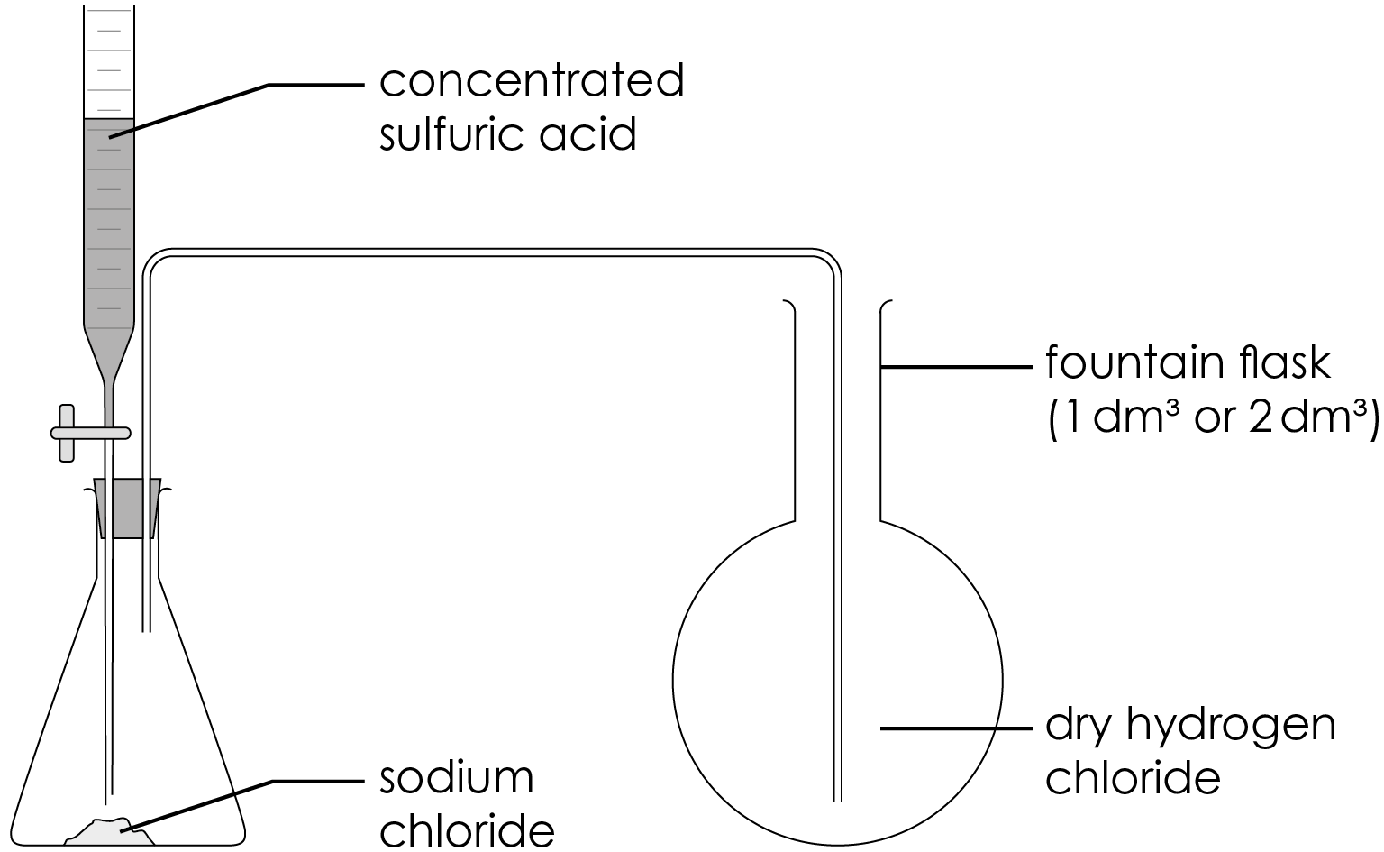
- Purge the air out of the flask containing sodium chloride, by dripping about 1 cm³ of sulfuric acid onto the sodium chloride.
- Hold a piece of damp universal indicator or blue litmus paper near the end of the delivery tube. It will turn red when hydrogen chloride starts to emerge from the tube.
- Position the delivery tube in the round-bottomed flask. Slowly fill the flask with hydrogen chloride, by dripping more sulfuric acid onto the sodium chloride in the gas generator. Test to see when it is full by holding damp indicator paper near the mouth of the flask. Allow the gas to pass for a little longer, even if the indicator paper turns red.
- Stop the gas stream and remove the delivery tube from the round-bottomed flask.

Teaching notes

The demonstration of the fountain experiment takes about 15 minutes.

Try the fountain experiment before demonstrating it to a class, to make sure the flask can be successfully filled with $HCl$ gas. Be careful not to disconnect the flask from the gas supply too soon, even if $HCl$ can be detected at the outlet. Oven drying the glass apparatus beforehand improves the chance of success.

The solubility of hydrogen chloride in one volume of water at 0°C and 1 atm is 506 volumes.

During the demonstration, ask learners to answer the questions on slide 6 of the presentation (and on the learner worksheet).

The fountain demonstration
- Set up the equipment, as shown in the demonstration set up before the lesson.
- Fill the bowl with tap water and add enough universal indicator solution to make the colour clearly visible.
- Refit the bung to the flask containing the hydrogen chloride gas and clamp it in position over the bowl of water. Ensure the valve at the end of the glass tube jet is well immersed in the water and the system is airtight.
- Carefully attach the bulb of the teat pipette filled with water to the pipette tube, without squeezing any water into the flask.
- Remove the clip from the valve. The water starts to rise slowly up the tube as the gas dissolves in it. To speed up this process, squeeze a few drops of water into the flask from the pipette.
- All the hydrogen chloride in the flask dissolves in the water drops from the pipette, creating a vacuum in the flask. Water is then sucked up at great speed from the bowl, creating a spectacular ‘fountain’ in the flask. The indicator in the water changes colour to red. The extent to which the flask fills with water depends on how much air was left in the flask. It can fill almost completely.

The properties of hydrochloric acid practical

Carry out the properties of hydrochloric acid as a class practical. The experimental method is provided on the student sheet and as integrated instructions in the lesson slides, available to download from rsc.li/wheelbarrow.
The investigation takes about 20 minutes. Use the results table and conclusions table on slides 11 and 12 to summarise key points from the experiments.

Answers

Teacher demonstration
- $HCl$
- At the start: green (neutral)

At the end: red (acidic)
- hydrochloric acid
- hydrogen chloride + water → hydrochloric acid

Follow-up questions
- Hydrogen chloride is a gas at room temperature. It is colourless.
- B
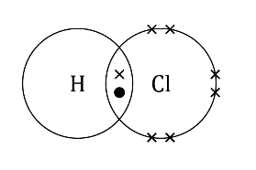
- (a) A substance that is soluble will dissolve in a suitable solvent.

(b) Bubble hydrogen chloride into water and test for conductivity. If it conducts electricity then the hydrogen chloride has dissolved.

OR Bubble hydrogen chloride into water and test the pH. If it is acidic then the hydrogen chloride has dissolved.

(c) $HCl\left(g\right)+ H_{2}O\left(l\right)→ HCl \left(aq\right)$

(d) A hydrogen chloride molecule consists of a hydrogen atom covalently bonded to a chlorine atom. They share an electron pair. When hydrogen chloride dissolves in water, each chlorine atom takes an electron from each hydrogen atom, forming a negatively charged chloride ion and a positively charged hydrogen ion. The new solution is called hydrochloric acid.

- (a) neutralisation

(b) Scaffolded

hydrochloric acid + sodium hydroxide → sodium chloride + water

Unscaffolded

$$HCl(aq) + NaOH(aq) → NaCl(aq) + H_{2}O(l)$$

- (a) hydrogen

(b) Light the gas with a splint and if it pops, hydrogen is present.

(c) Scaffolded
zinc + hydrochloric acid → zinc chloride + hydrogen

Unscaffolded
$Zn(s) + 2HCl(aq) → ZnCl_{2}(aq) + H_{2}(g)$

- (a) Carbon dioxide

(b) Bubble the gas through limewater and if it goes cloudy, carbon dioxide is present.

(c) Scaffolded

sodium carbonate + hydrochloric acid → sodium chloride + water + carbon dioxide

Unscaffolded

$$Na_{2}CO_{3}(s) + 2HCl(aq) → 2NaCl(aq) + H_{2}O(l) + CO_{2}(g)$$

- Hydrogen chloride is a covalently bonded molecule. There are no free electrons in the structure to act as charge carriers. Therefore it cannot conduct electricity.

When hydrogen chloride dissolves in water, ${ H}^{+}$and${ Cl}^{-}$ ions are produced, forming hydrochloric acid. Hydrochloric acid can conduct electricity because the ions are free to move in the solution and act as charge carriers.

