Chromatography

Learning objectives
- Construct and interpret diagrams of the apparatus used for chromatography experiments.
- Describe how you can tell that a sample is a mixture from its chromatogram.
- Explain why samples travel different distances in chromatography experiments.

Introduction

Chromatography is a useful separation technique based on chemicals’ solubilities – in other words, how well chemicals dissolve in particular solvents. In the pharmaceutical industry, chromatography is used to check the purity of medicines. In the food and drink industry, it is used to detect contaminants in batches of produce. And forensic scientists use chromatography to detect the presence of tiny amounts of chemicals in crime scene samples, such as hair or soil.

There are many different types of chromatography, but paper chromatography is the technique you focus on at school, and it’s the type of chromatography we’ll discuss in this structure strip.

Instructions to learners
- Stick the structure strip in the margin of your exercise book/paper.
- Follow the prompts in the structure strip and use your knowledge to write a summary of chromatography:
- Reflect on what you already know about chromatography
- Where have you seen the key words before?
- If you'd like more support, what other sources could you use to find the information, e.g. a textbook, online?
- Complete the extended answer question to apply your knowledge of chromatography to a new context.

Keywords

Use these keywords in your responses:

• chromatography • mobile phase • stationary phase • chromatogram • $R_{f}$ value • soluble • solvent • solubility
Chromatography | Chromatography | Chromatography | Chromatography | Chromatography
Draw a labelled diagram of an apparatus set up for paper chromatography.  Describe two key things about the origin line for the experiment to be successful. | Draw a labelled diagram of an apparatus set up for paper chromatography.  Describe two key things about the origin line for the experiment to be successful. | Draw a labelled diagram of an apparatus set up for paper chromatography.  Describe two key things about the origin line for the experiment to be successful. | Draw a labelled diagram of an apparatus set up for paper chromatography.  Describe two key things about the origin line for the experiment to be successful. | Draw a labelled diagram of an apparatus set up for paper chromatography.  Describe two key things about the origin line for the experiment to be successful.
Explain the terms:  - mobile phase  - stationary phase  and give a common example of each. | Explain the terms:  - mobile phase  - stationary phase  and give a common example of each. | Explain the terms:  - mobile phase  - stationary phase  and give a common example of each. | Explain the terms:  - mobile phase  - stationary phase  and give a common example of each. | Explain the terms:  - mobile phase  - stationary phase  and give a common example of each.
How does a chromatogram show there is more than one substance in a mixture? | How does a chromatogram show there is more than one substance in a mixture? | How does a chromatogram show there is more than one substance in a mixture? | How does a chromatogram show there is more than one substance in a mixture? | How does a chromatogram show there is more than one substance in a mixture?
Explain how chromatography works to separate the substances in a mixture. | Explain how chromatography works to separate the substances in a mixture. | Explain how chromatography works to separate the substances in a mixture. | Explain how chromatography works to separate the substances in a mixture. | Explain how chromatography works to separate the substances in a mixture.
Give the formula for calculating $R_{f}$and describe how to use a chromatogram to determine $R_{f}.$  (Use a diagram if needed). | Give the formula for calculating $R_{f}$and describe how to use a chromatogram to determine $R_{f}.$  (Use a diagram if needed). | Give the formula for calculating $R_{f}$and describe how to use a chromatogram to determine R_{f}.  (Use a diagram if needed). | Give the formula for calculating $R_{f}$and describe how to use a chromatogram to determine $R_{f}.$  (Use a diagram if needed). | Give the formula for calculating $R_{f}$and describe how to use a chromatogram to determine $R_{f}.$  (Use a diagram if needed).

Extended answer question

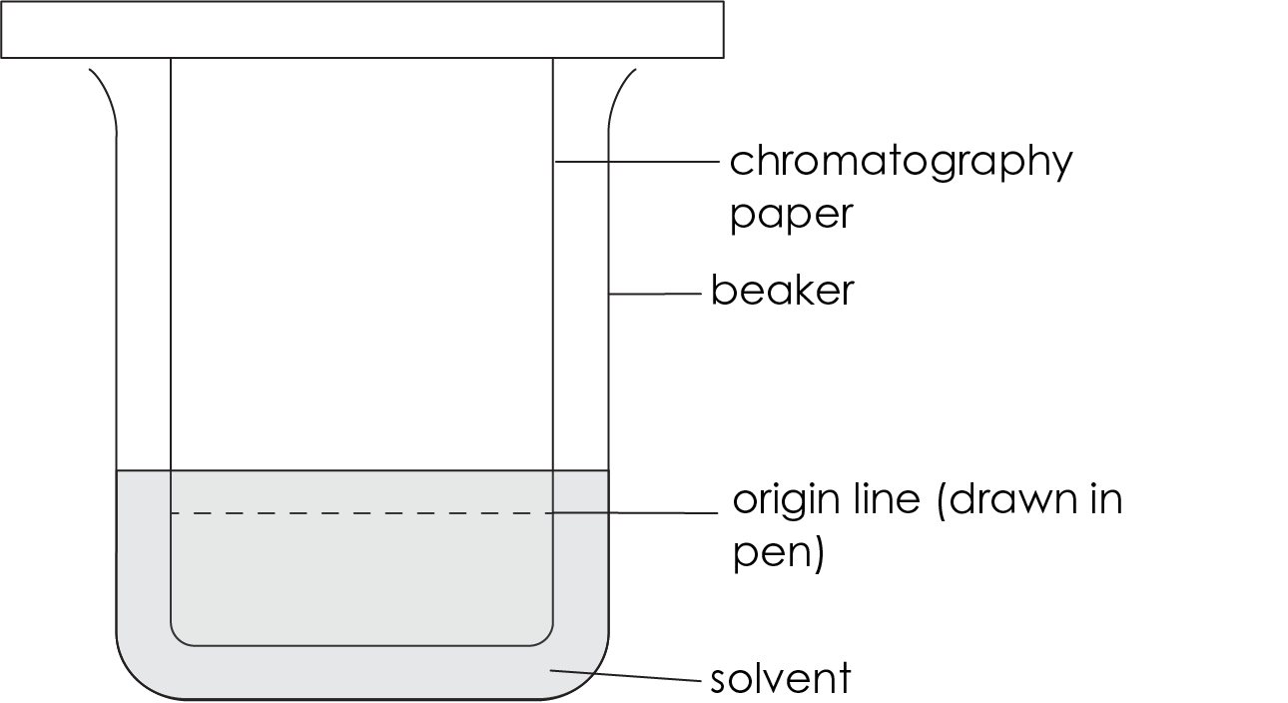
The diagram shows an apparatus set up for a chromatography experiment. The apparatus is not set up correctly. Identify the errors and explain why these errors would affect the results of the experiment. Suggest improvements to rectify the errors.

