Representing elements and compounds

This resource is part of the Structure strips series of resources, designed to support literacy in science teaching. More resources in this series can be found at: rsc.li/4aXYgzt.

Learning objectives
- Construct and interpret diagrams, formulas and names of elements and compounds.
- Describe the format of chemical symbols.
- Describe the differences between elements and compounds.

Introduction

Atoms of elements are the building blocks of all substances. All the known elements are organised in the periodic table and represented by their chemical symbols. However, many of the everyday chemicals we use are compounds, not elements. While chemical symbols represent elements, combinations of different chemical symbols in a formula represent compounds. The names and diagrams of compounds are also different to the names and diagrams of elements.

How to use structure strips

Structure strips are a type of scaffolding you can use to support learners to retrieve information independently. Use them to take an overview at the start of a topic, to activate prior knowledge, or to summarise learning at the end of a teaching topic. For more ideas on how to use structure strips with your learners, visit rsc.li/3EszCfr.

Structure strips have sections containing prompts, sized to suggest the amount that learners must write. Ask learners to glue the strips into the margin of an exercise book and write their answers next to the sections, in full sentences or in bullet points. When learners have finished using the structure strip, they will have an A4 page set of notes and examples.

Scaffolding
- Encourage learners to use the suggested key words in their answers. These link with our corresponding key terms support resources for Elements, compounds and mixtures at 14-16 (rsc.li/4j5xfyj) and at 11-14 (rsc.li/42AcGmK).
- To further support learners, include additional prompts in the structure strip. If learners are struggling to engage with the task, supply them with sentence starters created from the example answers. Alternatively, get learners to discuss the prompts with a partner before attempting their answer.
- As learners grow in confidence, ask them to attempt the extension task first and then use the structure strip to improve or self-assess their attempt.
- Use the tips in this article to further support your learners’ understanding of the difference between elements and compounds: rsc.li/4x1RoML.

Metacognition

This resource supports learners to develop their metacognitive skills in three key areas.
- Planning: the strips provide scaffolding to plan the written response. Learners will decide where to gather information from (textbooks, own notes, revision websites). Ask learners: is the source of information you are using reliable?
- Monitoring: learners are prompted by the questions in the structure strip and can check their own answer against the prompts. Ask learners: have you covered all of the prompts in the space provided? Do you need to change anything to complete the task?
- Evaluation: learners can self-assess or ask a peer to check their work against the answers. Ask learners: did you achieve what you meant to achieve? What will you do differently another time?

Example answers

Example answers for the structure strip are on page 3. Learners can write the answers as bullet points or prose.

Representing elements and compounds | Example answer
Define the terms element and compound. | An element is a pure substance made of only one type of atom.  A compound is a pure substance made of two or more different elements joined by chemical bonds; the atoms are in a fixed ratio.
This diagram shows an element.  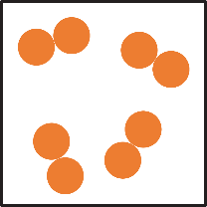  Draw a diagram to represent another element and one to represent a compound. | 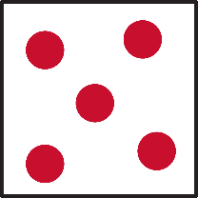 another example of an element diagram  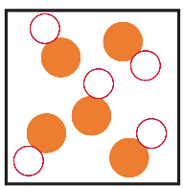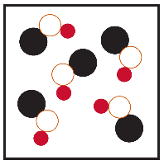examples of compound diagrams
Describe some of the ways that elements are named and give an example in your response. | Many element names end in ‘-ium’, for example magnesium and calcium. Elements can be named after people, places or gods. Many of the elements known by the ancients have unique names that are not named in this way, their origins may be in languages like Greek or Latin.  0BGuidance: provide a periodic table for learners to refer to. For example, the RSC’s interactive periodic table: periodic-table.rsc.org. Task learners with researching where particular element names originate from, as an extension activity.
What format is used for chemical symbols?  6BUse examples in your answer. | Chemical symbols are usually one or two letters. All chemical symbols begin with a capital letter. If there is a second letter in the symbol, then it is a lower-case letter. For example, $C$ is the chemical symbol for carbon and $Cu$ is the chemical symbol for copper.
Give some examples of the names and chemical formulas of compounds and discuss some naming rules. | 1BMany compounds have two parts to their names and give some clue as to the elements contained in the compound.  2BFor example, sodium chloride ($NaCl$) contains sodium and chlorine atoms, the second word has the ending ‘-ide’ which suggests it is in a compound.  3BIn some compounds, the name indicates how many atoms of elements are in a compound.  4Be.g. carbon monoxide has the formula $CO$, the prefix ‘mono’ means one atom of oxygen.  5BCarbon dioxide has the formula ${CO}_{2}$, the prefix ‘di’ means two atoms of oxygen are in the compound.

Extended answer question

Get learners to answer the question after they have attempted the structure strip. The structure strip activates the required knowledge which learners then apply to the question.

Consider reframing the context of this question to one your learners are more familiar with, to empower them to unlock their existing science capital. Read our article about targeting science capital (rsc.li/40FAMLP).

Example answers to extended answer question
- Ozone is a compound because its formula has a little 3 in it.
Ozone has the formula $O_{3}$. It is an element, not a compound as the chemical formula only has oxygen atoms. The small 3 shows how many atoms are in the chemical formula.
- Water is neither an element nor a compound as it doesn’t have a chemical sounding name.
Water is a compound, it has the chemical formula $H_{2}O$, with two hydrogen atoms and one oxygen atom chemically bonded together. The names of substances can help us decide if they are an element or compound. However, water is a very common substance and so tends to be known by its common name.
- Gold is a compound as its chemical symbol has two letters in it.
The chemical symbol for gold is $Au$, there is one capital letter and one lower case letter. It is an element. If it were a compound the chemical formula would contain more than one capital letter.

