Conservation of mass in dissolving and precipitation
This resource is from the Assessment for learning series which can be viewed at: rsc.li/44jTX18. This series contains lesson plans and associated resources to actively involve students in their learning.

Resource components
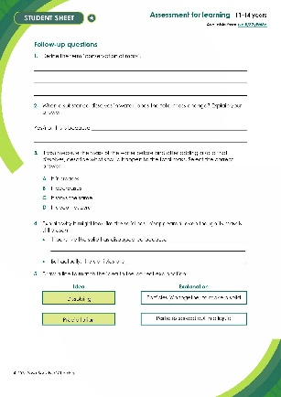 | 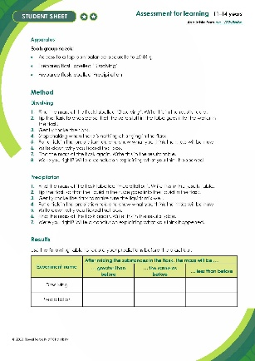 | 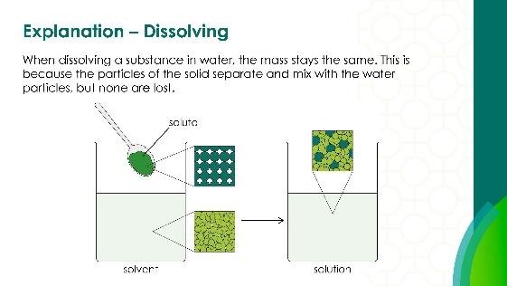
Scaffolded student sheet :  a worksheet with additional prompts and scaffolded questions including word-fill | Student sheet : a worksheet including the method, tables to record observations and follow-up questions | Presentation: lesson slides to guide learners through the class practical and follow-up questions, including answers for self-assessment

Learning objectives
- Recall the definition of conservation of mass.
- Predict the finding of an experiment using prior knowledge of particles and conservation of mass.
- Measure the mass of a solution accurately using a top pan balance accurate to ±0.01g.
- Analyse your results and link these to the principle of conservation of mass.

Success criteria
LO1 is to be discussed prior to the practical through a group activity. LO2–4 are based on the practical and results of this activity, with LO4 assessed further through a series of questions to support learner understanding.

Introduction
In this lesson, learners will carry out a practical involving dissolving substances in water and mixing solutions to produce a precipitate. This provides an opportunity to challenge common misconceptions, particularly the idea that mass is ‘lost’ when a substance dissolves or is ‘gained’ when a solid appears during a reaction.
The lesson is framed around a key conceptual question: Where does a solid go when it dissolves, and where does a solid come from when it forms in a reaction?
Learners often rely on what they can see, leading to misunderstandings (e.g. dissolved substances no longer exist, or precipitates are ‘created’ from nothing). This practical is designed to make these observations explicit and create cognitive conflict.
The core scientific principle underpinning the lesson is the conservation of mass – that mass is neither created nor destroyed, even during chemical reactions. Learners should be guided to connect their observations and measurements of mass to particle-level explanations, recognising that substances are rearranged rather than lost or formed from nothing.
This simple practical activity challenges learners’ thinking about mass conservation when substances dissolve or when chemical reactions produce precipitates.

Scaffolding
There are two versions of the student worksheet: scaffolded (✪) and unscaffolded (✪✪). The scaffolded sheet offers more support to allow learners to access the questions. For example, learners may be asked to choose from a series of prepopulated answers or fill in gaps to answer longer questions. Some questions have more information to aid understanding.

Alternative strategy
If time and/or resources are short, you can demonstrate the chemical reactions. Groups can discuss the results and make their predictions as suggested.

Technician notes
Read our standard health and safety guidance (rsc.li/3zyJLkx) and carry out a risk assessment before running any live practical.

Equipment
Apparatus
- A top pan balance accurate to ±0.01 g
- Prepared flask labelled ‘Dissolving’
- Prepared flask labelled 'Precipitation’
For the prepared flasks labelled ‘Dissolving’
- Conical flask, 500 cm³
- A small tube to fit comfortably inside the flask
- Stoppers to fit the flask tightly
- Water, about 150 cm³ in the flask
- About 5–10 g of one of these solids in the small tubes:
  - sodium chloride,
  - sugar,
  - copper(ii) sulfate (HARMFUL)
For the prepared flasks labelled ‘Precipitation’
- Conical flask, 500 cm³
- A small tube to fit comfortably inside the flask
- Stoppers to fit the flask tightly
- Pairs of solutions at 1 mol dm⁻³ that form a precipitate on mixing.
For example:
  - sodium sulfate
barium nitrate (HARMFUL and OXIDISING)
  - potassium iodide
lead(ii) nitrate (TOXIC)
  - ammonium phosphate
calcium chloride (IRRITANT)

Safety and hazards
- Learners should wear safety glasses throughout the practical activity.
- For all substances please refer to CLEAPPS, SSERC or your local safety advisory body for more information and advice regarding safe handling and disposal.
- The hazards will depend on the solute and the pair of solutions you have chosen. The information for the examples given are provided below.

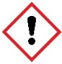
Solute
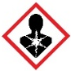
- Copper(ii) sulfate, $CuSO_{4}$(s) HARMFUL if swallowed. Causes skin irritation. Causes serious eye damage. Very toxic to aquatic life with long lasting effects. See CLEAPSS Hazcard HC027c.

Reactants
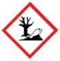
- Lead(ii) nitrate, $PbNO_{4}(aq)$ HARMFUL if swallowed or inhaled. May damage the unborn child and suspected of damaging fertility. May cause damage to organs through prolonged or repeated exposure. Very toxic to aquatic life with long lasting effects. See CLEAPSS Hazcard HC057a.
- Calcium chloride, $Pb{(NO_{3})}_{2}(aq)$ IRRITANT - causes skin irritation and serious eye irritation. May cause respiratory irritation. See CLEAPSS Hazcard HC019a.
- The following reactants are currently not classified as hazardous:
  - Sodium sulfate, ${Na}_{2}SO_{4}(aq)$, CLEAPSS Hazcard HC098b
  - Barium nitrate, $Ba{(NO_{3})}_{2}(aq)$, CLEAPSS Hazcard HC011
  - Potassium iodide, $KI$(aq), CLEAPSS Hazcard HC047b
  - Ammonium phosphate, ${(NH_{4})}_{3}PO_{4}$(aq) CLEAPSS Hazcard HC072

Products
- Sodium nitrate, $NaNO_{2}(aq)$, and Potassium nitrate, $KNO_{2}\left(aq\right)$ HARMFUL if swallowed. See CLEAPSS Hazcard HC093.
- Lead iodide, $PbI_{2}$(s) HARMFUL if swallowed or inhaled. May damage the unborn child and suspected of damaging fertility. May cause damage to organs through prolonged or repeated exposure. Very toxic to aquatic life with long lasting effects. See CLEAPSS Hazcard HC057a, refer to SSERC or refer to your local safety advisory body.
- Ammonium chloride $NH_{4}Cl$(s) HARMFUL if swallowed. Causes serious eye irritation. See CLEAPSS Hazcard HC009a, refer to SSERC or refer to your local safety advisory body.
- The following products are currently not classified as hazardous:
  - Calcium phosphate, ${Ca}_{3}{(PO_{4})}_{2}(aq)$, CLEAPPS Hazcard HC072
  - Barium sulfate, $BaSO_{4}$(s), CLEAPPS Hazcard HC010B

Preparation
- To prepare the flasks, tie a piece of thread around the neck of each small tube. Ensure that the length of the thread supports the tube in an upright position in the flask but allows the contents to mix without being opened when the flask is tilted.
- Put the chosen solid into the tube. Put about 150 cm³ of water in the flask. Use the thread to arrange the prepared tube in the flask so that the contents mix when the flask is tilted. Label the flask ‘Dissolving’.
- Put the chosen solution (10–20 cm³) into the tube. Put the second solution in the flask. Use the thread to arrange the prepared tubes in the flask so that the contents mix when the flask is tilted. Label the flask ‘Precipitation’.
Method

Dissolving
- Find the mass of the flask labelled ‘Dissolving’. Write this in the results table.
- Tip the flask to one side so that the solid in the tube goes into the water in the flask.
- Gently shake the flask.
- Stop shaking when there is nothing changing in the flask.
- Put a tick in the prediction table to show what you think the mass will be now.
- Write down why you ticked that box.
- Find the mass of the flask again. Write this in the results table.
- Were you right? Write a conclusion explaining what you think happened.

Precipitation
- Find the mass of the flask labelled ‘Precipitation’. Write this in the results table.
- Tip the flask so that the liquid in the tube goes into the liquid in the flask.
- Gently shake the flask to make sure the liquids mix well.
- Put a tick in the prediction table to show what you think the mass will be now.
- Write down why you ticked that box.
- Find the mass of the flask again. Write this in the results table.
- Were you right? Write a conclusion explaining what you think happened.

Teaching notes
Introduce the topic, and the learning objectives, by explaining to the learners that they are going to look at two events which:
- people often explain using different ideas
- they will come across a lot in chemistry, so they need to understand them correctly.
Pose the question to learners: Where does a solid go when it dissolves, and where does it come from when it appears?
Ask learners to work in groups to make predictions about what happens when they mix the two substances in the flask labelled Dissolving together, in terms of both physical observations and observations of mass, and to explain their predictions.
Learners then complete the practical, recording the mass before and after, discuss the results and agree on an explanation.
Learners repeat the above method, using the flask labelled Precipitation.
Learners work in groups to describe and explain their results. Each group should feed these back to the class. You can then clarify any misconceptions to ensure that learners understand that mass is conserved when substances dissolve and in precipitation reactions.
Allow learners time to complete the follow-up questions to consolidate their understanding.
Support and encourage learners to change their thinking to a scientifically correct viewpoint.

Answers

Conclusion
When dissolving a substance in water, the mass stays the same. This is because the particles of the solid separate and mix with the water particles, but none are lost.
When adding the two substances together in a precipitate reaction, the mass stays the same. This is because the precipitate forms when the particles in the two solutions join together to make a solid.

Follow up questions
- The principle of conservation of mass states that mass cannot be created or destroyed in a chemical reaction, only rearranged.

- No, the total mass does not change because the dissolved substance is still present in the solution.

- The total mass should increase by the mass of the solid added.

- It looks like it has disappeared because it has spread out evenly in the water, but its particles are still there.

- The particles of the solid separate and mix with the water particles, but none are lost, so the mass stays the same.

- Spilling liquid, evaporation or not measuring carefully could make it seem like mass has been lost.

- The total mass stays the same.

- The precipitate forms when particles in the two solutions join together to make a solid.

- This is because all of the substances present (liquids and solids) contribute to the total mass.

- In both processes, particles are rearranged or spread out, but none are lost, so the total mass stays the same.

