Filtering muddy water: Johnstone’s triangle

This resource is from the Johnstone’s triangle series which can be viewed at: rsc.li/43jMfSn.

Learning objectives
- Name the equipment used to filter muddy water.
- Explain why the filtrate can pass through the filter paper but the residue cannot.
- Recognise the particle diagrams for different parts of the mixture.

How to use Johnstone’s triangle

Use Johnstone’s triangle to develop learners’ thinking about scientific concepts at three different conceptual levels:
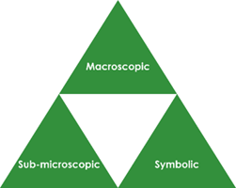
- Macroscopic – what we can see. Think about the properties you can observe, measure and record.
- Sub-microscopic – smaller than we can see. Think about the particle or atomic level.
- Symbolic – representations. Think about how we represent chemical ideas including symbols and diagrams.

For learners to gain a deeper awareness of a topic, they need to understand it at all three levels.

When introducing a topic, don't introduce all three levels of thinking at once. This will overload working memory. Instead complete the triangle over a series of lessons, beginning with the macroscopic level and then introducing other levels, in turn, once secure.

The levels are interrelated, for example, learners need visual representation of the sub-microscopic in order to develop mental models of the particle or atomic level.

Find further reading about Johnstone’s triangle and how to use it in your teaching at rsc.li/4pIDZq2.

Scaffolding

Share the structure of the triangle with learners prior to use. Tell them why you are using it and how it will help them to develop their understanding. Use an ‘I try, we try, you try’ approach when introducing Johnstone’s triangle for the first time.

More resources

To further develop learner’s thinking in all areas of Johnstone’s triangle, try our Developing understanding of filtration worksheets (rsc.li/3TixOgg). These include icons in the margin referring to the conceptual level of thinking needed to answer the question.
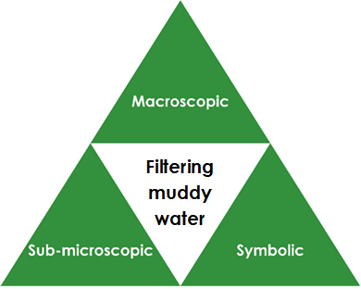
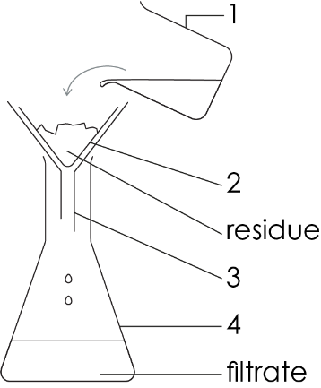

Macroscopic – what we can see

Some muddy spring water is a mixture of water, dissolved minerals and tiny solid fragments of mud. Name the filtering apparatus shown in the diagram.

1. beaker 2. filter paper

3. funnel 4. conical flask

Name the part of the mixture that will not pass through

the filter paper (the residue). mud

Symbolic – representations

Give the letter of the particle diagram that represents the following:

solid fragment of mud C

liquid water with dissolved minerals A

pure liquid water B

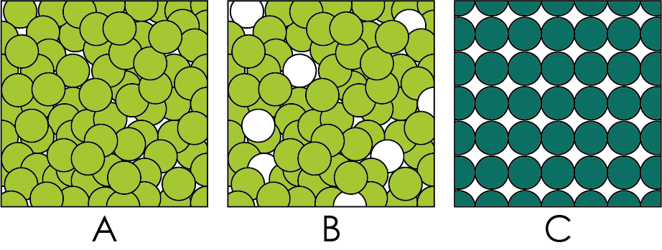

Draw what represents a single water particle and a single dissolved mineral particle. water mineral

Would a real fragment of mud contain more or fewer particles than the diagram? more

Sub-microscopic – smaller than we can see

The muddy water mixture is made up of water particles, particles of dissolved minerals and tiny solid fragments of mud.

The solid fragments of mud are made up of a large number of mud particles.

Can you see: particles of water? no fragments of mud? yes

Which are larger, particles or mud fragments?

fragments of mud

Explain why the tiny fragments of mud are not able to pass through the filter and form the residue left in the filter paper.

The tiny fragments of mud are larger than the holes in the filter paper.

Explain why the water particles and particles minerals can pass through the filter paper to form the filtrate.

The particles are smaller than the holes in the filter paper.

